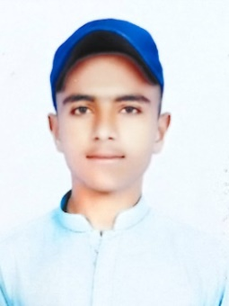

* Urdu
* English
* Pashto

Languages

* Cricket
* Football
* Traveling
* Reading Books & Articals
* Basic Computer
* 1 Years worked as a sales man in Millinyam Mall Quetta.
* 6 months worked as a sales man in Gold City Mall Quetta.

Extra Skills and Hobbies

Experience

|  |  |  |
| --- | --- | --- |
| Degree/ Diploma | Institute/ Board/ University | Division |
| Metric | BBISE Quetta | 1st |

Qualification

Father Name : Riaz Ahmed

Date of Birth : 28-10-2003

Nationalaty No : 54400-7396552-1

District : Quetta

Religion : Islam

Material Status : Single

Personal Information

Secure a responsible opportunity to fully utilize my training and skills, while making a significant contribution to the success of the company.

OBJECTIVE

Contect No: 0313-183906 Address: Patial Road, Railway Colony, Quetta.

Jawed ahmed