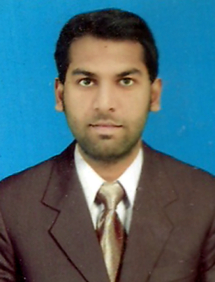

**JAMSHED ALI SHAIKH**

**Address: LUQMAN MEMON MOHALLA NEAR RASHIDI**

**HOUSE KHAIRPUR MIRS**

**Cell: 0300-2574900**

**E-mail:** [**jamshedalishaikh4@gmail.com**](mailto:jamshedalishaikh4@gmail.com)

OBJECTIVE

To get employed in a well reputed and growth-orated originations

Where I can better utilize my knowledge and skills for the accomplishment of company’s goals and objectives; and gain experience while enhancing productivity and reputation of the company, and contribute for the positive work environment and the growth of corporation.

PERSONAL INFORMATION

* FATHER’S NAME : **GULAB KHAN SHAIKH**
* SURNAME : **SHAIKH**
* DATE OF BIRTH : **01-01-1996**
* CNIC : **45203-8799910-7**
* DOMICILE/PRC : **DISTRICT KHAIRPUR**
* MARITAL STATUS : **SINGLE**
* RELIGION : **ISLAM**
* NATIONALITY : **PAKISTANI**

QUALIFICATION

|  |  |  |
| --- | --- | --- |
| **DEGREE** | **YEAR** | **BOARD/UNIVERSITY** |
| B.COM | 2016 | SHAH ABDUL LATIF UNIVERSITY KHAIRPUR |
| INTERMEDIATE | 2014 | BOARD OF INTERMEDIATE AND SECONDARY EDUCATION SUKKUR |
| MATRICULATION | 2012 | BOARD OF INTERMEDIATE AND SECONDARY EDUCATION SUKKUR |
| CIT | KHUWAJA INSTITUTE KHAIRPUR | |
| HARD WARE AND NETWORK TECHNICIAN | MEHRAN UET SHAHEED ZULFQAR ALI BHUTTO CAMPUS KHAIRPUR | |

SKILLS

* **OFFICE AUTOMATION( MS OFFICE )**

MS word, Power Point

Basic Knowledge about:

* **PROGRAMMING LANGUAGE**

Java, HTML

EXPERIENCE

* **DUBAI ISLAMIC BANK** (Currently working as a Financial Consultant ) from October 2019 to December 2020
* Account Opening.
* **SINDH YOUTH ORGANIZATION** (Worked as a Volunteer)
* Where we manage the organization on volunteer level and help student in there in their respective problems (Also to arrange donation and education for needy persons). January 2017 to January 2018.
* **PAKOLA GUL BOTTLERS PVT LTD** (7 months, November 2016 to May 2017)
* Designation: Accountant,
* Job Description: To manage accounting Information of mentioned company.

TRAININGS

* Fundamental of Islamic Banking Operation at National Institute of Banking Finance (NIBF) Sukkur Conducted on January 27 to 31 in 2020 at Sukkur

REFERENCE

* **Will be furnished on request.**