Curriculum Vitae

SHABBIR HUSSAIN
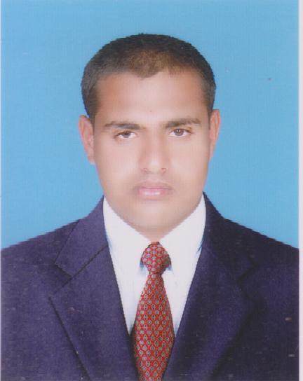  Father's Name:  Zafar iqbal  Date of Birth:  16-06-1993  Domicile:  Vehari(Punjab)  Marital Status:  Single  Nationality:  Pakistan  CNIC:  36603-9047792-7  Contact:  (+92)302-6582798  (+92)304-5209388  Mailing Address:  Chak No 155Wb More Rab Rakha Tehsil & District Vehari  E-Mail:  Hshabbir034@gmail.com | OBJECTIVE:  “To be a part of an organization which favors creativity, team work, appraise & compensate the sincere efforts, provide the learning and development opportunities and committed to its vision and mission statement.”  ACADEMIC QUALIFICATION:  Degree Year Marks Board/University  B.A 2019 473/800 B.Z.U MULTAN  D.A.E Mechanical 2013 2692/3400 PBTE GCT Multan  Matric(science) 2010 826/1050 BISE Multan  SKILLS & ATTRIBUTES:  I possess strong interpersonal, presentation, analytical and verbal Skills. I offer my excellent negotiating and convincing power.  - Excellent Communication Skills (English, Urdu, Punjabi)  - Good in Planning & Organizing, Delivery of work.  - Proactive, loyal, hard working, a good team player and a self-starter.  - Good in influence communication during working with others.  DIPLOMA  - 1 Year Diploma computer software (D.I.T) in bright career computer vehari  - 6 Month course shorthand and computer typing in naveed academy vehari  EXPERINCE:  - Currently working as a Tehsil Tb ssistant Vehari in Punjab Tb program DG health  18 Months Experience as a Data Entry Operator PITB Porject in DHQ Hospital Vehari  3.8 Years Experience as a Computer Operator in Cammbridge College of Commerce Kasur  LANGUAGES:  - Urdu  - English  - Punjabi  REFERENCES:  References will be furnished on demand.

