H

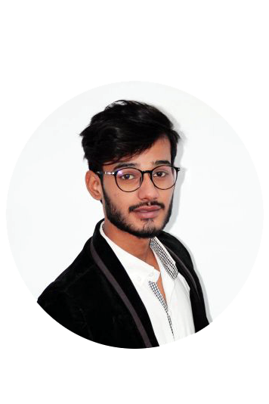

Objective

I am a motivated individual, with an excellent sense of humor, who enjoys challenges and work brilliantly under pressure. Extremely ambitious, gal oriented with a clear and conical vision of Riture objectives Eager to find a position offering long term potential with a structured, defined career Progression.

Skill Highlights

|  |  |
| --- | --- |
| * ADOBE PHOTOSHOP * ADOBE PRIMERE PRO * Ms OFFICE |  |

Personal profile

Father Name : Muhammad Ejaz

Religion : Islam

Dob : 16-August-2003

Nationality : Pakistani

Martial Status : Single

Experience

* video Editor.
* Computer operator AL-Rehman flour mill 1year experience.
* Accountant assistant at Grainy bread company 6 Month experience.
* Outdoor work At Zamzam Floor mill 2 year experience.

Education

MATRICULATION : From Govt boys Secondary High School

INTERMEDIATE. : From Korangi NO 3 Degree College Science And Commerce For boys.

Utter

MUHAMMAD MUZAMMIL

Contact

**Address:**

House No Ls27,Street No 37/2,Sector 35-C Area Raza Colony Korangi 3-1/2 Karachi

**Phone:**

0312-2731304

0323-2745136

**Email**

Muzammilsheikh933@gmail.com

Languages

English

URDU