**Hafiz Khalid Mehmood**

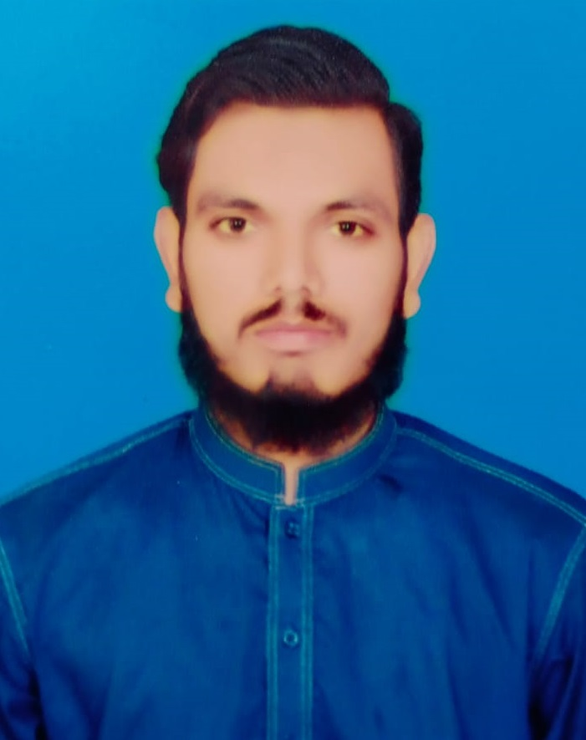

**Address:** Gali school wali muhallah muft Pura kasur

**E-mail:**

hafizkhalidstar@gmail.com

**Mobile:**

0320-4979226

0316-4829619

## Personal Bio Data:

* Fathers Name Muhammad Arif
* Date of Birth 09-August-1998
* Nationality Pakistani
* N.I.C # 35102-5257317-1
* Marital Status Single
* Religion Islam

## Objective: Secure a responsible career opportunity to fully utilize my training and skills, while making a significant contribution to the success of the company.

**Academic Qualification:**

* M.Sc Chemistry (2020)

Government college university of Lahore

* B.Sc ( 2018)

University of Punjab

* F.Sc ( Pre Engineering) 2016

Government islamia college kasur

**Experience:**

* Tehseen Nutraceutical industry kasur.( As a Quality Control Analyst).

**Skills :**

* MS Office , MS Excel , MS word

**References:**

* Will be furnished on demand .