# Shahzad Akber

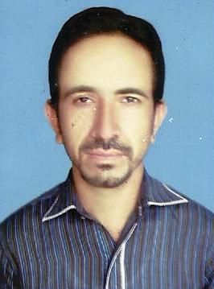



**Position Applied For__________________________________________**

***PROFILE***

**To built a challenging career and polishing the abilities through practical work. Knowledge is my tool, experience is an asset and struggle is my belief. These are my keys to success for opening the doors of horizons to serve humanity. So I wish to work as team with a leading organization providing good learning opportunity.**

**QUALIFICATION**

|  |  |  |
| --- | --- | --- |
| **DEGREE** | **BOARD/UNIVERSITY** | **Div.** |
| **Matriculation** | **Board of Intermediate and Secondary Education Bwp** | **2nd** |
| **Intermediate (F.A)** | **Board of Intermediate and Secondary Education Bwp** | **2nd** |
| **Graduation (B.A)** | **Islamia University Bahawal pur** | **2nd** |

**PERSONAL INFORMATION**

**Father’s Name : Ghulam Akber**

**Date of Birth : 14-07-1989**

**N.I.C # : 31302-6299051-9**

**Domicile : Punjab (District Rahim Yar Khan)**

**Marital Status : Married**

**Religion : Islam**

**Nationality : : Pakistani**

**Permanent Address : Moza Kotla Nawab P/O Nizam wala**

**Tehsil Liaquat Pur,District Rahim Yar Khan**

**Mailing Address : Moza Kotla Nawab P/O Nizam wala**

**Tehsil Liaquat Pur,District Rahim Yar Khan**

**Contact No. : 03008774582**

**Email address. s03008774582@gmail.com**

**WORK EXPERIENCE**

**\* So at u phone farnchice At Liaquat pur**

**\* Team leader at Ktc Khan pur and Liaquat pur**

**\* brand embasidor at Mobilink jazz cash account 2 year**

**\* Community out reach officer 2 year(Awaz2 project)**

**\* Community Mobilizer 4 Month NADRA (international rescue comety)**

**\*Family planing champion 18 Month iRC(PPIF project**

**\*Target Ali Akber group 2 year field ofiser(Agriculture)**

**\* Sygenta Pakistan 2 year field offiser(Agriculture)**

**Field work**

**Traning Course**

* NSER TRAINING 2 DAYS
* ASER TRAINING 2 DAYS
* WASEELA TALEEM BISP TRAINING 5 DAYS
* IDARA TALEEM O AGAHI TRAINING 5 DAYS
* APEX TRAINING 2 DAYS
* **EREST**
* Reading News paper
* Reading Books
* Cricket

**COMPUTER EXPERTIES**

## Expert to use MS. Office(World ,Excel,Power Point) ,Windows 7 , 8 Ep etc.

## Inpage Urdu,Corel Draw (Composing ,Designing),Internet

* Very Good typing Speed

**LANGUAGES**

1. **English**
2. **Urdu.**

* **Punjabi**
* **Sarieki**
* **HARYANVI**

**REFERENCE**