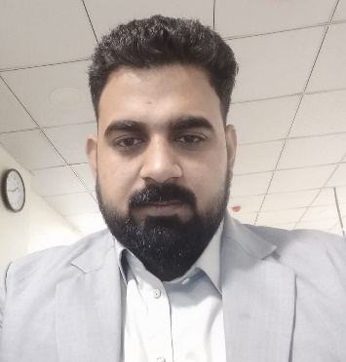

**Taj Ud Din**

Plicl Eco Staff College, 2nd floor G8/4-islamabad

Email:khantajudin33@gmail.com Phone: 0334-5585924

**OBJECTIVE**

“Seeking a suitable and rewarding career, with an esteemed Organization this would offer good ‘advancement potential, challenges, and opportunities

To zoom my carrier growth, contributing to the success of the Organization”

# PERSONAL INFORMATION

# NIC: 17101-6454186-5

# DATE OF BIRTH: 10-03-1999

# FATHER NAME: SARDAR UD DIN

# RELIGION: ISLAM

# NATIONLITY: PAKISTAN

**EDUCATION**

* **Master of criminology**
* University of Peshawar, Peshawar

2018-2022

* **Bachelor of Science**
* Bacha khan University charsadda, charsadda

2016-2018

* **FSC from BISE Peshawar**

2014-2016

* **DIT from technical board Peshawar**

2107-2018

* **Matric Science from BISE Peshawar**

2012-2014

# 

# EXPERIENCE

**Postal Life Insurance Company Limited (July 2022 to till now)**

**(Management Trainee Officer/Agency department)**

During this Placement he has performed the following task:

* Verification and Evaluation New Customers Data Record
* Digitalization Word Processing) Insertion, Deletion, Modification and Maintenance of Database Policy
* Assistance to Head Of the Agency Department
* Performed multiple Administrative tasks including drafting letters, filing and maintaining records of Dak inward/outward, etc.

**Computer skills**

* MS Windows (WIN XP, WIN 7, WIN 8, Win 10), Internet, E-mail, Searching & Browsing
* MS-Word, MS-POWER POINT,

**Languages**

* + Pashto
  + Urdu
  + English

Reference will be furnished on demand