***c***

***v***

urriculum

itai

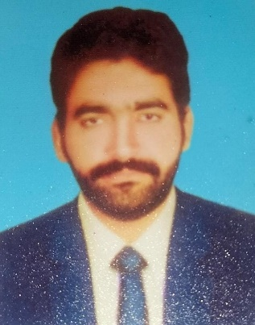

**Postal Address:**

Chah Deewan Wala Post Office Bagh Tehsil o District Jhang

**Mob:**

0347-0468185

**Email:**

[Safderabbaslak599@gmail.com](mailto:Safderabbaslak599@gmail.com)

**Safdar Abbas**

**PERSONAL INFORMATION:**

**Father's Name** : M. Ismail Nadeem

**Date of Birth** : 01-08-1997

**Nationality** : Pakistani

**Religion** : Islam

**Domicile** : Jhang (Punjab)

**Marital Status** : Single

**CNIC** : 33202-9475110-7

**EDUCATION AND QUALIFICATIONS:**

**BA**

2019

BISE, Faisalabad

**Intermediate**

2016 Major: Gen Science

**Matric** 2014

Major: Pre-Engineering

Scored: 588/1100

BISE Faisalabad

**ADDITIONAL SKILLS AND EXPERIENCE**

* MS-Office: (MS Word, MS Power Point, MS Excel)
* Ability to Interact with Diverse People
* Good Problem Solving and Analytical Skills
* Energetic, Self-motivated, and Hardworking

**WORKING EXPERIENCE**

* + - * + Issues of Agricultural Loans as Project
        + 2 years’ experience as a Senior Sale Officer in Gourmet Beverage.
        + 8 Month work as a Sales Executive at Suraj Fertilizers Pvt.

**INTERESTS:**

* Reading Books, Columns and Magazines, Watching Television

**LANGUAGE**

* English, Urdu, Punjabi.

**REFERENCE:**

* Will be provided on Demand