CURRICULUM VITAE
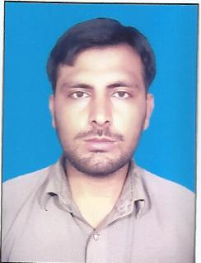
ADIL KHAN
Father’s Name: Bashir Khan
Date of Birth: 9th November 1992
Domicile: Peshawar (K.P.K)
C. N. I. C No: 17301-4100077-1
Marital Status: Single
Religion: Islam
Languages: English, Urdu and Pashto
Present Address: Alnoor Colony Street No 5 Village & P/O Khazana Payan Tehsil and District Peshawar
Permanent Address: Khan Pur p/o Shagi Bala Nahaqi Tehsil & District Peshawar.
Contact No’s: 0307-8468608

EDUCATIONAL QUALIFICATIONS:
S NO | Certificate/Degree | Marks/Total Marks | Session | Board/University
01. | S.S.C | 427/900 | 2008 | BISE Peshawar
02. | F. A | 550/1100 | 2010 | BISE Peshawar
03 | B.A | 594/1000 | 2013 | A.I.O.U Islamabad
04 | M.A | 618/1100 | 2015 | Peshawar University

EXPERIENCE:
- Heavy Machinery (Loader) From 2nd May to 1st June 2013.
- 1 year experience CIP VIP Lounge facilitator in Bacha Khan International Air Port Peshawar 2018 to 2019.
- 1 year experience chick the boarding pass business class passenger for CIP VIP Lounge Bacha Khan International Air Port Peshawar 2019 to 2020.
- From 2016 up to now as a Janbaz Army Force.

COMPUTER SKILL:
Six Months Certificate in Computer Sciences from Decent Institute of Information Technology Peshawar.

