v
c

urriculum

itae
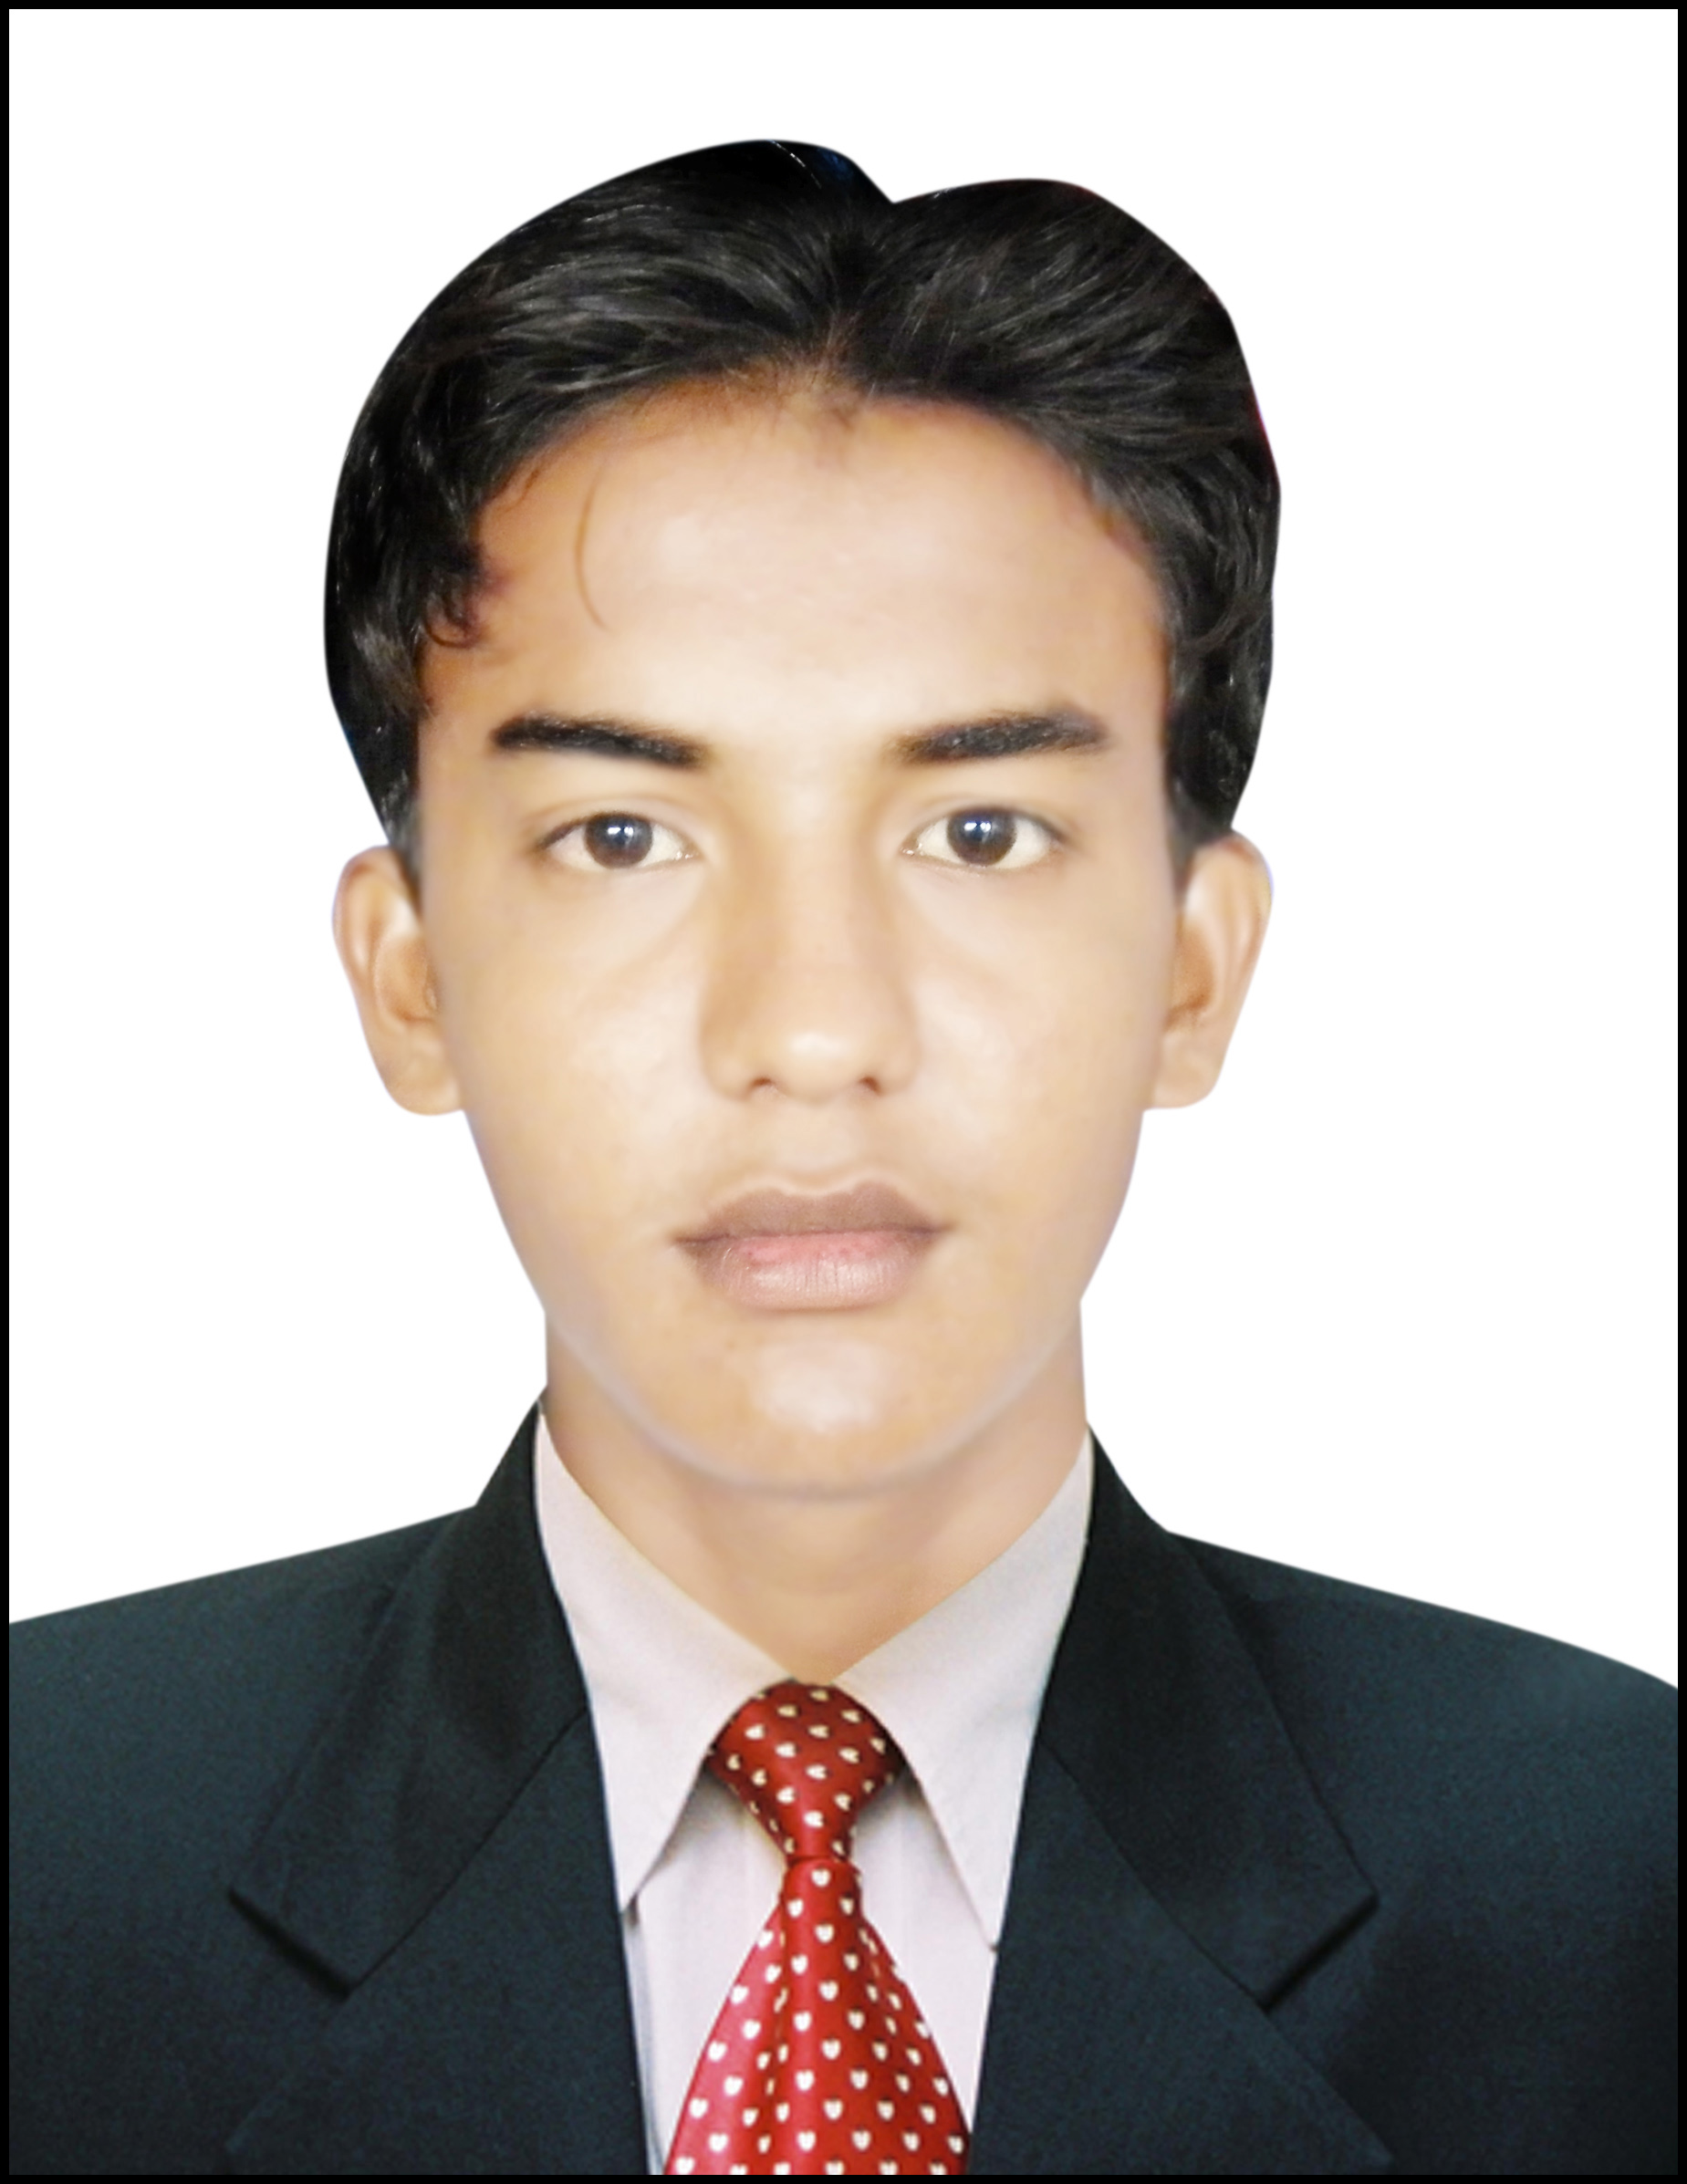

Mr. IRFAN UMAR

ADDRESS: Ward # 02 Golarchi District Badin.
Cell No: 0345-2791931
E-mail : smirfanumar@gmail.com
OBJECTIVE

To pursue a long term, challenging and rewarding career in a position with organization that seeks employees with the positional for growth and achievement.
PERSONAL DATA

Father’s Name: Muhammad Umar

Surname: Rahimoon

Date of Birth: 05-01-1997

C.N.I.C No. 41102-9046277-9

Nationality: Pakistani

Religion: Islam

Marital Status: Single

Domicile: District Badin(Rural)
ACADEMIC QUALIFICATION

Degree | Passing Year | Board | Progress
BS Computer Science | 2018 | U Sindh Badin Campus | 2nd Class
Intermediate | 2014 | BISE Hyderabad | Grade “C”
Matriculation | 2012 | BISE Hyderabad | Grade “B”

ADDITIONAL COURSE

- 1 year Diploma in Information Technology (DIT) From Sindh Technical Education Board Karachi.

LANGUAGES

Sindhi- Urdu - English

REFERENCE

- Can be furnished on demand.

