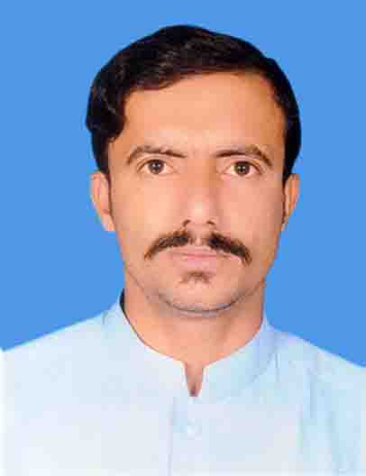


Objective:
I being a dynamic aggravated and action oriented young man, present myself with all my devotion, dedication and commitment for the best of your well-substantiated organization. I cordially assure you, if given a chance, would capitalize my abilities. To enhance my skills and potential by working in an environment that is conducive to learning, hear work and creative things and I wish to apply my experience to challenging takes leading to growth and development of organization

Personal Detail:

NAME: Muhammad Asif Khan
FATHER NAME: Muhammad Younis
ADDRESS: Mohallah Kamal Khel Shirqi Post Office Kulachi Tehsil Kulachi District DIKhan
CNIC #: 12101-1594206-1
DATE OF BIRTH: 14-04-1990
RELIGION Islam
DOMICILE DIKHAN KP
MARITAL STATUS: Single
NATIONALITY: Pakistani
CONTACT # 03450990545
EMAIL ADDRESS: asekhan76@Gmail.Com

Academic Qualification:
Subject | Board/College/ University | Marks |  | Years | Division
SSS | BISEDIKHAN | 518/900 | 58% | 2008 | B
FSC (ICS) | BISEDIKHAN | 550/1100 | 50% | 2010 | C
B.COM | Qurtuba University Dikhan | 1549/2200 | 70.40% | 2013 | A
MBA-G 3.5 | Gomal University Dikhan | 3043/3700 | 82.24 | 2017 | A
Hafiz Quran | Wifaqul Madaress Multan | 65/100 | 65% | 2005 | A
DIT | KPBTE Peshawar | 1141/1400 | 82% | 2018 | A+

Hobbies:
Volley Ball, Book Reading, Internet Surfing, Computer,
Languages:
English, Urdu, Saraiki, Pashto

Experience:
- six month Experience in WHO as a post Of TTM (temporary Tehsil Monitor) In Tehsil Daraban Kalan
- 8 Years Experience in WHO as a post of UCPO (Union Council Polio Officer) dealing with community.
- Three Years Experience in KYM TECHNOLOGIES (P.Ltd) as a GENERAL MANAGER & Receptionist dealing with customer for the payment received.
- Attended Different Types of Training session for the post of PARA TEACHER in ITA dealing with community for the admission of illiterate children.
- I was conducted Assessment sheet door to door collect data about illiterate children for the admission of Govt School.
- 4 Years Experience In CTC As A Union Councile Polio Officer (UC Kulachi & Maddi)
- All Ready Polio Activities Conduct In Tehsil Kulachi Specialy In Teams Training And Post Campaign Activities.
- I Have Doned All Polio Related Activities In Tehsil Kulachi Which Is 4 UCs asigned Target From WHO Offce Dikhan I Have Conducted

