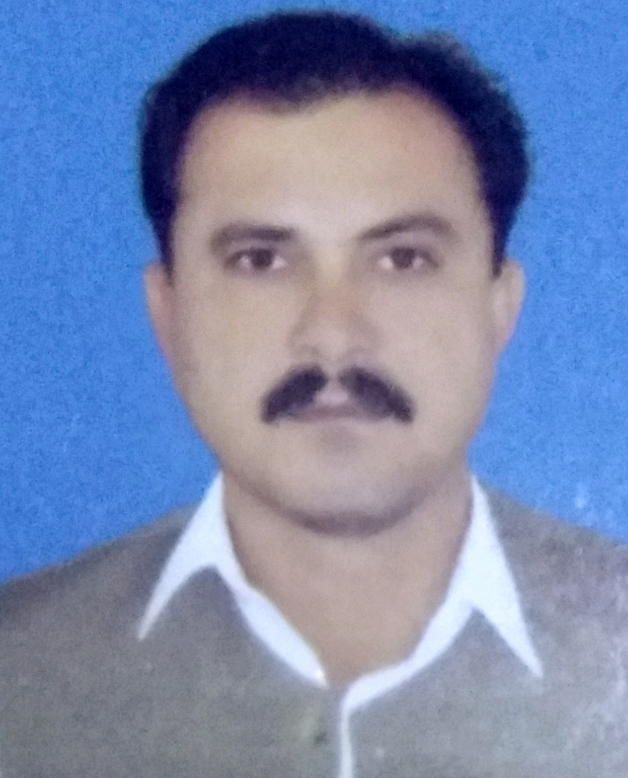
GHAZI KHAN S/O GHULAM RASOOL
Date of Birth: 04-Jan-1987
CNIC No: 12101-6455688-1
Address: Zafar Abad Colony Kamrani Chowk, Dera Ismail Khan
Mobile: +923439899974
Email: kghazi171@gmail.com
OBJECTIVES

Qualified for challenging, responsibilities and decision-making assignment with a progressive organization that gives me scope to update my knowledge and skills, a part of a team that dynamically works towards the growth of the organization and gain satisfaction there off.
SKILLS AND EXPERTIES:

- Medical Technologist
- Expert in Public Health related operations.
- Multilingual.
- Effective Communication.
- Target Oriented.
- Campaigns Management.
- Monitoring and Evaluation.
- Excellent Interpersonal Skills.
- Team Management.
- Social Mobilization and Organization.
- Conflict Resolution.

EDUCATION

- Master Public Health (MPH) ABDUL WALI KHAN UNIVERSITY MARDAN
- Physio therapist (DPT) H,I,M,S PESHAWAR
- Medical Technology MEDICAL FACULTY PESHAWAR
- B Pharmacy PHARMACY COUNCIL PESHAWAR

EMPLOYMENT HISTORY

UNION COUNCIL POLIO OFFICER (UCPO)
CHIP TRAINING CONSULTANTS – FUNDED BY WHO.
UC Kotla Saidan, Dera Ismail Khan - 01-Feb-2018 to till date.
JOB DESCRIPTION / MAIN DUTIES
Supplementary Immunization Activities (SIAs)
- Pre-campaign
- Micro-planning: - Assist in preparation and updating SIA micro-plans. Validate the micro-plans in the field. Help in identifying and mapping high-risk areas in the specific UC.
- Assist in selection of appropriate vaccinators as per given criteria and in their distribution as per need.
- Assists in monitoring of timely distributions of DDM cards. Ensure that cards are filled properly and upon completion of campaign their submission to the provincial office for further processing.
- Follow up and report to PEO on timely payment of incentives to the frontline workers.
- Trainings: - Assist the DPEOs and district trainers in planning, coordinating, and organizing training sessions for vaccination teams and supervisors.
- Partnership and Coordination: Promote partnership with all influencing factors at UC level in support of SIAs.
- Campaign Implementation
- Monitoring: - Monitor the process of implementation of the campaign as per guidelines and provide feedback to DPEO
- Data collection: and analysis: - Collect and collate the tally sheet data from the area of responsibility on daily basis.
- Ensure proper implementation of SIAs with special attention to hard-to-reach areas and under- served high risk populations.
- Attend the daily evening review meeting at UC level for every SIAs and record the findings/observations for corrective action on the following day of the campaign.
- Participate in preparation of realistic catch-up plans for missed children and monitor their implementations.
- Participate in organizing the re-do/sweeping activities in the UC as required in the light of PCM/LQAs/marker survey results.
- Facilitate the work of Independent Monitors.
- POST Campaign
- Market Survey.
- PCA (post campaign Assessment)
- Monitor and Support the EPI Outreach session.
- Monitor and Support the EPI Fix center and fill the fix center check list and submit the report every Thursday to DHO office.
- AFP surveillance:
- Collection and submission of weekly zero reports from all HCFs in their UC to DHO every Monday.
- Visiting all priority 3 AS sites and assigned informal healthcare providers, to inquire about AFP cases
- Visiting all health facility Focal Persons in the UC to inquire about AFP cases recently admitted
- Immediate reporting of any AFP case found to the PEO/ DSO.
- Facilitating in AFP cases investigation and stool sample collection.
- For active AFP surveillance visits to HCFs on regular basis.

UNION COUNCIL POLIO OFFICER (UCPO)
WORLD HEALTH ORGANIZATION (WHO)
UC Lachra, Dera Ismail Khan - 01-Dec-2014 to 31-January-2018.

JOB DESCRIPTION / MAIN DUTIES
SAME AS ABOVE

MEDICAL TECHNOLOGIST
THE JOHANNITER International Assistance
Field Office Dera Ismail Khan, Sep 2- 2014 to Nov 30- 2014
JOB DESCRIPTION / MAIN DUTIES
- Manage sick child, adults on based on standard guidelines through rational dispensing of Prescribed Medication.
- Dispense drugs and counsel the caregivers accordingly on.
- To provide and maintain good quality services in the provision of medication based on the primary health care principles
- Keep Proper record of medicines and its consumption in the Facility.
- Submit consumption report on fortnightly basis & Keep record at Health Facility as well.
- Prepare new medicine request on consumption basis.
- Submit consumption report on fortnightly basis & Keep record at Health Facility as well.
- Awareness among the sick regarding the use of Medications
- Awareness among the patients about proper dosage and its significance in the treatment of Disease
- It will help to maintain effective & efficient medicine supply chain management within the facility.
- Proper record keeping for the Audit purposes.

SOCIAL MOBILIZER
DISTRICT HEALTH OFFICE (DHO) – Conditional Grant Nutrition
DHO Office Dera Ismail Khan – Jan 5- 2014 to June 30- 2014
JOB DESCRIPTION / MAIN DUTIES
- Community mobilization and beneficiaries’ screening
- Community sensitization on the program objectives and methods to stimulate & eventually promote the understanding and participation of the target population.
- Elicit community involvement in case finding, referral, encouraging attendance and minimize defaulters
- Support to the Community Nutrition Volunteers during screening.
- Prepare activity plan for the screening exercise in consultation with the CNVs and OTP/SFP Team Supervisors
- Seek and provide feedback on screening program implementation schedule and activities plan as appropriate to enhance coverage and maximize impact
- Participate in the selection of the decentralized mass screening sites to ensure access and high coverage
- Organize and facilitate regular community screening sessions for CNVs with the guidance of OTP/SFP Supervisors
- Provide technical support to CNVs on mobilization, active case finding, defaulter tracing and home follow up visits through follow up trainings and on job coaching and supportive supervision
- Supervise activities at Community Screening
- Ensure ongoing comm: mobilization activities including satisfactory active case finding, referral & follow-ups.
- Ensure quality of screening exercise and adherence to protocol through active supervision
- Compile the screening data
- Network and coordinate with the relevant sectors
- Establish good relationship with the Taluka and UC authorities and community leaders.

HEALTH AND HYGIENE OFFICER
HAMDARD WELFARE ASSOCIATION
Dera Ismail Khan– January 2- 2013 to Dec 31-2013.
JOB DESCRIPTION / MAIN DUTIES
- Health and safety officers are responsible for promoting positive health and safety culture
- To maintain a safe work environment for company employees.
- Data entry and production of reports as and when required.
- Develop material on Health & Hygiene
- Carry out community assessments within in field areas to assess the issues pertaining to hygiene
- Impart session to children and parents on significance of health & hygiene practices
- To work for the promotion of Health & Hygiene practices at community level
- Regular field visits of to various field areas to observe the wash facilities
- Conduct meetings with community and figures such as parents, teacher etc.
- Written and verbal reporting on progress on weekly basis

MEDICAL TECHNOLOGIST
SAVE THE CHILDREN
Dera Ismail Khan, Swat and Peshawar (KPK) – January 11 - 2010 to December 31-2012.
JOB DESCRIPTION / MAIN DUTIES
Sr # | Objectives (Major/routine) | Key Tasks | Deliverable/ Expected Output | Time Frame
1 | Primary Health Care Services for flood effected community of the District | - Manage sick child, adults based on Standard guidelines through rational dispensing of Prescribed Medications. | Awareness among the sick regarding the use of Medications | Daily
2 | Health---Promotion through Community Mobilization | - To Provide and maintain good quality services in the provision of medication based on the (PHC) principles.  - Dispense drugs and counsel the caregivers accordingly on.  - Counsel men as a partner in Reproductive Health | Awareness among the patients about proper dosage and its significance in the treatment of Disease | Daily
3 | Drug Management Protocols | - Health Facility Inventory management  - 3.Keep Proper record of medicines and its consumption in the Facility.  - 3. Submit consumption report on fortnightly basis & Keep record at Health Facility as well.  - 3.Prepare new medicine request on consumption basis.  - 3.4- Organize/Participate in health education sessions in the BHUs and ensure that ORWs provide the sessions. | It will help to maintain effective & efficient medicine supply chain management within the facility.  Proper record keeping for the Audit purposes. | Every 15 days of month

MEDICAL TECHNOLOGIST
DHQ TEACHING HOSPITAL – DERA ISMAIL KHAN
Dera Ismail Khan – March 2- 2007 to Dec 2008.
.
JOB DESCRIPTION / MAIN DUTIES
- Manage sick child, adults based on Standard guidelines through rational dispensing of Prescribed Medication.
- To Provide and maintain good quality services in the provision of medication based on the primary health care principles
- Prepare & share daily, weekly and monthly progress report on medicine
- To maintain the medicine stock
- Awareness among the sick regarding the use of Medications
- Awareness among the patients about proper dosage and its significance in the treatment of Disease
- Daily Treatment the patients in DHQ D. I. Khan ward.

COMPUTER SKILL:

- Microsoft Windows (Operating System)
- Microsoft Word
- Microsoft Excel
- Microsoft PowerPoint

LANGUAGES PROFICIENCY

- Pashto (Mother Tongue), English, Urdu, Saraiki

REFERENCES

S. # | Name | Contact No. | Reference Type
1 | Dr. Sardar Alam, Area Coordinator (WHO) | 0334-9142143 | Professional
2 | Dr. Nisar Ahmad Khan, Immunization Officer – WHO | 0331-8602177 | Professional
3 | Sikandar Ali Khan, Programmer Data Analyst – WHO | 0336-9799734 | Professional

