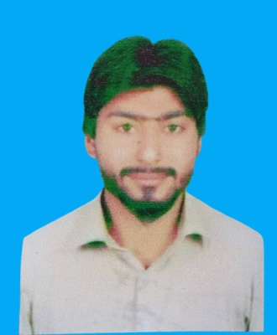

***Urriculum itae***

Atif Hussain Mirjat

**Address** : p/o Village Bhar khan Mirjat

Taluka Jhando Mari District Tando Allahyar

**Cell No: 0301-3247561**

**Email :** atif.hussain913@gmail.com

***OBJECTIVE***

To seek a challenging position in a reputable, progressive and growing organization where, I may be able to utilize my skills and abilities with an opportunity of growth, advancement and enhancement of my knowledge and practical experience.

# QUALIFICATION:

* Matriculation ‘’B’’ Grade
* Intermediated ‘’B’’ Grade
* Bsc ‘’2nd Class’’

# EXPERIENCE:

* 02 Years Work Experience as a Shopkeeper

# PERSONAL DATA:

* Father Name : Ghulam Mustafa
* D.O.B : 10-01-1996
* Marital Status : Single
* CNIC : 41703-0619107-5
* Religion : Muslim
* Nationality : Pakistani
* Language : Urdu, Sindhi

# Reference:

# Will be furnished upon request.