**Dur Muhammad**

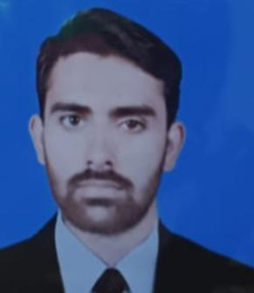

**Chok peer Jahania Post office Misali school,**

**Thsel & District Muzaffar Garh.**

**Cell #: (+92) 0300-0738747**

**E-mail Address:** ji6426294 .

### *Self-defining lines*

*Hard work is my obsession and perfection is a passion I seldom surround. These features demand sincerity, devotion and clarity of mind. Helping and accommodating others and molding to the requirement also add to my salient features*

### *Career Objectives*

Seeking for a position in a professional and challenging environment where I can contribute to the shared vision and growth of the organization, while expanding my knowledge, in the field of Development.

### *personal information*

Fathers Name: Malik Abdul Rasheed

Gender Male

Date of Birth: April 20, 2005

CNIC #: 32304-4702997-3

Marital Status: single

Domicile Muzaffargarh (Punjab-Pakistan)

### *educational & Professional qualification*

|  |  |  |  |
| --- | --- | --- | --- |
| **Degree** | **Board/University** | **Year** | **Percentage** |
|  |  |  |  |
|  |  |  |  |
| **Metric**  **F.SC** | BISE DG Khan  BISE DG Khan | 2019(science  2021(science) | 1053/1100  1020/1100 |

### 

### *computer skills*

I am quite capable of working Computer under Microsoft Windows XP, Window 8 and 10 environments and have good command over Microsoft Office, In-Page Urdu, CorelDraw and Internet

### *personal characteristics*

**Confident:** I have God gifted quality of confident and remain calm even under hardest conditions and do it with sheer confident what I am doing.

**Hard Working:** I have a built in thrust for work. I loved to remain busy and always active that is the reason I care for even the minutes thing in my working.

**Good Analyzer:** My friends always praise my analytical characteristics. They find me a good analyzer of the situations.

**Motivator:** Have a quality to motivate people to achieve the desired results. This quality also helps in teaching, training and customers care activities.

**Linguistics:** Good grip over multiple languages, which make me viable to work under multiple places and environments.

Saraiki (Mother Language)

Punjabi

Urdu

English

### *interests*

Social Work With Group

Strengthening By Computer Skills

Reading And Writing

### *relevant skills*

 Strong management skills  
 Demonstrated ability to research and consolidate information  
 Ability to maintain confidential information  
 Exceptional communication skills  
 Excellent organizational and time management skills  
 Ability to manage complex spreadsheet

### *professional skills*

Organizational Management

Excellent Leadership & Advocacy skills

Project Management & Report writing skills

Communication, Coordination & Counseling skills

Supervision, Monitoring and Evaluation skill

Good Command over mobilization & motivation

### *References*

***Will be furnished upon request***