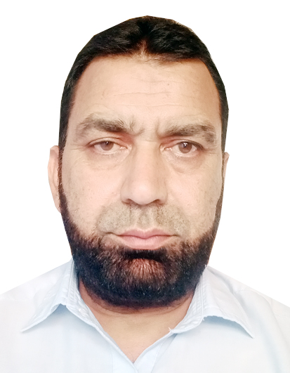
CURRICULAM VITAE

PERSONAL INFORMATION

Name: NIAZ MUHAMMAD.

Father name: SHAMROZ KHAN.

Date of Birth: 12/03/1975

N I C No: 17101-0338115-7

NATIONALITY: PAKISTANI

Address: KPK Distt, CHARSADDA, Teh, & P/O

SHABQADAR. Mohallah, Fatima Khil.

Contact No: 0334-1518920 / 0344-9098638
E-Mail Address mc1shabqadar@gmail.com

ACADEMIC RECORD:
S. No | Title of Degrees | Marks | Obtain Marks | Institutions
1 | Bachelor of Arts | 550 | 397 | U.O. Peshawar
2 | F.A | 1100 | 706 | BISE Peshawar
3 | S.S.C | 850 | 620 | BISE Peshawar
4 | COMPUTER  SKILLS | Certificate 6 month | _ | Spectrum computer college Charsadda

_
►Work & Experience.
Job Title: Social Mobilizer. Jan 2007 to May 2007.
Organization: PVDP & CHIP
Responsibilities:
- Assist and support the Project Manager in implementing the aims and objectives of the program/ organization.
- In a team process, plan, develop and implement strategies for community mobilization and participation under the overall guidance of Project Manager and PVDP head office. This may include:
- Initial data collection, community meetings and team planning exerc Community meetings at the field level;
- Stakeholders’ meetings.
- Community Awareness and Mobilization: Organization of SMC’s and in a team process and with the support of SMC’s mobilize local male and female community members, parents to ensure their regular support for reactivation and strengthening of schools.

- Sensitization/Capacity Building of School Teachers/SMC: Support Education Resource Person (s) in implementing sensitization and capacity building campaign at community level.
- Establish close Liaison with Department of Education and other stakeholders: In a team processes to ensure establishment of teenage school with community participation, ensure enrolment of students and the smooth handing over of the schools to department of education
- In collaboration with the team to prepare event and monthly reports on the progress of the program.

Job Title: Admin & Finance Assistant. June 2007 to September 2008
Organization: PVDP & CRS
Responsibilities:
- Maintain and keep leave record as well as personal file records of the project staff in consultation with Project Manager
- Prepare monthly cost estimate of the project in consultation with Project Manager.
Maintain daily cash statement.
- Check and verify bills, quotations, requisitions for different purchases and other expenses related to the project beside the Project Manager.
- Check, verify and ensure the expenses of vehicle and its proper use.
- Prepare comparative statement and purchase form and accordingly forward it to Project Manager
- Prepare Monthly/quarterly financial reports of the project in consultation with Project Manager and submit it to PVDP main office for necessary action.

Job Title:: M&E Officer. November 2008 to May 2011
Organization: PVDP & World Food Program
"Monitoring & Evolution Officer: Food item distribution in Govt School of Distt Buner Funded by WFP (World Food Program)
Responsibilities:
- Monitoring teams during distribution of cooking oil and wheat in Govt schools for boys and girls in district buner.
- Meeting with concern Education officers according teacher and student absentees.
- Make a complete report of SM and distribution in schools to present project coordinator for further action

Job Title: Team Leader: Emergency Relief for flood affected People in Distt Charsadda
Organization: PVDP & NCA
Responsibilities:
- Door to door visit of the flood affected areas and collect data of the effected people, distribute food and non-food item.
- Make plan to send Doctors for woman and children to provide them health facilities
- Maintain data of food item and medicine (all related logistic food, nonfood item and medicine).

Job Title: UCPO MC1 Shabqadar (Union Council Polio Officer) from 2013 to till date
Organization: WHO “Polio Eradication Initiative “
Responsibilities:
- (1) Pre- campaign:
- Micro-plan:. Assist in preparation and updating SIA micro-plan as well Desk and Field validation of micro-plan in the field .Help in identifying and mapping high-risk area in UC.
- UPEC Meeting: Support and Facilitation UPEC meeting at UC level.
- Teams Training: Monitoring and Supporting Polio teams training for improvement of polio campaign.
- Assist in selection of appropriate vaccinators as per given criteria and in their distribution as per need.
- Assists in monitoring of timely distribution of DDM cards. Ensure that cards are filled properly and upon completion of campaign their submission to the provincial office for further processing.
- Trainings – Assists the PEOs and district trainers in planning, coordinating, and organizing training session for vaccination teams and supervisors.
- Partnership and Coordination: promotion partnership with all influencing factors at UC level support in PEI and EPI.
- (2) Campaign Implementation
- Monitoring: Monitoring the process of implementation of the campaign as per guideline and provide feedback to DPEO
- Data collection: and analysis:- Collect and analysis of tally sheet data from the areas on daily basis.
- Ensure proper implementation of SIAs with special attention on hard-to-reach areas and under- served high risk population.
- Attend the daily evening meeting at UC level for every SIA and record the finding/observations for corrective action on the following day of the campaign.
- Participate in preparation of realistic catch-up plan for missed children and monitor their implementation.
- Participate in organizing the re-do/sweeping activities in the UC as required in the light of PCM/LQASs/market survey result.
- Facilitate the work of independent Monitors.
- (3) Post Campaign:
- PCA : conducting Post campaign Assessment in different UCs of the District
- Out Reach session: Monitoring and Facilitation out Reach Session of Routine Immunization.
- AFP Surveillance: Close contacting with the health care providers in concerned union council to mobilizing them for identifying and reporting acute placed paralysis (AFP) cases.
- Zero Dose: collect data of zero children during and post campaign, and report to EPI technician for further action.
- Communication and Awareness: Support ComNet staff in Awareness regarding PEI, EPI and Covid-19 pandemic.

References
Masood Akhtar Finance Manager PVDP Cell No: 0333-6552777 & 0345-6557777
Dr Javid IO CHD Cell No: 0345-1643544
Dr Waheed Kamran PPEO KPK Cell No: 0323-6940000
Dr Feroz Shah EPI Coordinator DHQ Charsadda Cell No: 0333-9322622

