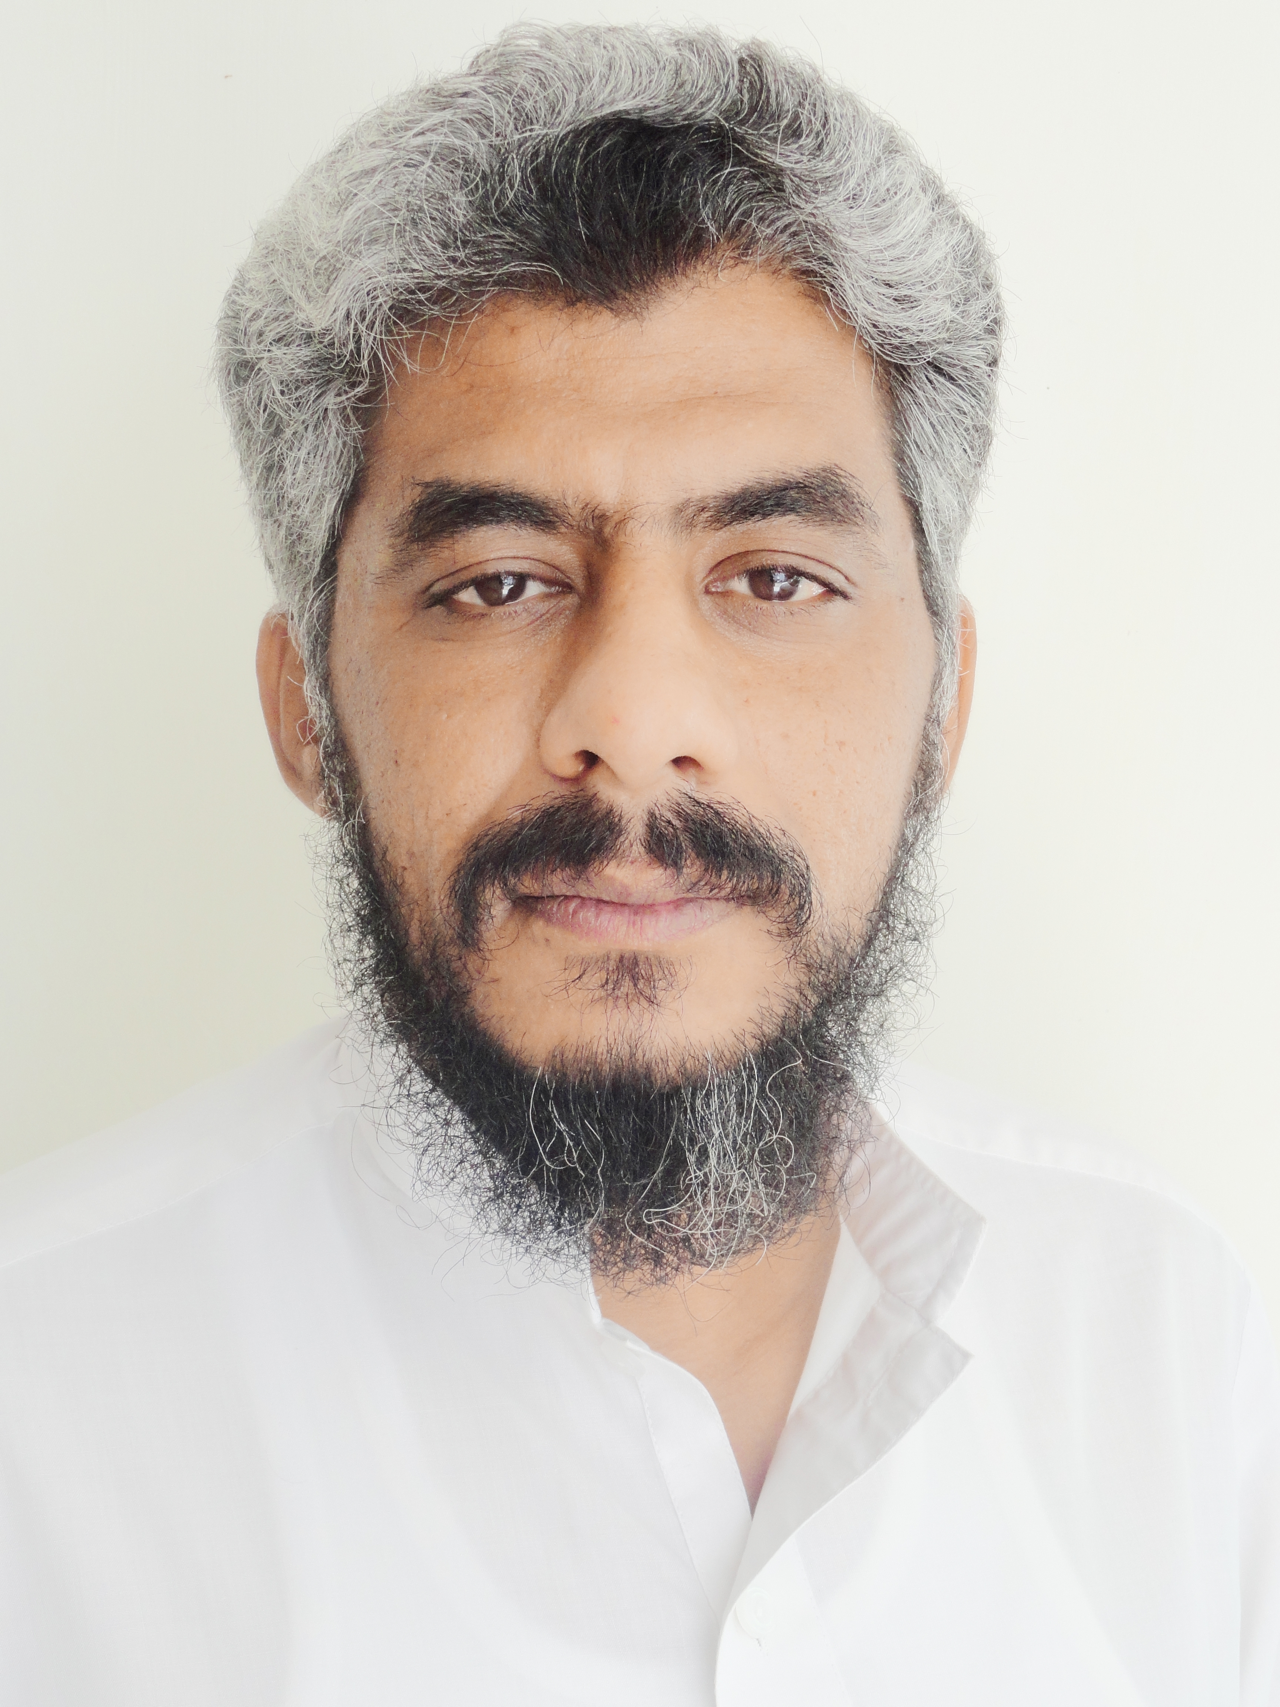 |  | Jawad Durrani  PERSONAL SUMMARY  A well-presented, amiable and efficient individual. A Finance Manager with more than 18 years industry experience, been involved in various aspects of Financial Management and Project Management. Have skills and expertise in latest accounting software. Bear strong interpersonal communication skills with ability to read and interpret intelligently. Also skilled to express ideas clearly and able to react effectively under stress and challenges. An individual who is comfortable working in a fast paced, hands-on, growth orientated work environment.  OBJECTIVE  To acquire a job that can motivate me to demonstrate my administrative and interpersonal skills in an environment beneficial for my personal growth and for the organization.  WORK EXPERIENCE  Finance Manager  Health Berry Pharmaceutical (SMC)  October 2022 till date  - Checking payment vouchers and resolving discrepancies  - Preparing Journal Vouchers related to payments and monitoring the timely disbursement of funds.  - Ledgers reconciliations with Distributors and suppliers  - Settlement of petty cash in a timely manner  - Checking bank and cash receipt vouchers and resolving discrepancies.  - Monitoring timely deposits in bank accounts  - Monitoring and ageing of Receivables  - Preparing bank reconciliations statements.  - To support in Tax related matters, deduction & submission of Tax documents u/s 149, 153(1)(a), (b) & (c)  Finance Manager  Pak Women  December 2019 to March 2020  - Checking payment vouchers and resolving discrepancies  - Preparing Journal Vouchers related to payments and monitoring the timely disbursement of funds.  - Settlement of petty cash in a timely manner  - Checking bank and cash receipt vouchers and resolving discrepancies.  - Monitoring timely deposits in bank accounts  - Monitoring and ageing of Receivables  - Preparing bank reconciliations statements of the project.  - To support in Tax related matters, deduction & submission of Tax documents.  - Payroll checking and preparing reconciliations.  - Reconciliation of Grants of projects  - Coordination for Audit of project  - Preparation of Financial reports for Donor Agencies  - Booking of Project monthly invoices  - Extending support to program staff for preparing budgets and assisting Executive Director with preparation of budget  Senior Finance Officer  Centre of Excellence for Rural Development (CERD)  February 2009 to September 2018  Key responsibilities included:  Worked as Senior Finance Officer at Islamabad head office of Center of Excellence for Rural Development (CERD). The Key responsibilities included:  - To ensure and maintain the Financial System, to meet the statutory compliance/requirements of donor.  - Support financial planning, cash forecast and reporting by entering and maintaining data in the financial reporting system. Liaise with programme sections to source planned and expended budget information and ensure the system reflects data which is correct and up to date.  - Support the office team as well as regional office team in the monitoring & implementation of strategic plans.  - Planned monthly and Quarterly detailed implementation plan against the plan target.  - Planning and assisting the planning team for project monitoring plan both internally and externally.  - Visiting projects site to monitor and evaluate the activities as in the required manners.  - Preparation of Monthly financial reports at Office level.  - Ensure timely disbursement of Funds required by program and to suppliers.  - Preparation and updating of daily bookkeeping in accordance with the guidelines set forth in the financial manual.  - Preparation of monthly Expenditure Reports.  - Tax Working i.e. Salary Tax u/s 149, Rental Tax on Buildings u/s 155, Rental Vehicles/Transport u/s 153(1) (c) and Supplies/Purchases u/s 153 (1) (a).  - Preparation of monthly cash position.  - Liaison with banks, Tax Office, EOBI.  - Reviewing of postings in MIS.  - Preparation of Bank reconciliation statement for the concerned banks in MIS.  - To Administer and work hand in hand with cashier in cash handling and advise him for payments.  - Preparation on monthly basis the reconciliation of expenditure with the petty cash.  - Prepare Budget versus Actual Statement (BVA) for all Donors and these are UNHCR, UNICEF, UNWFP, UNOCHA, GIZ, NCA and UNDP (for Management & Program).  - Preparation of financial proposal and budgeting  - Any other assignment assigned by senior officials  Assistant Manager Accounts  CECOS UNIVERSITY PESHAWAR  September 2005 to October 2008  Key responsibilities included:  - Manual and Computerized Accounts Handling (Daily Voucher, Cash Book, Leger, Bank Book, Income Statement and Balance Sheet).  - Preparation of Administrative budget.  - Verification of Data entry in the accounting software (FICS) as per budget and account Heads.  - Implement/ensure internal controls and internal checks as per SOP.  - Provide support to all programs in preparing program budget.  - Planned monthly and Quarterly detailed implementation plan against the plan target.  - Variance reporting of monthly financial statements to higher authorities.  - Consolidate the Monthly progress reports.  - Responsible for process of salaries, Medical claims, joining reports and all HR related issues of employees of unit.  - Take monthly back up of Financial Data Entering transactions in the Accounting software.  - Participation and organizing meetings and workshops related to related to financial matters.  - Filing of Income Tax Returns.  - Procurement and Data Management.  - Computerized Accounting (Preparation of financial statements using Financial Software of the University).  - Inter-Communication with university departments.  - Recovery Statement and Recovery of dues from students.  - Maintenance of Petty Cash.  - Preparation of Cash forecast for office day to day expenditure.  - Budgeting (based on previous year expenses)  - Auditing.  Senior Accounts Officer  MKB GROUP OF COMPANIES  Nov 2000 – Sep 2005  - Develop financial reports and analysis for management to support decision making and review of programme implementation. Regularly monitor and coordinate with programme sections to ensure efficient utilization of financial resources.  - Develop financial reports and analysis for management to support decision making and review of programme implementation. Regularly monitor and coordinate with programme sections to ensure efficient utilization of financial resources.  - Prepare vouchers i.e payment journal and receipt.  - Collect and examine supporting documents.  - Prepare cheque and ensure that they are properly delivered.  - Record all transactions in relevant ledgers and other books of accounts.  - Ensure that all accounts records are filed in an orderly manner provide the technical assistance to the junior staff.  - Prepare monthly bank reconciliation statement.  - Aging of outstanding advances.  - Data entry in the accounting software Financial Information Control System Accounts Operating bank accounts of the organization.  - Maintaining and recording daily transaction in accounting software handling. (Maintenance of Cash Book, Ledger, Income Statement and Balance Sheet).  - Filing of Income Tax Returns.  - Preparation of Monthly Sales Tax Return.  Finance Officer  LEENA INDUSTRIES (PVT) LTD  Feb 2000 – Oct 2000  - Maintain petty cash record, general ledger and keep track record of Organization assets.  - Prepare cheque and advances to suppliers/service providers, maintain ledger of advances and assist in settlements in accordance with the agreed contract.  - Prepare local purchase orders and ensure quality/quantity of goods before delivery.  - Survey local market and advise the procurement committee/management team.  - Prepare cash /bank payment vouchers with complete supporting documentation in every transaction.  QUALIFICATION  Master of Business Administration, Major in Finance  1999  Division 1st  Al-Khair University  Bachelor of Business Administration  1997  Division 1st  Al-Khair University  Intermediate (Arts)  HSSC  1995  Govt College Peshawar  Matriculation (Arts)  SSC  1992  Muslim Public School, Peshawar Cantt  ACHIEVEMENT & EFFORT  - Approach all work activities with a deliberate focus to ensure that each task is completed correctly, efficiently and effectively.  - Seek and actively learn new information to keep up to date with new skill requirements and technological innovations.  - Perform requested duties beyond the expected requirements and ensure absolute satisfaction with produced work.  TRAININGS ATTENDED  - Two days training on “Finance Capacity Building” by PAIMAN/JSI on 22nd February 2010 to 23rd February 2010 at Islamabad.  - Two days training on “Finance Capacity Building” by Green Acre Associates Ltd on 18th & 19th September 2014 at Islamabad.  INTERNSHIP/FIELDWORK  - Worked as Internee in the Remittance, Advance/ Credit department section at Muslim Commercial Bank Limited.  LANGUAGE PROFICIENCY  - English, Pashto, and Urdu in addition to other local languages.  REFERENCES  - Mr. Jahangir Khan Khattak  Manager Admin & Finance, Water & Sanitation Services Peshawar, WSSP  Cell No: 0333-5200071  - Mr. Sagheer Ahmad Daudzai  Finance & Program Associate, United Nations World Food Program  Cell No: - 0346-8564277
CONTACT

Email: imjawaddurrani@gmail.com
Cell: +92-321-9693301, +92-333-9110090

KEY POINTS
- Keen on traveling
- Extensive event planning & organizing experience
- Hands-on
- Multitasker

SKILLS
- Financial Planning and Decision making
- Critical Thinking

AREA OF EXPERTISE

- Budget Management
- Project Management
- Event Reporting

