:

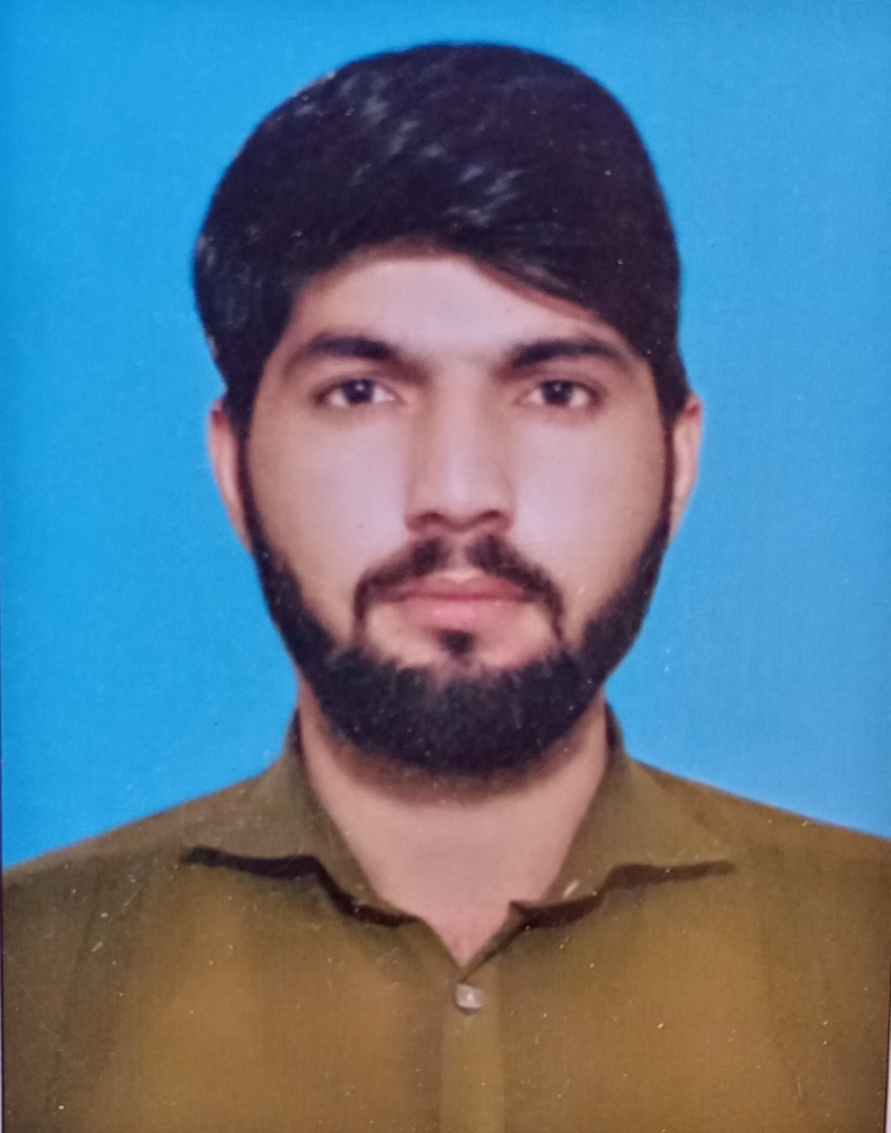

**Shahid Muhammad**



Shahidm1122a@gmail.com

+ 92 (347) 2891092

Feb 04, 1995



**Career Objective:**

Believe in achievements through hard working and determination. Work honestly and sincerely in the interest of my career and as well as equal to the interest of staff and organization I work for, want to prove my ability as a hard working person and set an example of myself and always try to keep my hard working in all sorts of services. My experience has given me the confidence to be a self-starter and be proactive team member, highly motive to set and achieve standard of confidence performance

**Strength**:

A good learner and well-presented personality holder. Having good communication skills and a very good team player as given a chance to work with more than one staff heaving good public communication skills and holding an analytical mind to make decision as per the situation..

**PROFESSIONAL QUALIFICATION:**

* **(BA) Bachelor Of Arts From University of Karachi,**

**Pakistan**

* **Intermediate from Karachi Board**

**( Pre Medical )**

* **Matriculation from Board of Secondary Education Karachi**

**( Science)**

* **Experience**
* **2 Years’ experience in PEI Program**
* **2 Years’ experience in Ttsp**
* **4 Years Area Level Social Mobilizer PEI Program in Orange Town Uc 12 MujahidAbad Now working Area Level Social Mobilizer in Uc 03 Hanifabad**
* **1 Year Experience On Ehsaas Program**
* **1-year experience as school teaching**

**Computer Skills:**

* MS Office.
* Typing.



**Languages:,**

**Urdu , Pashto , English**