JAMIL AHMAD

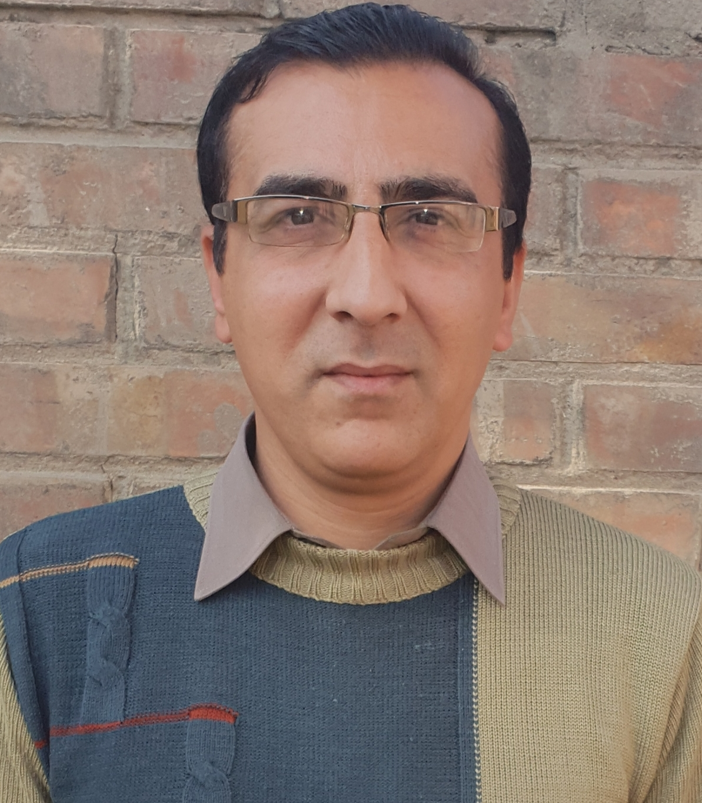 | Email:  1. jamil_aries@yahoo.com 2. Jamilkhan428@gmail.com  Phone:  Cell: 03499128714  Address:  House # 966, Sector # 4, KTS, Haripur.
Personal Profile: | Date of Birth: 11/04/1979  Place of Birth: Haripur, Pakistan  NIC #: 13302-0500302-3  Nationality: Pakistani  Gender: Male
Career Objective: | To be a part of an organization which would give me an in-depth exposure in the day today administration of the firm and also to play an integral role in the growth of the company, to contribute and enhance my creative and intellectual potential for the success of the organization.
Experience:  Polio Project  MicroMerger/NEOC  (June 2021 – Oct, 2022) | National Emergency Operation Center (NEOC) Monitor: Third Party Field Monitoring (TPFM) Project,Haripur.  Third Party Field Monitoring Project, District Haripur.  1. Monitoring Pre-Campaign activities (DPEC Meeting, UPEC Meeting, READINESS MEETING, AICs training, FLWS Trainings, Microplans Desk Review& Field Validation & MPQA-WHO )  2. Monitoring INTRA (Household Clusters, Role of AICs, Team NEAP Status, Vaccine Management, Missed Children Recording, Collection of Operational Information, ULEM, DLEM.  3. Market Survey, Post Campaign Monitoring (PCM).  4. NA and Refusal Verifications.  5. Reporting all data collected to NEOC on daily basis.  5. Coordination and liaison with Deputy Commissioner (DC)/Additional Deputy Commissioner (ADC)/Assistant Commissioners (AC) and District Health Officer (DHO)/DDHO, EPI Coordinator/PEI coordinator & DPCR/DEOC for data collection, monitoring their activities and sharing fields monitoring finding for instant improvements in the activities.  6. Attending Review meeting for Progress Sharing.  7. Any task assign by the PC.
WASH Project  PATs/CLTs Project  (Oct, 2016- May, 2020) | M & E and Reporting Officer/Focal Person  Public Health Engineering Department (PHED) /UNICEF, Peshawar;  Community Led Total Sanitation (CLTs) Project  Location: Public Health Engineering Department, Pakhwal Chowk, Mansehra  Jobs Descriptions (JDs)  - To ensure compliance with the project performance monitoring plan during project implementation.  - Suggesting appropriate monitoring and evaluation tools and system that effectively ensure project deliverables and progress.  - Oversee or coordinate in conducting baseline, midterm, endline project surveys and gathering data in a reportable format.  - Devise quantitative and qualitative indicators that measure the progress of the project.  - Design tools to measure the achievements mentioned in the logical Frame Work.  - To provide timely reports for course correction and for any amendment and modification in moving towards the right direction.  - Assist senior management in preparation of project reports, monitoring and evaluation reports, monitoring surveys reports, baseline and endline survey reports and organization annual reports.  - To work in close Liaison with other responsible entities related to the project including UNICEF and PHED.  - To perform any other duties as assigned by the project management.
Education Project  (Jan, 2013- Sep,2015) | Capacity Development Officer (CDO)  Citizen Engagement for Social Service Delivery(CESSD) Project, Sarhad Rural Support Program(SRSP) Talokar Road, Pandak, Haripur  “Project on Primary Education Improvement Through Citizens Engagement”  Cross Cutting Theme “ Gender & Social Accountability”  Jobs Descriptions (JDs)  - Project orientation to community and all other stakeholders in the district  - Liaison & coordination with Education department  - Data collection and base line survey with collaboration of line departments  - Activation of PTCs through continuous meetings and to ensure the inclusion of women members  - Capacity building of PTCs on their roles and responsibilities, social accountability, and gender mainstreaming.  - Arrangement of PTCs elections with the coordination of Education department  - Preparation and submission of monthly work plans  - Maintenance of file records both at community and office levels  - Timely monitoring of project activities and submission of progress reports  - Collection of case studies  - Submission of Field Trip Report (FTRs) on daily basis  - Identify initiatives for the improvement of education system through PTCs  - Attend training, workshops and the donor sector meetings across the KP
Livelihood Project:  Value Chain Project-Seedling  (Sept, 2011-Oct, 2012) | PRODUCTION & MARKETTING OFFICER (P&MO),  Sarhad Rural Support Program(SRSP) / Mennonite Economic Development Associate (MEDA) Project, Talokar Road ,Pandak, Haripur  Gender Aspect Of  the Project “Women Empowerment Through Economic Development”  Job Summary: (Three Main Components of this Role)  1. Provision of Technical training for raising quality plants & Crops.  2. Providing Technical assistance for disease Identification, prevention and cure in crops (Wheat, Maize) & Plants (Fruit, Forest, Ornamental Plants). Once disease identified then recommendation of available Pesticides (Herbicides, Fungicides & Insecticides) in market for correction of disease in Crops, Vegetables and Fruits in order to ensure both quantity & Quality of Produce.  3. Marketing of ready produce in Local & National Markets like Commercial Nurseries, Agri Department, Forest Department, Farmers,  In Haripur, Abbottabad, Mansehra, Islamabad, Peshawar, Lahore (Patoki).  JOB description (JDs)  - Formulate strategies for improved market opportunities to increase sustainable income for homebound women seedling producers along with marketing coordinator  - Capacity building of field staff about basic seedling production keeping in view the environmental concerns of the project  - Formulate strategies for technical and field related seedling production problems like disease identification, Pesticide recommendation etc  - Along with marketing coordinator and field staff ensure quality and demand driven seedling among women seedlings producers  - Capacity building of lead farmers/sale agents on basics of seedling production keeping in view the environmental concerns of the projects  - Research and catalogue market opportunities for seedlings sub sector  - Work with the project team to build collaborative relationships with key value chain actors and stakeholders (Commercial Nurseries, Agri Department, Farmers, Pesticide Dealers etc)  - Prepare and update a catalogue of different types of seedlings in collaboration with Rural Facilitators  - Document barriers to market growth and development for seedlings and identify competitive requirements;  - Determine production and marketing training requirements to improve management and profits for seedlings producers;  - Plan and deliver trainings as required;  - Carry out market research and undertake field visits as and when required;  - Facilitation in Linkages development of homebound women seedling producers with other value chain actors.  - Any other task assigned by project coordinator
Trainer | Trainer: Participatory Planning  under the Project, ‘Support to KP Government in Effective Implementation of KP Local Government Act 2013’ &  Under the Thematic area of “ Enhancing the Capacity of Elected Representative and Strengthening Citizens Engagement for Transparent, Responsive, Efficient and Accountable Local Government” Center For Governess and Public Accountability /USAID Citizen Voice Project (CGPA/USAID CVP)  Trainer: (CESSD Project , Alif Ailaan Project & MEDA Project)  Training Delivered To PTCs/SMCs member:  1. Two days training on Social Accountability.  2. Two Days Training On Gender In Education.  3. Two Days Training On PTC Roes & Responsibilities revised PTC Guide Book.  4. Three Days Training On Community Score Card.  5. One Day Training On PTC Networking.  Training Delivered To LSO  1. Three Days TOT training for LSO Mater Trainer Regarding Community Resource Person (CRP), Household Data , School level Data & School Enrolment Retention Data.  Training Delivered To Women Seedling Producer &Sale Agent:  1. Three Days Training on Advance Nursery Management, Vegetative & Non Vegetative plant Propagation.  2. One Day training On Health & Safety.  3. One day Training on Marketing Techniques.  4.One Day Training On Financial Management  5. One day training on Community Based Saving Groups (CBSG)
(May, 2003- Aug, 2006) | Monitoring & Evaluation Officer,  Rural Development Project (RDP), Near Hazara University Haripur Campus. Haripur,  JOB description (JDs)  - Review and maintain system and tools and modify the same to effectively monitor results (Output, Outcome and impact)  - Work closely with M&E Manager to ensure efficient and effective monitoring of all interventions.  - Support and contribute in defining and refining indicators to facilitate result base management.  - Identifying training needs and participate in the same as required to ensure quality training for community. (TNA)  - Provide necessary data for planning and implementation purposes.  - Contribute in preparation of annual plans, reports and developing indicators.  - Facilitation of field staff in identifying weak areas and suggest measures for improvement  - Carry out data entry and update of Monthly Progress reports  - Carry out project annual and bi annual surveys  - Develop case studies and success stories  - Any other task assigned by PC
(April, 2002-May, 2003) | SOCIAL ORGANIZER,  Rural Development Project Haripur, KPK, Pakistan  JOB description (JDs)  - Conducting Dialogues and meetings for the formation of new COs/VOs & LSOs.  - Updating the record and Filing of COs/VOs documents.  - Updating the record and filling of community organizations.  - Managing and facilitating of overall social Mobilization process i.e. conducting base line surveys, identification of poor households at village level, formation of community organization, need identification of community through dialogues, implementation of development packages and Networking of the community organizations.  - Preparation of Micro plans and village development plans (VDP)  - Facilitation of the coordination mechanism of different stakeholders at the regional level  - Preparation of Proposals for community organizations and monthly / quarterly reporting  - Presentation of Social Organization Unit (SOU) in the meeting with donors, govt. and NGOs  - Participatory Rural Appraisal (PRA) Tool was learnt and used for need identification, planning and also for prevailing resource identification, Resources need to allocate by donor prevailing problem and their solution were found while using PRA methods and approaches like transect walk, social mapping, Seasonal Calendar, institutional or Venn Diagramming, seasonal calendars, daily time use analysis, linkage diagram, well being grouping or ranking, analysis of differences, matrix scoring and ranking, team contracts and interaction, shared presentation and analysis, participatory planning ,budgeting, implementation and monitoring, drama and participatory video making, handing over the stick etc.
Education:  2008 | Birmingham International College United Kingdom  Post Graduate Diploma (PGD) in Management Studies
2002 | KPK Agricultural University Peshawar, Pakistan  M.Sc. Agriculture  Specilization in Soil & Environmental Sciences  Result CGPA&%age 3.55/4.00 (79%)
1997 | Telecom Boys Public School & College T&T Colony Haripur  Intermediate (Pre-Engineering)  Board Of Intermediate & Secondary Education Abbottabad  Results 724/1100(65.81%)
1995 | Govt. High School, Sector No.4.KTS. Haripur  SSC (Science)  Board Of Intermediate & Secondary Education Abbottabad  Results 556/850(65.41%)
Skills:  - Computer  - Languages | MS-Word, MS-Excel, MS-PowerPoint Internet explorer, MSTAT  English, Urdu, Hindko, Punjabi, Pashto
Key Competencies: | - Self motivation  - Verbal and written communication skills  - Attention to detail  - Problem solving  - Decision making  - Stress tolerance  - Flexibility  - Adaptability  - Headworker  - Team Work  - Punctual
Academic Research: | - A review paper, “soil Boran Extraction by Different Techniques”, Submitted to the Department of Soil and Environmental Sciences, NWFP Agricultural University Peshawar.  - A special problem, “Columns Study on the Accumulation of Chloride at the Different Depths down the Profile from Muriate Of Potash (Mop) Fertilizer”. Submitted to the Department of Soil and Environmental Sciences, NWFP Agricultural University Peshawar.
Trainings: | - Five days training on Pakistan Approach to Total Sanitation (PATS) Plus & School Led Total Sanitation Approach organized by UNICEF Pakistan.  - Three Days Training on Participatory Planning Organized by  - USAID CVP.  - Two days training on Social Accountability organized by CESSD.  - Two days training on Gender in education organized by CESSD.  - Three days training on Community Score Card (CSC) organized by CESSD.  - One day training on glade propagation by SRSP.  - Three days training on advance Nursery management & vegetative and non-vegetative plant propagation conducted by horticulture department university of Haripur.  - One day training on Harassment at workplace organized by SRSP.  - Two days training on Marketing skills for seedling through Entrepreneur and Community Development Institute (ECDI).  - Three days Gender Sensitization Workshop through SRSP.  - Planning with Community through Participatory Rural Appraisal (PRA), Human Resource Development Institute (HRDI) Islamabad.  - Evaluation of Community Programs, Human Resource Development Institute (HRDI) Islamabad.  - Skills for Social Organizations, Human Resource Development Institute (HRDI) Islamabad.
References: | Mr. Shahid Mehmood  Executive Engineer  Public Health Engineering Division, Mansehra,  Ph. 03005627727  Email: smswati@yahoo.com  Miss Samar Jabeen  Provincial Coordinator,  MicroMerger Pvt Ltd.  Ph. 03098883264, 03339255662  Email: samarmalik16@gmail.com  Mr. Mazar Iqbal  Research Officer  Hazara Agricultural Research Station, Abbottabad  Ph. 03339327501  Email:Mazhar.kts@gmail.com  Shakeel Ahmad,  Project Manager,SABAWON,  Peshawar,  Ph. 03459213036  Email: sabawon.shakeelahmad@gmail.com

