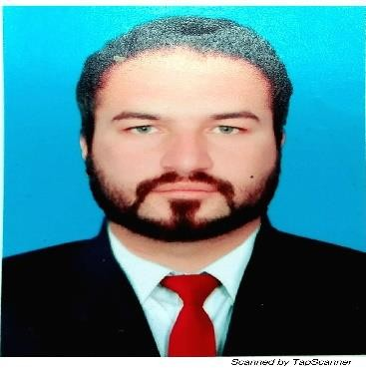 | Muhammad Abbas Khan  Marketing Executive  Riphah International University,  Islamabad.   +92-3330001056   abbaskhan0504@gmail.com

Profile
My experience and education make me confident and capable of self-motivation, Responsible with excellent communication, and interpersonal skills and relating to the members of the team to achieve common goals and objectives of the organization.


Education

Msc (Economic) Graduated: 2018
Department of Economic Academic Field: Micro & Macroeconomic,
University of Peshawar, KPK Research Methodology.
Peshawar, Pakistan Research/Thesis Title: Education status of the house hold and the vulnerability to dengue epidemic.

Bachelors of Arts Graduated: 2013
Department of Arts Academic Field: English, Economic Abdul wali khan University, KPK
Mardan, Pakistan


Career Highlights

Outreach incharge (Nov 2019-Present)
Marketing & Admission Department, Riphah International University, Islamabad Pakistan.

Marketing & Sales Executive (October 2015- Sept 2019)
Gulf alliance builders & developers Islamabad, Pakistan.

Customer relationship officer (Sept 2014- Sept 2015)
Jazz Mobilink Islamabad, Pakistan.

Management trainee officer (Oct 2013 - Dec 2013)
Margalla Hotel Islamabad, Pakistan.



Professional Experience

Riphah International University, Islamabad

Outreach & Marketing Executive
Responsibilities:

- Plan and Develop the Project Idea.
- Monitor Project Progress and Set Deadlines
- Solve Issues That Arise
- Manage the Money
- Evaluate Project Performance
- Overseeing and developing marketing campaign
- Perform qualitative and quantitative research and consultation on relative markets
- Organizing career counselling sessions at colleges and universities for the students
- Organizing events and seminars
- Organizing all the outdoor activates
- Managing all the operational task regarding Marketing department.

Mobil ink Jazz (Islamabad)
Position: Customer Relationship officer
Responsibilities:
A relationship sales officer is a professional whose overall responsibilities include managing customer expectations, identifying new business markets and recording daily customer transactions.
- Excellent written and oral communication abilities
- Strong negotiation skills
- Superior problem-solving skills in healthcare and everyday situations
- Able to apply critical thinking skills to resolve difficult issues
- Able to listen to and comprehend people’s problems with the intent to solve them

- Excellent record-keeping and data entry skills related to healthcare programs

Professional Skills

  - Marketing strategy
  - Data collection and analysis
  - Communication skills & networking ability
  - Good teamwork skills

