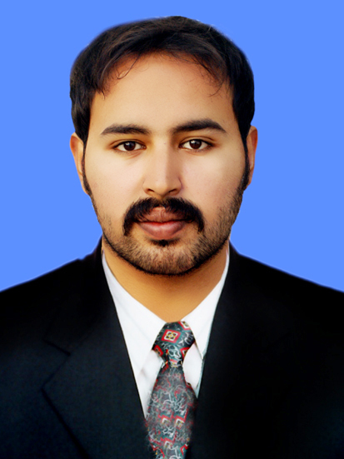

JUNAID ZAMAN AWAN

E-mail: j.zaman22@gmail.com

Mob# 0332-763-1095
0336-211-2223
Objective
To make solid contribution towards the organization I serve by bridging the gap between exciting resources of the organization and its strategic financial objectives by adopting suitable strategies either on my own or as part of a management team with special emphasis on quality of service.

Personal Statement
I am confident person with the ability to learn and adapt quickly to new challenges and to handle difficult situation under pressure. I have good communication skills, which enables me to work effectively either on my own or as a part of the team.

Postal Address

Mohallah Kirri Alizai Near Masjid Zulnorain Dera Ismail Khan K.P.K

Qualification
- 4 Years DHMS
Last year
Sirajia Medical College

- 4 Years BSCS Honor (MCS)
Affiliated from GOMAL UNIVERSITY

- 3 Years Diploma in Associate Engineering
Session 2007 to 2010
University of Peshawar

- S.S.C science
Session 2007
Board of intermediate and secondary education
Dera Ismail Khan

Personal information
- Father’s Name Sher Zaman Awan
- Nationality Pakistani
- Domicile KPK (Dera ismail khan))
- Date of Birth 22 August, 1990
- CNIC # 12101-3942054-9
- Marital Status Married

Fields of Interest

- Office Work
- Volunteer Services
- Community Mobilization
- Organizing districts trainings
- Graphic Designer
- Professional Photography

Languages

- English, Urdu & Saraiki

Previous Job Status

- Provincial Trainer in weapon contamination department (ICRC)
- Federal Mater Trainer at NIBAF ( National Institute of Banking & Finance )
- M & E Officer at Society For empowerment of BINT-E-DAMAAN

Current Job Status

- Working as a COMMUNICATION OFFICER

Responsibilities

- Management, Execution And Monitoring Of All Activities
- To work in close coordination with teams to ensure quality of work.
- Manage relationships with relevant stakeholders, including but not limited to Government departments at the Agency and local levels, community and tribal elders, and local organizations and communities
- Ensure the successful implementation of project activities
- Field visits to program targeted districts, and communities.
- Support partners in developing tools for allowing smooth monitoring of activities.
- Coordinate with finance staff on accounting, budget and financial reporting
Professional Experience

- 1 Year Worked as a INCHARGE OF COMMUNICATION team with Pakistan Red Crescent Society (PRCS) DIKhan Branch,
- 1 Worked as Trainer M.R.E (Mine Risk Education) in ICRC (International Committee Of Red Cross) from Nov 2014 to DEC 2015
- Worked as AFO (Area Field Officer) in Apex Consulting Pakistan from 1st Apri 2016 to August 2016
- 1Year Worked as Trainer of (DDRT) DISTRICT DISASTER RESPONSE TEAM with Pakistan red crescent society DIKhan Branch
- 1 Year Worked as COMMUNICATION OFFICER in THE LIGHT organization
- Worked as an I.T Incharge from September 2009 to December 2011 at Dera Ismail Khan.
- 6 months worked as a Graphics Designer in Local newspaper of DIKhan
- 1 Year Worked as a Trainer in BINT-E-DAMAAN
- Honorary Designated as General Secretary of KPK in SYP (State Youth Parliament)

Experience of
Trainings/ Courses/Workshops/Fields

- Organized lots of trainings “Dissemination Sessions of RCRC movement”
- Attending Three days Workshop of FIRST AID TRAINING by, PRCS KPK Branch Distt: dera Ismail khan (Participated).
- Attended YABC (YOUTH AS AGENTS OF BEHAVIORAL CHANGE) Training, from 16th – 18th April 2013.
- Have Attended Field work in R.F.L ( RESTABLISHMENT OF FAMILY LINKS)
- Attended 3 days training from private organization TIENS
- Experience with AFAQ organization
- Organized DISTRICT YOUTH CONVENTION 2013
- Organized INTERNATIONAL YOUTH DAY 2013
- PRESIDENT of colleges CBS SOCIETY ( CHRACHTER BUILDING SOCIETY )
- 3rd Position holder on district level in YOUTH CARNIVAL 2013 organized in D.C.O office from KPK Government
- Attended Five days training by the foreigner trainees of WEAPON CONTAMINATION
- Attended two days training on MOBILIZING THE CITIZEN FOR GROSS ROOT POWER organized by HDO with support of USAID
- Attended the 5 days Training of DDRT (DISTRICT DISASTER RESPONSE TEAM ) UNDER THE SUPERVISION OF PRCS
- Attended 5days training of Advance TOT ( TRAINING OF TRAINERS ) in Islamabad from ICRC
- Attended 3 days training REPORTING IN EMERGENCY held in Peshawar under the flag of PRCS
- Attended 2 Days training on WRITE TO INFORMATION ACT from HDO (Humdum Organization)
- Attended 3days training of Advance TOT ( TRAINING OF TRAINERS ) at Dikhan from CTC

Computer Skills

- Certificate in I.T Advance Diploma in Testing Board Peshawar
- Certificate in professional M.S office and internet from Micronet college
- Good Command on Internet and E-mail.
- MS Office, Adobe, Web Browsing, Personal Emailing and Other Multimedia.
- I have good skills in Computer Hardware and Software especially in M.S Office
- Good Command on Graphics Designing.

