Muhammad Waqas
MSc International Relations (IR)
Social Sciences
BZU Multan 2009

+92. 3036558284  waqas.ch2020@gmail.com Chak No. 604/TDA Wandher District Muzaffargarh

Summary

Highly energetic, passionate and committed professional with more than 14 years of experience in Monitoring & Evaluation Coordination, Communication intervention, Project implementation, social mobilization, social mapping, trainings, community engagement, supportive supervision activities and dealing emergency program at various levels.

Areas of Experties:

- Monitoring & Evaluation Polio Project and Community Engagement for Polio Eradication at District Level.
- Supportive mechanism for Polio Eradication with District Health Team.
- Communication Intervention.

- Social Mobilization, IPC and Challenge Mapping.

- Risk Communication and Community Engagement (RCCE).

- Coordination for Polio Eradication.
- Supportive Supervision of Polio Campaigns at District Level.
- Monitoring & Evaluation.

- Report Writing and Data Collection.
- Data Analysis.
- Management and Operation.
- Social Mapping & Capacity Building.
- Trainings of Master Trainers.
Provide data analysis reports to PEOC and NEOC
Provide Assistance in LQAS, PCM and Market Survey
Data Analysis of SIAs
Monitoring of PTPs, and Transit Teams.
Process of DDM Cards
Data Quality Assessment of Still Missed children and zero dose Children
Monitoring of Polio Teams
AFP Surveillance
Skills
Training Methodology | Microsoft Office | Public relations

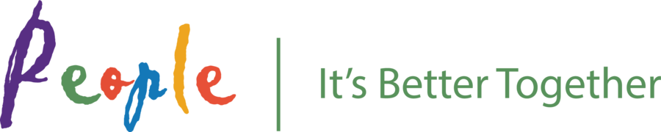

Currently Working with PEOPLE as a DHCSO (COMNet Project) based at District Multan (Division Multan) (July 2021-Present)
- Serving as a District Focal person for Planning and implementation of evidence based communication plans, missed children log book data and Supportive Supervision of Polio Campaign (Pre, intra and post Campaign)under supervision of Divisional Communication Officer(DCO) Multan.
- One Year Work as DHCSO District Hafizabad (Division Gujranwala)

Experience.

Nov 2017 - Jan 2018 Acting DHCSO (OIC) District Muzaffargarh Division DG Khan
COMNet, District Muzaffargarh, Pakistan 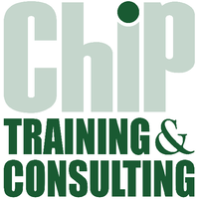
- Highlight issues and challenges regarding communications during the daily evening meetings at district level.
- Support and Facilitate the External Missions/Delegations in field.
- DEOC Support and Follow up of UPEC/ DPEC.
- HR Management and Staff Meetings.
- Ensure social profile data of high risk groups missed during campaigns is incorporated into UC level micro plans in all COMNet supported UCs.
- Community Engagement and Liaison with Stakeholders
- Ensure the social profile data of HR groups is incorporated into the UC level micro plans in all COMNet supported UCs.
- Gather data on reasons from missed children and develop data driven communications for chronic missed children.
- Support in covering maximum number of missed children post campaign.
- Report on the verified missed children data (refusal, NA and inaccessible) to the district polio control room & provincial level Government focal person and provincial COMNet coordinator.
- Report on the missed children covered to district polio control room & provincial level Government focal person and provincial COMNet coordinator.
- Monitor and facilitate vaccination team trainings with special focus on IPC component.
- Develop plan for interpersonal communication (IPC) and counseling sessions with chronic refusal households and community influencers and implement it with the COMNet team in the district as pre campaign activity.
- Supervise and monitor polio campaigns.
- Accompany vaccination teams and facilitate entry into households within the district.
- Complete monitoring checklists.
Jul 2013 – June2021 | U c c s o

COMNet, Muzaffargarh, Division DG Khan Pakistan

- In coordination with the Chip Training & Consulting supported Union Council Communication Support Officer (UCCSO), ensure communication and social mobilization planning is included in UC micro plans of the highest quality.
- Conduct Orientation Sessions, FGDs, market and other surveys.
- Community Engagement and Coordination with NGOs ,CBOs.
- Identify UC-level activities for inclusion in District level communication plan and communicate to District Health Communication Support Officer (DHCSO)
- Ensure effective communication on movement of high risk groups to UCOs/DHCSO/DMO in other districts where underserved groups are moving.
- Collaborative Meetings and Interactive Sessions to achieve the assigned task.
- Conduct Community Medical Camps (CMC).
- Support in micro planning, including determining best timings (flexible) for vaccination activities
- Create and manage a network of reliable ‘informers’ with contact details of incoming migrants/labourers, nomads, temporary slum dwellers, etc.in all revenue villages of the UC
- Hold community events, meetings, rallies, etc. to mobilize underserved groups for polio vaccination and RI
- Support Government Partners during Polio rounds to cover missed households.
- During house to house campaigns, ensure that the SMs accompany vaccinator teams and help the teams in vaccinating all children in the community Leading and Supervising for Social Mobilization and Community Engagements.
- Support Social Moblizers (SMs) in creating awareness and educating the community about on-going activities for polio eradication and routine immunization
- Facilitate SM Induction Trainings as well as all Refresher Trainings with the help of Line managers
- Provide exhaustive field orientation and on-the-job training to SM’s. Relating and Networking (Community engagement)
- Identify non-government organizations (NGOs) and civil society organizations (CSOs) who can conduct social mobilization activities at the community level and conduct resource mapping
- AFP Surveillance support.
- Interpret SM data for planning specific interventions and assist SM in the implementation
- Collect, interpret and analyses data on polio and routine immunization
- Using data, participate in block level coordination meetings to ensure high vaccination coverage and appropriate social mobilization activities for the above mentioned underserved and high risk groups
- Identify influencer(s) to support team during vaccination
- Motivate and mobilize religious leaders, schools, Lady Health Workers (LHWs) and other local influencers at the block level and in resistant pockets
- Maintain regular contact with occupational leaders/contractors of labours and brick kilns for IPC (interpersonal communication) and utilizing them as influencers to mobilize migrants and nomads for vaccination during Routine Immunization & Supplementary Immunizations Reporting / Output.
- Weekly feedback to DHSCO on progress, constraints and performance.
- Reporting forms and formats monthly.
- Detailed micro-plan of SM activities including Polio round as well as routine immunization sessions and survey of migratory movements, nomads, slums & their coverage through immunization activities.

Sep 2010 – Mar 2013 Community Moblizer(CM) 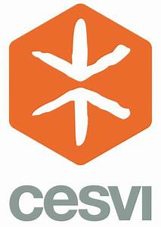
Cesvi International, District Muzaffargarh, Rajanpur Division DG Khan Pakistan
- Conduct appropriate and regular field visits to assigned sites (beneficiary locations) and directly involve in implementation of project activities efficiently, effectively and with flexibility.
- Be responsible for doing regular assessments and designing assessment tools in coordination with the Project Assistant if necessary
- Interact and work in project operations with flood affected populations respecting their opinions, experience and participation.
- Conduct and develop communication channel with the relevant focal point within beneficiaries in the operation area.
- Encourage community engagement in the activities carried out by CESVI in the operation area.
- Under coordination of the Project Assistant and in-coordination with Field Assistant, conduct the identification of the vulnerable groups, individuals in the target community.
- Under coordination of the Project Assistant and in-coordination with Field Assistant and Technical Team, arrange, organize and mobilize community for the meetings and/or training.
- Management of human and other resources efficiently in the site assigned.
- Under coordination of the Project Assistant, liaison with field Resource Management Unit to ensure the required facilities are provided for timely and correct implementation of the activities.

Lodhran Pilot Project (LPP) Facilitator Child Protection (CP) Project District Rajanpur,
(DG Khan Division)
FGDs Session to engage Parents
• Non-discrimination
• Child participation
• Best interests of the child
• Do No Harm
• Counseling Sessions
• Advocacy Meetings
• Meeting with Stakeholders
EFU Life Assurance Ltd. District Manager District Multan (Multan Division).
One year Field Experience With EFU Life Assurance Ltd offers financial planning for
Saving, child education, marriage, protection, investment and retirement .

Crispo M.Suliman & G. Area Sales Manager (KPK) D I Khan Division

One Year Experience as a Area Sales Manager at Crispo foods M Suliman & G Company
Trainings.

- 02 days training Session on Google Mapping and Social Mapping arranged by CTC in Multan dated on 23-05-17 to 24-05-17
- 01 day training Session on Training Methodology arranged by CTC in Lahore dated on 07-11-16
- 02 day training Session on Leadership and Management and Anti Harassment arranged by CTC in Multan dated on 19-5-16 to 20-5-16
- 02 days training Session on Communication, Micro Plan, Tele sheets and EPI arranged by CTC in Multan dated on 22-1-16 to 23-1-16
- 02 days training Session on Communication and EPI arranged by CTC in Multan dated on 28-12-15 to 29-12-15
- 01 day training Session on Communication and IPV arranged by CTC in Multan dated on 26-10-15
- 02 days training Session on Master Trainer arranged by UNICEF in Multan dated on 14-10-14 to 15-10-14
- 01 day training Session on EPI in program of Polio Eradication arranged by UNICEF in Multan dated on 24-7-14
- 01 day training Session on Online Data updating and Reporting in program of Polio Eradication arranged by UNICEF in Multan dated on 22-3-14
- 02 days training Session on EPI arranged by WHO (World Health Organization) in Muzzaffar Garh dated on 03-3-14 to 04-3-14
- 01 day training Session on NA and Missed Children Regarding Polio Eradication arranged by UNICEF in Multan dated on 18-2-14
- Social Maping (Cesvi Italian)
- Social Moblization Skills (Cesvi Italian)
- Health and Hygine (Conducted by Cesvi Italian)
Certificates | 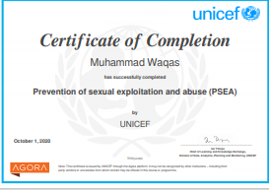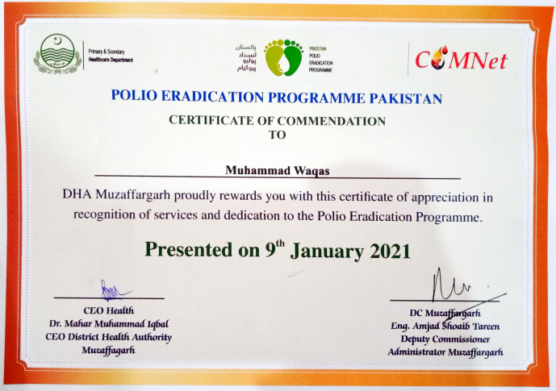  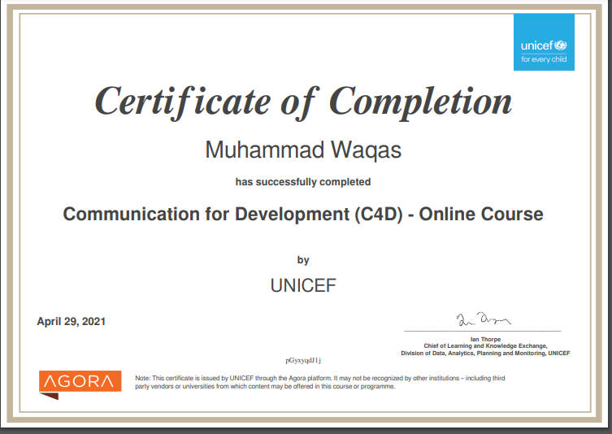
Personal Information | - Date of Birth 08-11-1986  - Marital Status: Married  - CNIC: 32303-1047287-5  - Domicile # Muzaffargarh  - Permanent Address: Chak No. 604/TDA ,UC Wandhar Dist.Muzaffargarh
Languages

English | Punjabi | Urdu | Saraiki
Expert | Expert | Expert | Expert

(Understanding of Pashtu, Related to Polio programs).

References;-

Naveed Iqbal
Coordinator PDMA
0331-4368582
naveediqbals@hotmail.com

