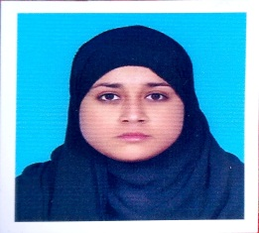
CV

Name : Salbia Fatima
Father’s Name : Akhtar Ali Raza Jaffari
Date of Birth : 11-08-1998
Religion : Islam
CNIC No : 38402-4114999-4
Contact Number : 0301-1457900
Permanent Address : Mohallah Hussainia Jaffaria Sahiwal Dist Sargodha

Mailing Address : C/O Akhtar Ali Raza Jaffari
Senior Computer Operator Air Base Inter College
Mushaf Sargodha
Academic Qualifications:
Class | Year | Marks | Grade/Division | School/College/University
SSC | 2014 | 617/1100 | C | Govt. Comprehensive Girls High School Sargodha
HSSC | 2016 | 751/1100 | B | Govt. College For Women Farooq Colony Sargodha
BA | 2018 | 565/800 | 1st | Govt. College For Women Farooq Colony Sargodha
MSC  (Sociology) | 2022 | CGPA  3.27 | 75.34% Marks | University Of Sargodha

Professional Qualification
B.Ed. | 2022-Present | AIOU 2nd Semester (Continuous)

Experience:
Working as a teacher at Air Base Inter College Mushaf Sargodha wef 01 September 2021 to till date
Skills:
- First Aid: Health and Physical Education
- Language: English ( Listener + Communicator), Urdu, Punjabi
- Internship: Completed in Benazir Income Support Program (BISP)
Leisure:
- Reading Books
- Watching Informative TV Channels
(SALBIAFATIMA)
D/O Akhtar Ali Raza Jaffari
Air Base Inter College
Mushaf Sargodha Cell No: 03011457900

