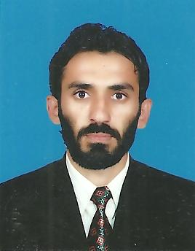
Imran ullah Khan
Resume
Mailing Address:
Noor Abad Colony Sheikh Yousaf Adda District
Dera Ismail Khan
Mob: 0346-9171968
Ph# 0966-741228
E-mail imranmarwat2010@gmail.com

OBJECTIVE
To seek a career position in a progressive organization which should be challenging and demanding where I can practice my repertoire and learnt new skills.

PERSONAL INFORMATION

- Father’s Name : Muhammad Aslam Khan
- Date of Birth : 01-04-1987
- C.N.I.C # : 12101-4206013-3
- Domicile : LakkiMarwat (Khyber Pakhtunkhwa)
- Nationality : Pakistani
- Religion : Islam
- Marital Status : Married
ACADEMIC QUALIFICATION

EXAM | YEAR | MARKS | % Age | BOARD / UNIVERSITY
MBA (Finance) | 2009 | 1748/2200 | 79.4% | Gomal University D.I.Khan
B.Sc | 2007 | 309/550 | 56.1% | Gomal University D.I.Khan
F.Sc | 2005 | 725/1100 | 65.9% | B.I.S.E Bannu
S.S.C | 2003 | 543/850 | 63.88% | B.I.S.E Bannu

MAIN SUBJECTS:

- Management,economics,accounts,finance etc
EXPERIENCE:
- Working as UNION COUNCIL COMMUNICATION & SUPPORT OFFICER with PEOPLE in Polio eradication programme in District DI KHAN since April 01,2021.
- Working experience as UNION COUNCIL COMMUNICATION & SUPPORT OFFICER with Chip training and consulting PVT LTD in Polio eradication programme in District DI KHAN from March 31,2015 to March 31,2021.
- 13 months experience as Social mobilizer with Chip Training and consulting PVT LTD in POLIO ERADICATION INITIATIVE District D I KHAN.
- Experience of Survey regarding Nutrition and Food security By sustainable development foundation( UN_WFP )in District TANK & D I KHAN (K P K)
- 06 months experience as a Hygiene Promoter in flood emergency WASH project with HANDICAP INTERNATIONAL in TANK (KPK) 2010-2011.
- 06 months experience as an Internee(Admin) in EDO Health Office under National internship Programme D.I.Khan.
- 08 weeks experience as an Internee Financial statement analyst in United Bank Limited D.I.Khan.

COMPUTER COURSE:

- 03-months computer course Office Automation from Commerce D.I.Khan.
- Diploma of PEECH TREE the complete accounting software.
LANGUAGE SKILLS

- English, Urdu Pashto & Saraiki

