Muhammad Haroon
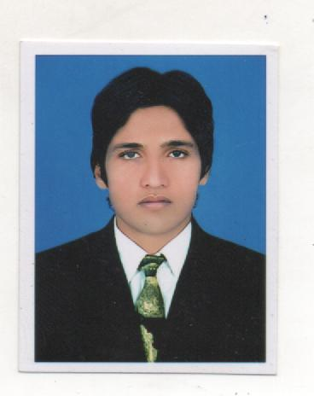  Date of Birth  20 March, 1993  Father’s Name  Muhammad Mushtaq  CNIC #  34101-1388604-5  Present Address  New Kashmir Colony, Chanda Qila, Near Haji Murad Eye Trust Hospital, Gujranwala  E-mail  Honeyharoon786@Gmail.com  Mobile #  0301-6301992 | Objective:  To work in a progressive organization that incorporates varied spectrums of work & diversity, this endows consistency, competency & expertise in professional as well as social spheres, enabling collective excellence and technical growth, personal fulfillment with welcome attitude for new ideas and concepts to enhance the overall growth of the organization.  Qualification:  - L.L.B 2019  Punjab UNIVERSITY, GUJRANWALA  - M.A Social Work 2016  UNIVERSITY OF SARGODHA GUJRANWALA  - Graduation 2013  GOVERNMENT COLLEGE GUJRANWALA  - Intermediate 2010  B.I.S.E GUJRANWALA  - Matric 2008  B.I.S.E GUJRANWALA  Professional Skills:  - Advocate Peace Internship  - Advocate at DBA-GRW  - Advocate at TAX BAR-GRW  - Short Hand  - Computer Literacy  - MS Office, Excel, PowerPoint, MS Word  - Excellent Typing Skills  - Effective Communication Skills  Work Experience: t  - Bargad volunteerism(2years)  - Monitoring and evolution Officer APEX Till PCM 10  2 year.  Apex district supervisor 5 round PCM  Women Soco-Economic Empowerment project  - District Supervisor 2 Month’s Project in SOSEC Islamabad(BOS Survey)  - MICS SURVEY 2017-18  - District coordinator Alrehmat Welfare Society 6 Month’s  - NSER Project Soco-Economic  Registry(Area Coordinator)  - Opm (Bisp baseline survey) 6 month  - Lahore school of Economics(Gujranwala team coordinator) 1.5 years  - Bureau of statistic listing(women economic empowerment)  - IDEAS Revenue department Comparative monitoring  - Social mobilization with Sanjh-preet  - CTC-WHO ICM(Independent District Monitor) -2020-21 Phase1st & 2nd  - CTC-WHO District Monitor Measles Rubella Campaign  - ITSP app survey of PMIU  Strengths:  - Hardworking and enthusiastic with high level of tolerance for ambiguity  - Professionally committed  - Ability to take Initiative  - Adaptable to hectic working conditions  - Willing to Re-locate  - Team performer with strong interpersonal and communication skill  - Responsible and Target Oriented  Extra Curricular Activities:  - Reading Books  - Watching T.V.  - Internet Surfing  References:  To be furnished on demand.

