Curriculum vitae
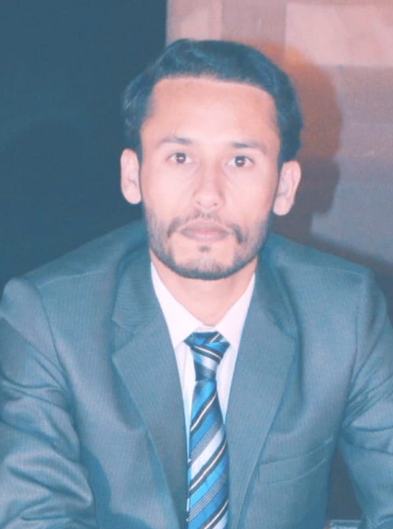
Muhammad Arslan
Cell No: +923030792073 E-mail: arslan02uos@gmail.com

CAREER OBJECTIVE
A highly motivated and enthusiastic Sociology graduate seeking to apply my knowledge and skills in a professional setting, while also continuing to develop and learn new skills.
PERSONAL DETAILS
Father Name: Asghar Ali
Date of Birth: 08 August 1995
CNIC NO: 38103-1703450-7
Passport NO: F7413213
Marital Status: Single
Nationality: Pakistani
Domicile: Bhakkar
Religion: Islam
Current Address: Quide-Azam colony kallurkot district Bhakkar.
Permanent Address: Chak No 58 M/L Tehsil & Bhakkar, Pakistan.
ACADEMIC RECORD
Examination | Year of Passing | Board/University | Marks %age/GPA
BS Sociology | 2021 | University of Sargodha Sub-campus Bhakkar | 3.52/4.00
Intermediate | 2016 | BISE Sargodha | 856/1100
Matriculation | 2013 | BISE Sargodha | 679/1050

EXPERIENCE
- Conducted literature reviews and assisted in data collection and analysis for various research projects
- Managed and organized data using statistical software (SPSS)
- Contributed to the preparation of research reports and presentations
- Assisted in recruiting participants and scheduling interviews
- Participated in community outreach programs aimed at addressing social issues such as homelessness, poverty, and education
- Assisted in organizing and promoting events and fundraisers
- Worked collaboratively with team members to plan and execute projects
Maintained records of volunteer hours and activities
- Six Week internship in Social Welfare Complex Town-ship Lahore from July 01, 2019 to August 10, 2019
- Composed a Thesis Research on Assessment of Socio-Cultural Barriers Regarding Female Participation In Sports Activities at Higher Education Level.
- 1 Year of experience with WHO in Quality assessment of Immunization Campaign through LQAS.

SKILLS
- 1 year Diploma of DIT ( Diploma in Information Technology) from Degree College Kallurkot Bhakkar (77% Marks obtained)
- Skilled in data analysis and interpretation using statistical software SPSS.
- Proficient in Microsoft Office Suite (Word, Excel, PowerPoint, Inpage)
- Excellent communication, leadership, and team-working skills
- Strong analytical, problem-solving, and decision-making abilities

DISTINCTIONS
- Event Management
- Punjabi speech
- Rock Climbing
EXTRA CURRICULAR ACTIVITIES
- Reading Books and Domestication of Goats
- Playing Outdoor & Indoor games,
- Making good relations and friends
LANGUAGES
- Good Communication in English (Written & Oral)
- Urdu (Native Language)
- Punjabi (Mother Language)
- Saraiki
- Rangri

REFERENCES

Department of Rural Sociology University of Agriculture Faisalabad
Dr. Naveed Farah
+923217607529
Department of Rural Sociology University Agriculture Faisalabad

