s

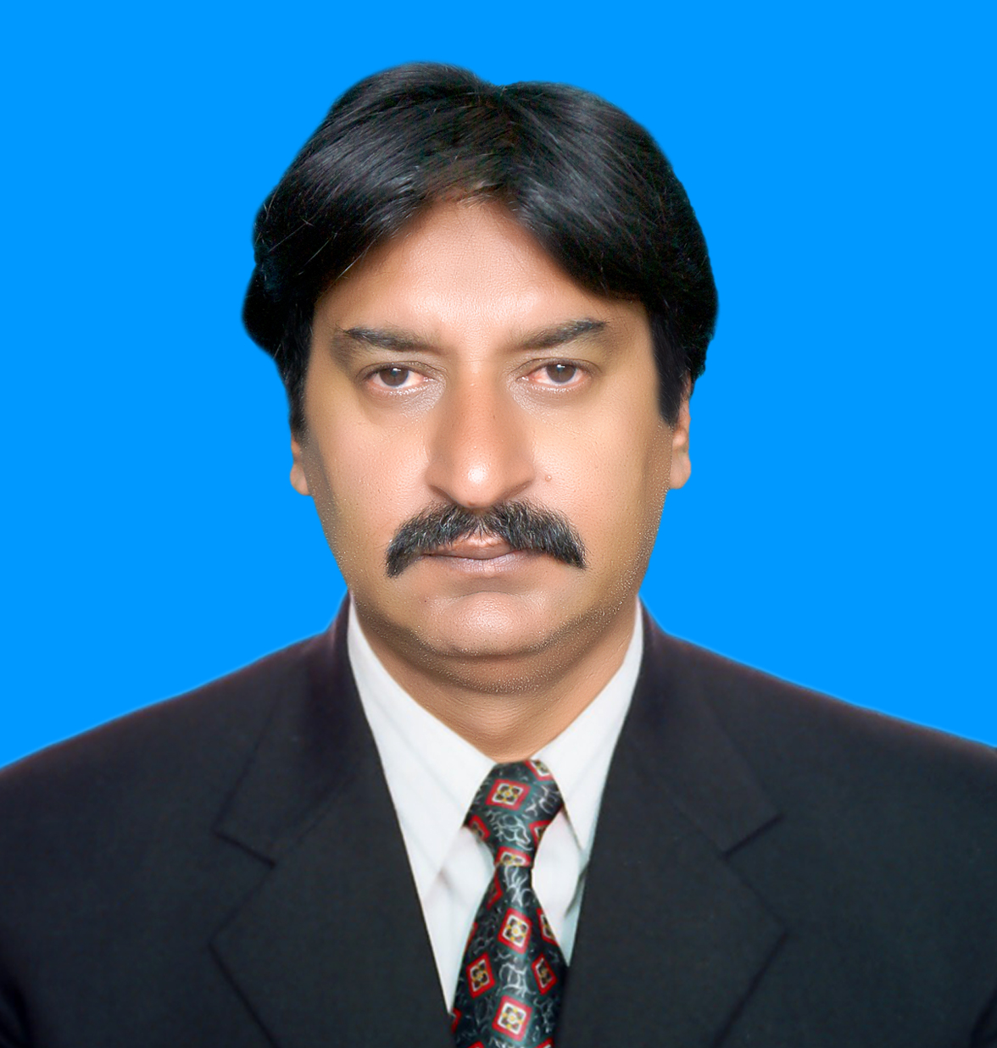
URRICULUM
ITAE

Muhammad Farooq Khan

OBJECTIVE

To seek satisfaction while serving in an organization where I can apply my knowledge and experience gained so far and groom my technical and managerial skills and work for the organization as valuable asset to the organization.

PROFILE:

Master's in Mass Communication with Public Relation, Social Psychology, Research Methods, Development Support Communication, National & International Current Affairs and Electronic & Print Media.

s
QUALIFICATIONS

ADDRESS
Mahalla
islam pura
H # 17 ,$ # 2
mumtazabad
Multan

sE-Mail
farooqrohi@gmail. com
Contact NO

+92-302-5792699 +92-342 5782699

EXAM |  | YEAR | BOARD/UNIVERSITY
M.SC |  | 2013 | A.I.O.U(Mass Communication)
B.A |  | 1997 | Punjab University Lahore
F.A |  | 1990 | B.I.S.E Multan
S.S.C |  | 1986 | B.I.S.E Multan

PERSONAL DATA

Father Name : Sahib Dad Khan
Date of Birth : 1969
Nationality : Pakistani
CNIC# : 12101-2249339-3
Domicile : Multan
Religion : Islam
Marital Status : Married
Gender : Male

PROFESSIONAL EXPERIENCE

:

Designation : Union Council Polio Officer
Duration : 3 years
Company : World Health Organization
(Punjab Health Department, Multan)

Designation : Polio Monitoring Officer
Duration : 3 years
Company : Chip Training Consulted (CTC)
(Punjab Health Department, Multan)

Designation : Polio Trainer
Duration : 2 years
Company : Ucmo.s Aic.s Polio Woekers
(Punjab Health Department, Multan)

Designation : Net Work Coordinator
Duration : 6 Months
Company : Lead Pakistan (ISD)
( Alif Ailaan project )

Designation : Trainer & Facilitator
Duration : 3 Months
Company : Inter News
(Media & Good governess)
(Advocacy Election 2013).

Designation : Team Leader & Distribution Officer
Duration : 3 Months
Company : Red Crescent Dikhan
(Flood 2010 Dikhan)

Designation : Program Officer
Duration : 1 years
Company : Sahel Development Org (SDO)
( Health Project Dikhan )

- TRAININGS

- 21 to 23 Augt 2013: Democracy & Good Governance at Lahore
- 14 to 16 sep 2013 Proposal writing at Multan
- 29 to 31 Oct 2013 Organization Management at Islamabad
- 05 to 07 Jul 2013 Human Rights at Dikhan
- 07 to 11 May 2012 Flood Recovery at Islamabad by INTERNEWS
- 12 February 2011 Democracy Reporting international at Dikhan by INTERNEWS
- 27 to 30 Nov 2010. Basic Computer training at Dikhan by INTERNEWS
- 26 to 28 April 2010 Organization Management at Multan
- 01 Oct 2008 integrated soil and water resource management at Dikhan by Facult of Agriculture Gomel University

EXTRA-CURRICULAR ACTIVITIES:

- Network coordinator Alif Ailaan in Dikhan
- Project coordinator SAHEL Organization D. I. Khan.
- As trainer polio training ucmo,s & Aic,s
- EPI monitoring .Market survey ,AFP surveillance & etc

Computer Course

Diploma of Computer Application Software, Operating system windows 2000, Xp,
vista, HTML

Language

- English, Urdu, Saraiki & Punjabi.

REFRENCES:

- References will be furnished on request

s

