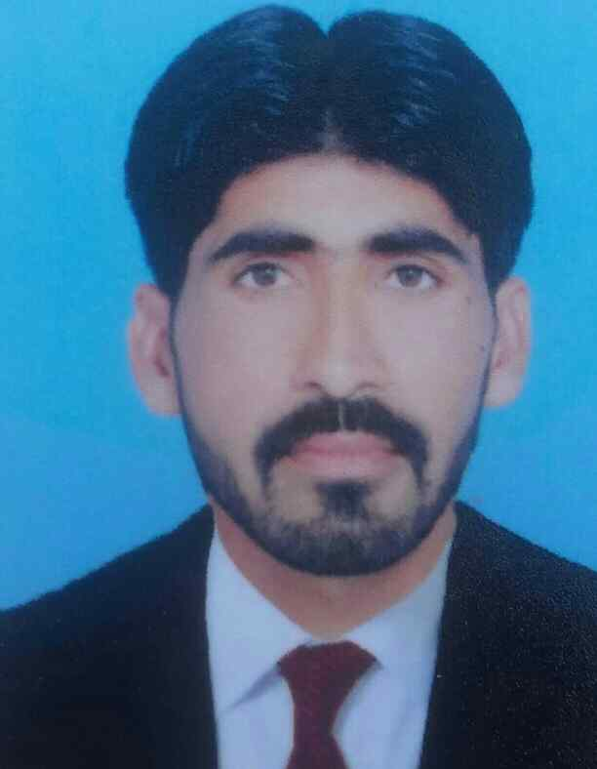 **CURRICULUM VITAE**

## ASGHER ALI

ADDRESS MOZA MUNDRANA P/O KANDIWAL TEHSIL

LALIAN DISTRICT CHINIOT

Cell No.0348-7365793

Email# asgharali65793@gmail.com

Objective:

I intend to pursue a professional career willing to commence exigent task finding valuable solution complex as well as core issue and utilize skills in developing re-engineering process and controls using cutting –edge information technology . Personal Data:

* Father’s Name INAYT
* Date of Birth 19-01-1997
* Religion Islam
* N.I.C# 33402-0381337-3
* Domicile CHINIOT
* Nationality Pakistani
* Marital Status SINGLE
* Gender MALE

Qualification:

|  |  |  |  |  |  |  |
| --- | --- | --- | --- | --- | --- | --- |
| Degree | Subjects | Passing Year | Total Marks | Obtained Marks | Percentage | Board/University |
| Master | Social work | 2020 | 2200 | 1510 | 68.24% | University Of Sargodha |
| Bachelor | Arts | 2017 | 431 | 800 | 53% | University Of Sargodha |
| Intermediate | Arts | 2015 | 805 | 1100 | 73% | B.I.S.E Faisalabad |
| Matriculation | Science | 2013 | 726 | 1050 | 69% | B.I.S.E Faisalabad |

Other Qualification:

* 3 Month Computer Cource in MS-Office at Government Degree College Bhagtanwala Sargodha.

Experience:

* One year experience in an organization (NCHD) National Commission for Human Development from (Feb-2019 to Dec-2019) in Social Mobilization process, and communication field and having good moral character.

Professional Skills:

Initiative, Hardworking Self-Motivated Goal and Task Oriented, Willing to Accept Challenging, and Capable of working under pressure., And Curriculum planning.

Language:

* Urdu
* Punjabi
* English
* Hobbies:
* Daily Jung News paper reading
* Books Reading
* Gardening
* References:

|  |
| --- |
| And will be provide on your demand |