***CAREER Objective:***

Positioning in a leading organization with major responsibilities that may utilize my

Interpersonal, communication, leadership and organizational skills effectively and

Efficiently.

***ACADEMIC QUALIFICATION:***

**BBA (H)**

### Government College University, Faisalabad. ( 3.56 / 4) (2016)

**I.COM**

B. I. S. E Faisalabad. **( 900 / 1100)**  **(2012)**

**SSC**

B. I. S. E Faisalabad. **( 833 / 1050 )** **(2010)**

***AREAS OF EXPERIENCE:***

1. **3 Years’ experience of Community Health Officer from Nov,2019 at Green star Social Marketing**

**Responsibilities**

* Visit and map private providers / private labs for inclusion in network. Full interview questionnaires and assist RC and DFS for final selection of potential private providers and labs.
* Assist RC and DFS for mapping and selection of informal providers / GP as part of universal TB care strategy.
* Keep engage and active all the network providers for case registration.
* Maintain good working relationship and liaison with district health authorities and other stakeholders.
* Responsible to conduct project activities including chest camps, community gathering and area notable meetings and ensure output as per SOPs.
* Organize and conduct all types of monthly and quarterly review meeting including data validation as per assigned targets
* Ensure the implementation of nation guidelines for TB treatment and project operational guidelines.
* Verification of all registered patients, labs and doctors for an effective implementation of the program.
* Counsel and motivate patient and family regarding the treatment and disease prevention through contact screening.
* Maintain the updated records at all level.
* Responsible for contact screening of the registered patients and follow up of the lost to follow up patients.
* Any other task assigned by the supervisor.

1. **1 year experience of Sale Representative from Oct 2018 to Oct 2019 at Lotte Kolosn Pvt Ltd,**

**Responsibilities**

* Design and develop marketing materials
* Monitor production of marketing materials
* Help prepare and conduct product presentations
* Help plan, coordinate and participate in marketing events
* Monitor and assess customer feedback.
* Communicate with sales regarding product and pricing changes
* Maintain promotional materials inventory
* Maintain archive of marketing material.

## 

## Muhammad Ali

S/o

## Mukhtar Ahmad

## D.O.B

## 18-02-1995

CNIC Number

33100-4338826-7

Address

P-134, St-4, Mehmoodabad FAISALABAD.

**Cell**: 0302-9311366

**E-Mail**

**M.Ali7646@gmail.com**

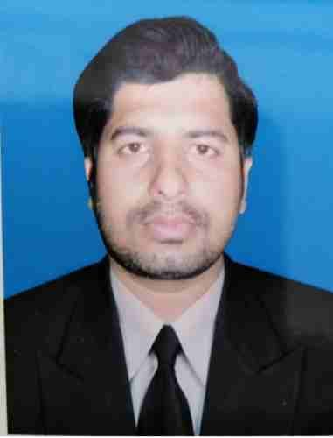

1. **2 years’ experience in the KPO (Data Entry Operator, Accountant) from Sept 2016 to Sept 2018, at the Lotte Kolson Pvt Ltd,**

**Responsibilities**

* Enter and updates data daily
* Use various databases to store and manage data
* Generate bi-weekly reports
* Cash Recovery, Cash Handling
* Maintain confidentiality of sensitive information
* Documents financial transactions by entering account information

***Computer skills:***

* MS Office
* Internet application
* Computer troubleshooting and assembling

***Interpersonal skills:***

Good interpersonal skills

* Adaptability
* Flexibility
* Integrity and initiative

***REFRENCES:***

* ***Will be available on demand.***