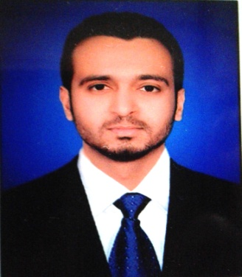**CURRICULUM VITAE**

***Asad Ali***

H # B/95, Near Warid Tower Mir Colony Tandojam.

District Hyderabad.

Contact # +923219565675

Email Address: Asad.sheikhq@gmail.com

**CAREER OBJECTIVE**

To avail challenging position in a reputed organization, which provide me opportunities to utilize my entrepreneurial skills and achieve career growth in line with corporate values and objectives.

**PERSONAL INFORMATION**

** Father’s** Name **:** Azam Ali

** Date** of Birth **:** 22nd-March-1994

** CNIC** NO **:** 41303-5006940-1

** Marital** Status **:** Single

**Religion** **:** Islam

**Domicile :** TandoAllahyar (URBAN)

** Nationality :**  Pakistani

|  |  |  |  |  |  |  |  |  |
| --- | --- | --- | --- | --- | --- | --- | --- | --- |
| **DEGREE** | **Major Field/**  **Subjects** | **Board/**  **University name** | **From(Year)** | **T0(Year)** | **Maximum Marks** | **Obtained Marks** | **Grade/ Division** | **Percentage**  **%** |
| **B.Sc Hons** | Plant Protection | S.A.U Tandojam | 2012 | 2016 | - | - | - | - |
| **Intermediate** | Pre-Medical | B.I.S.E | 2009 | 2011 | 1100 | 832 | A | 75.63 % |
| **Matriculation** | Science Group | B.I.S.E | 2007 | 2009 | 850 | 639 | A | 75.17% |

**QUALIFICATION**

**COMPUTER SKILLS**

* Microsoft Office XP (Word, Excel, Power Point, Access, in page Urdu)
* Having the knowledge to maintain Computer hardware and software information.
* English typing Speed: (Good)
* Can operate any software
* Urdu typing Speed: (Good)
* Internet Browsing & E-mail usage: (Excellent)

**OTHER SKILLS**

* 4 Months Office Automation Diploma from M.S Uni-tech Institute of Government in SadarHyderabad.
* Art of Spoken English Course from British institute of English.

**EXPERIENCE**

* (From August- 20 to Jan- 21) working experience as a Cashier at Max Bachat Mall, Hyderabad.
* (From March-19 to March-20) working experience as accounts manager in (HSFF) Hyder Shah Fruit Farm (Exporters) Quarter stop &Matiyaari.
* (From Aug-2018 to Feb-19) 6 months working experience as a Cctv operator in Bahria Town (Pvt) Ltd Karachi.
* (From feb-2017 to july-2018) 2 years working experience as a Regional accountant/ware house Incharge Baghban Enterprises Hyderabad.
* (From May-2013 to Jan-2017) 4 years Working experience as a Ware house keeper + Assistant accountant in Sayban International (Pesticides Company) Region Hyderabad.
* Working experience as a seed grading Supervisor in Super Nayab Seed Corporation company Tandojam.

**STRENGTH**

** **Quick learner and ability to grab new technologies.

** **Have lots of patience to understand the situation.

** **Good team player.

** **Good ability to cope up with new work environment.

**ABILITIES**

** **Hard Work and passion to learn.

** **Having the temperament to listen the others point of view.

** **Ability to share the knowledge with others.

** **Seeking for learning opportunities in every environment.

**LANGUAGES**

1. English
2. Urdu
3. Sindhi