##### *CURRICULUM*

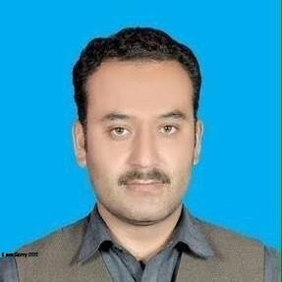

**V*ITA***

**MUHAMMAD JAVED**

Post Office Raja Ram Tehisl Shujabad Dist Multan.

Cell Phone No: +92-342-8672012. 0308-1721640.

**OBJECTIVE:-**

Applying my professional competencies or skills and hardworking behavior in a growing, dynamic & reputable Institute, where my knowledge and experience can be applied to potential.

 **PERSONAL BIO-DATA:-**

**Father’s Name** Abdul Raheem

**Date of Birth** 23-03-1990

**NIC No**  36304-8273589-9

**Nationality**  Pakistani

**Religion** Islam

**Marital Status** Married

**Domicile** Multan

**Gender** Male

**E-Mail Address** mjaveeeed473@gmail.com

**Health** Excellent

**QUALIFICATION:-**.

|  |  |  |  |
| --- | --- | --- | --- |
| **Qualification** | **Year** | **University/Board** | **Marks/%Age** |
| Matric (Science) | 2007 | BISE MULTAN | 509/850 |
| D.com ( Accounting ) | 2010 | Board Lahore | 666/1200 |
| B.A (BZU Multan) | 2012 | BZU Multan | 392/800 |
| MASTER (BZU Multan) | Waiting Result | | |

**Computer skills:**

* 14 Month Diploma of CA &DBM Computer Application in Vti Shujabad .
* Basic computer using + MS Office (Word Excel , Power Point)
* Inpage
* Window Installation.
* Software Installation.
* Internet Browsing, Email.

**EXPERIENCE:-**

* I have 2-Year Experience as a **Social mobilizer of Polio in** Health Department Shujabad Peried January 2021 to Dec 2022.
* I have 2-Year Experience as a **Polio Team Member in** Health Department Shujabad Peried January 2019 to Dec 2020.
* 01-Years experience as a (**Lab. Assistant & D.C) In Vocational Training Institutes** (A Project of the Govt Punjab+ Pak Army (Multan Cantt)
* 05-Years experience as a **Store Keeper ,Documents Controller** in Croplands Chemical & Seeds Services (Agriculture ) Peried January 2009 to 2013 (Bahawalpur,)



**COMMUNICATION SKILLS:-**

* Urdu and Punjabi. English.



**REFERENCE:-**

* Will be provided as per demand.