* **Mr.SohailArif.￼** 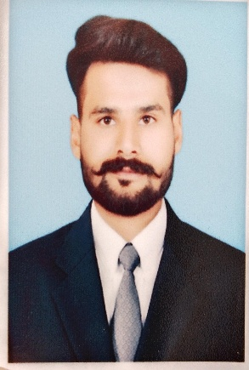

**Name: sohail Arif**

**Father’s Name: Arif Masih**

**Date of birth: 20/06/1997**

**Nationality: Pakistani**

**CNIC: 34301-7615879-9**

**Postal address: kassoki Road East Christian colony Hafizabad**

**Phone No.: +92-3246045596**

**Domicile: Hafizabad (Punjab)**

**Religion: Christian**

**Marital Status: unmarried**

# **Email Address: sohailkhansmile777@gmail.com**

|  |  |
| --- | --- |
|  | **Objectives** |

**To work with an organization where I can use my skills to improve the health care services for the betterment of humanity as well as the organization which promises best development of managerial objectives and further offers of distinct career and a growth oriented executive position in a professional set up, where strong management, communication and leadership skills could be instrumental in achieving the organizational objectives.**

|  |  |
| --- | --- |
|  | **Qualifications** |

|  |  |
| --- | --- |
| **Matriculation 2017** | **(BISE Gujranwala)** |
| **Pharmacy Technician (2 years) 2018 - 2020** |  |
| **Punjab pharmacy council Lahore Pakistan** |  |

|  |  |
| --- | --- |
|  | **COMPUTER SKILLS** |

* **Internet use**
* **MS Office**
* **Excel**
* **MS Powerpoint**

|  |  |
| --- | --- |
|  | **Hobbies** |

* **Reading Books and News Papers**
* **Internet use**
* **Listening Music**
* **Operating Musical Instruments**
* **Singing**
* **Running**
* **Exercise Gym and Kick Boxing**
* **Sports**

## PERSONAL SKILLS

* **Communication and Interpersonal Skills**
* **Managemental skills**
* **Mechanical skills of operating vents and other icu machines**
* **Motivational skills**
* **Leading skills**
* **Computer operating skills**
* **Clinical skills**
* **Driving**

**Expertise Languages**

* **Urdu**
* **Punjabi**
* **English**

# **Experience**

**1 year experience in Hospital medication .**

**1 years experience fazal din pharmacy.**

**1 year experience in prescription Handling in Hospital pharmacy.**

**Almost one Year working experience as safety warden in shell Pakistan on site U&S filling station ⛽ Gullberg 2 Lahore.**



**Diplomas**



**Diploma in medicine Technician.**

**Diploma in computer management**