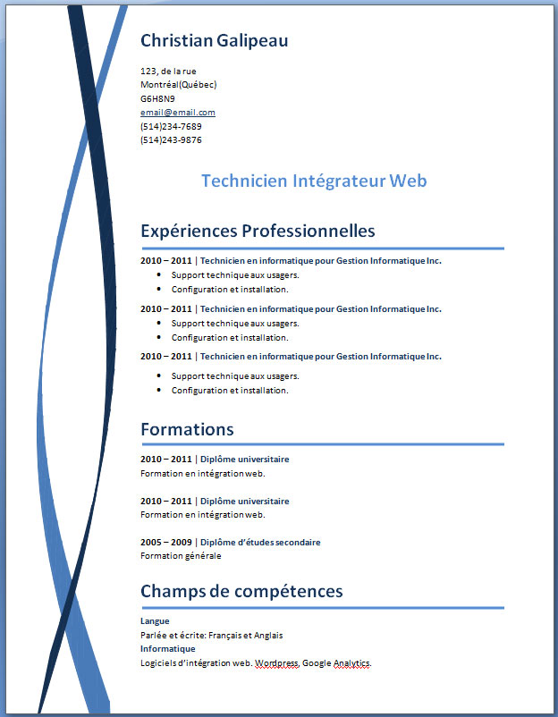
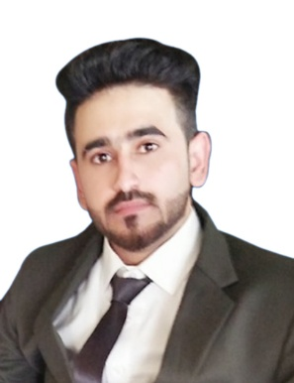

Muhammad Ikram Qureshi

Contact: 0311-5469882
Email: mikramqureshi534@gmail.com
Address: House#ZB-114 Street No.4 Mohallah Alamabad,Dhoke Hassu Rawalpindi

Objective
Seeking a position with a dynamic organization where I will have the opportunity of working under highly experienced professionals ,upgrading my knowledge and skills , utilizing my experience and education in working for the organization.
Academic Qualification
- DAE 2014-2017
BISE, Lahore
- SSC 2011-2013
BISE, Rawalpindi

Experience
- Cashier 17Oct2017-26 Jan 2020
Metro Cash & Carry , Islamabad
- 06 Month Experience as a Cashier at Beechtree
- I have been working as a Cashier at Sports Board of Punjab since Jan 2021.
Skills
- Microsoft word, Excel & Power Point
- Strong technical & Organizational Skills
- Communication & Presentation Skills
- Time management
- Team Player
Interest
- Internet/Social Media
- Social Work
- Sports
Languages
Urdu
English

