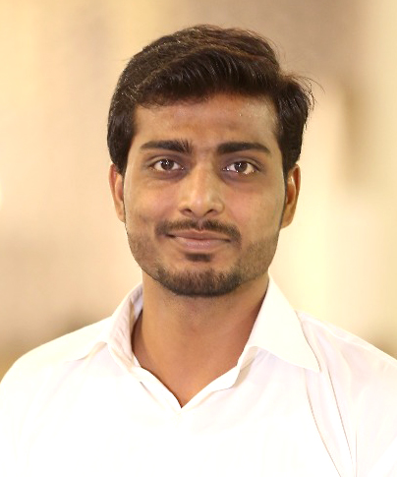
Muhammad Okasha Siddiqui
House No.R-815 sector 15-A/4 bufferzone north nazimabad , Karachi
okashasid@hotmail.com
okasha.siddique@gmail.com
03452542973 / 03101030388
Education
MBA (banking and finance) 2017, University of Karachi
BS (English), 2014, Federal Urdu University of Arts, Science and Technology, Karachi (16 years of education)
B.Com, 2015, university of Karachi
Intermediate, 2010, Board of intermediate education, Karachi
Matriculation, 2007 Board of Secondary education, Karachi
Experience
CHIP training & consulting as a Operation/Administrator
MARCH- 2019 to Present

Responsibilities:
- Recruiting and interviewing potential applicants on experience, skills, and education
- Administrative tasks of UC.
- Organizing and managing new employee orientation, on-boarding, and training programs for subordinates.
- Updating job requirements, when needed
- Maintaining employee records and paperwork
- Answering employee questions and addressing employee concerns
- Meetings with school administration , motivate them for govt rid and coordination with our staff,
- Social activates for smoothen of Health related activates,
- Campaigns Implementation:
- Monitor the process of implementation of the campaign as per guidelines
- and provide feedback to seniors.
- Data collection and analysis. Collect and collate the tally sheet data from the area of responsibility on daily basis.
- Ensure proper implementation of SIAs with special attention hardtoreach areas and underserved high risk populations.
- Attend the daily evening review meeting at UC level for every SIAs and record the findings/observations for corrective action on the following day of the campaign.

WHO (World Health Organisation) as a Operation/Administrator
APRIL- 2018 to FEBRARY -2019

Responsibilities:
- Administrative tasks of UC.
- Updating job requirements, when needed
- Maintaining employee records and paperwork
- Meetings with school administration , motivate them for govt rid and coordination with our staff,
- Social activates for smoothen of Health related activates,
- Campaigns Implementation:
- Monitor the process of implementation of the campaign as per guidelines
- and provide feedback to seniors.
- Data collection and analysis. Collect and collate the tally sheet data from the area of responsibility on daily basis.
- Ensure proper implementation of SIAs with special attention hardtoreach areas and underserved high risk populations.
- Attend the daily evening review meeting at UC level for every SIAs and record the findings/observations for corrective action on the following day of the campaign.

Joyland Pvt Ltd - Joy Cab & Pavilion End Club- Siddiqsons group
Finance officer (MAY -2017 to MARCH- 2018)

Responsibilities:
- Implement SAP Software for accounting purposes including
- Purchase Order
- A/P Invoice
- Outgoing Payment
- Record driver wise daily sales report
- Record incoming payments of all drivers on daily basis
- Flash daily sales report on timely basis
- Coordinate with the Banker on Bank Statement for Daily Bank Recon
- Create Vendors, Item, POs, GRN, A/P Invoice & Outgoing Payments on SAP
- Purchase of stationary and refreshment items and keep the record of it.
- Making cheques of all payments.
- Keeping and maintain store operations.
- Petty Cash Replenishment and ensure smooth & controlled flow of petty cash expenses.
- Visit to the Banker for making POs and deposit Cash.

Themes Collegiate | Karachi
Teacher cum coordinator 2015 to 2018
- Teaching Accounting , cost accounting, POC, Economics and Statistics (Intermediate and B.Com).
- Providing assistance to senior teachers in course designing and syllabus designing.
- Finding out digital material in support of curriculum.
- Monitoring and assessment of tests and exams.
- Designing of custom-made English language and Mathematics course for beginners.
- Registration of students and maintaining of admission worksheet
Workshops/ seminars attended
- Conventional and non-conventional banking from KUBS | Karachi.
- Pakistan stock exchange from KUBS | Karachi
- State bank of Pakistan from KUBS |Karachi
- FIPV survey from WHO |Karachi
Competencies Skills
Commitment Team worker
Integrity Data Entry
Communication MS OFFICE
Working with People Internet
Following Instructions and Procedures Computer Operator
Much Skills of Computer
Planning and Organizing

Personal Information
Fathers Name : Muhammad Jamil
Date of Birth : 12th June, 1991
Marital Status : Married
Nationality : Pakistani
Religion : Islam
Languages : Urdu & English
NIC No. : 42101-8063974-1

