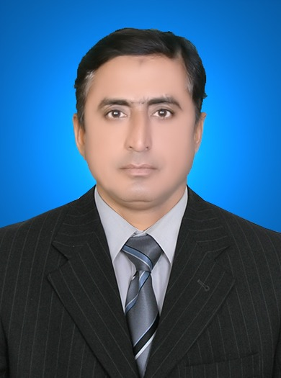
PERSONAL INFORMATION
QAMAR ZAMAN


H. No: B-1-9 Wapda Scarp Colony Khairpur Mirs, Sindh


0333-7584103, 0306-3110138


qamarzaman_72@yahoo.com

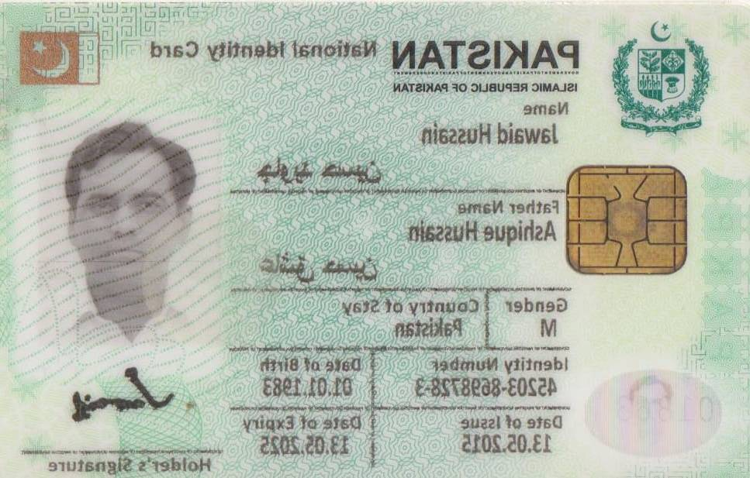
45203-0821800-7
D.O.B 13-03-1972
EDUCATION
1997 Master in Sociology (M.A)
Shah Abdul Latif University, Khairpur
1995 Bachelor in Arts (BA)
Shah Abdul Latif University, Khairpur
1992 H.S.C
B.I.S.E Sukkur
1988 S.S.C
BISE Sukkur
1996 C.I.T
TCC Khairpur

Key Skills & Experience:
- More than 18 years experiences in Field operation, Administration, Monitoring and Management implementing education project, Housekeeping and Sales & Marketing
- Working and supervising multicultural communities and staff in critical locations.
- Started work from grass root level in education program
- Strong organizational skills
- Excellent Managerial skills and skilled to recruit, develop and supervise staff as per project’s nature and needs for achieving the goals and objectives.
- Energetic and dynamic to meet up challenges from any situation for the best output of the project
- Capable to work under pressure for achieving targets
- Able to liaise with stakeholders, donors and inter department of the organization
- Better knowledge in preparing cost effective budget and controlling
- Excellent knowledge in computer as Excel, Word, Power point, Internet navigation

WORK EXPERIENCE
Organization: SEF Public High School
From: August 2018 to Onwards
Designation: Administrator
Project: Education
Donor: Sindh Education Foundation
Duty Station: Khairpur Mirs

Roles & Responsibilities

- Manage budgets, logistics and events or meetings
- Handle scheduling, record-keeping and reporting
- Ensure the school complies with relevant laws and regulations
- Develop and run educational programs
- Hire, train and advice staff
- Counsel Students when needed
- Resolve conflicts and other issues
- Communicate with parents, regulatory bodies and the public
- Have a hand in the creation of the school curriculum
- Implement actions that improve the school and the quality of education

Organization: : Chemonics International (US AID Funded Project)
From: February2018 to May-2018
Designation: Field Support Associate
Project: (SRP) Sindh Reading Program
Duty Station / District: Kashmor
Roles & Responsibilities

- Support teachers in implementing newly learned concepts and skills through regular follow-up support visits to schools.
- Work in close collaboration with teachers, head teachers and concerned education officer(s) in preparing and implementing school/ union council/ tehsil based reading improvement plans and strategies.
- Assist District Focal Person in compiling monthly, quarterly and annual progress reports by providing updated and accurate information from field.
- Support teachers in maintaining portfolios with up to the mark quality.
- Assist the district and provincial offices in undertaking monitoring and data collection tasks.
- Collect content analytics from tablets

Organization: Venerable Woman and Children Organization (VWCO)
From: August 2017 to December 2017
Designation: District Manager
Project: Women & Child Protection
Duty Station: Khairpur Mirs
Roles & Responsibilities

- Women Empowerments
- Education and Health
- Child Rights,
- Women Rights,
- Environment, Advocacy, Capacity Building, Rural Development,
- Poverty Alleviation,
- Water and sanitation and Hygiene

Organization: BRAC Pakistan
From: November 2012 to July 2017
Designation: Area Manager
Project: Education
Duty Station: Khairpur Mir’s & Qambar Shahdad Kot
Roles & Responsibilities

- To design and plan for launching the project’s activities in my commanding area.
- To increase the performance of existing project with planning and close supervision
- To supervise and monitor staff and project’s activities intensively to keep project in right track
- To analyze the budgets for cost controlling
- To prepare routine and other reports as well as analyze staff’s report
- To conduct regular meeting with staff
- To give feedback after monitoring project activities and to develop for rectification
- To logistic support / procurement / recruitment / Stock maintaining
- To keep close relation with communities as well as Govt. officials
- To explore expertise to achieve better outcomes of the project

Organization: National Institute of Population Studies (NIPS)
From: May 2012 to October 2012
Designation: Team Leader
Project: Population & Reproductive Health
Duty Station: Sukkur
Roles & Responsibilities

- To develop questioner for survey about family planning / reproductive health
- To hire surveyors
- To orient and make plan to surveyors for collecting impartial data.
- To monitor and supervise surveyors.
- To compile data and place it to the higher authority

SKILLS

- Interpersonal, communication (oral & written) & motivational skills.
- Substantial experience in integrated emergency grants and managing partners.
- Strong leadership, women empowerment, decision making & conflict resolution skills.
- Coordination, Reporting & Social Mobilization Skills.
COMPETENCIES
- Monitoring & Evaluation
- Community Mobilization
- Able to analyze and summarize complex technical and contextual information
- Ability to work successfully under pressure and ability to make timely decisions.
- Stress management.
- Ability to work as part of a team and to foster team spirit
- Team management competencies.

TRAININGS

Name of Training | Duration | Organized by | Area covered
Foundation Training | 12 days | BRAC | - To know about the organization.  - How to serve in BRAC education program.  - To know the responsibilities for the position
Operational Management Course (OMC) | 12 days | BRAC | - How operate the office management.  - How to manage, motivate, develop and supervise the staff related with the program.
Subject based training (Master Trainer) | 12days | District Govt. Education Department | - How to be a good Teacher.  - How to teach following easier teaching learning method  - How to increase quality of education.

LANGUAGES
- Sindhi
- English
- Urdu

HOBBIES
Social Activist, Reading Books & Daily NEWS Papers.

