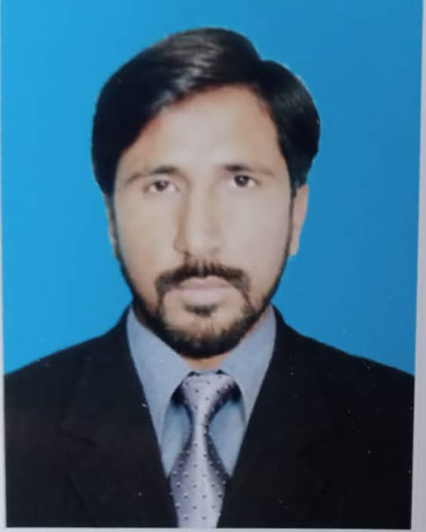 ATIF NAZIR

Address: Azeem Abad Near Thokar Niaz Baig Lahore

Mobile No: +923008491238

Email: [atifn6761@gmail.com](mailto:atifn6761@gmail.com)

**CAREER OBJECTIVE:**

I am hard working person and want to be the part of growth-oriented organization, where I can mesh my theoretical knowledge and boost my potential as well as leadership skill. I am astute, self- motivated, energetic, and carrier oriented person and willing to work accordingly to the best of my professional knowledge and competence. I am seeking for an opportunity to acquire breath of knowledge and experience. Therefore, it is my esteemed desire to join a network of well-connected professionals so I can enhance my professional skills.

**WORK EXPERIENCE**

**Company: Alkhidmat Foundation Pakistan (Central Punjab) Lahore**

**Position: Senior Resource Mobilization Officer**

**Location: Lahore, Pakistan**

**Period: October-2022 to till date**

**Responsibilities as Senior Resource Mobilization Officer**

* To prepare, review and amend SOPs of the department with the consultation of HR/R&D Department
* To ensure MOUs (Memorandum of Understanding) between AKF and Corporate sector on fund raising for projects
* To identify and preparation for upcoming and on-going funding opportunities
* To support the report writing of programmatic reports and technical support
* To draft & develop proposal by assembling information including project nature.
* To communicate prescribed proposal and report on completion of projects to each donor with concerned program manager
* To ensure appropriate representation of the regional office at strategic donor, partner, and Government meeting that could lead to resource acquisition and collaboration,

**Company: Rural Education and Economic Development Society (REEDS)**

**Position: Producer Unit Manager**

**Location: Vehari, Pakistan**

**Period: March-2017 to April-2022**

**Responsibilities as Producer Unit Manager**

* Developing improvement plan and review progress on annual basis
* Set up an appropriate data management system
* Holding the feedback sessions of Field staff for progress sharing and next planning on fortnightly basis
* Identifying and addressing issues/risks associated with implementation and Plan/ enforce implementation of corrective actions
* Collecting, compiling, and reporting the accurate data and submit at project level
* Operating whole system to collect, compile and report accurate data

**Company: Society for the Empowerment of the People (SEP)**

**Position: District Coordinator**

**Location: Vehari, Pakistan**

**Period: Jul-2015 to Jan-2017**

**Responsibilities as District Coordinator**

* Setting clear team goals and KPIs
* Delegating tasks and set project deadlines
* Overseeing day-to-day teams' operation and performance
* Doing regular performance evaluation
* Creating a healthy and motivating work environment and atmosphere
* Developing a well-designed and motivating evaluation program
* Communicating with teams about their performance
* Motivating team members
* Discover training needs and provide coaching
* Listen to team members’ feedback and resolve any issues or conflicts

**Company: Agency for Technical Cooperation & Development (ACTED) INGO**

**Position: Community Mobilizer**

**Location: Dera Ghazi Khan, Pakistan**

**Period: Apr-2010 to Apr-2011**

**Responsibilities as Community Mobilizer**

* Participating in assessments, Participatory Rural Appraisals, feasibility studies, stakeholder analyses and community consultations.
* Liaising with Governmental and non-Governmental Agencies.
* Supporting the development of agreements and MoUs with community-based organizations or other civil society groups.
* Mobilizing the community in the effective use of the community resources.
* Identifying unskilled and skilled Cash for Work beneficiaries in close cooperation with the steering committee.
* Supporting in the development of IEC materials for all activities implemented.
* Checking & controlling daily Workers attendance sheet on daily basis.

**EDUCATIONAL ATTAINMENT**

* Master’s in Business Administrations (MBA Marketing) 2017-2020

COMSATS University of Islamabad Vehari Campus

* Bachelor’s in arts (B.A) - 2014

Allama Iqbal Open University - Islamabad, Pakistan

* Intermediate (FA) - 2011

Board of Intermediate & Secondary Education - Multan, Pakistan

* Matric (10th Standard with Science Subjects) - 2009

Board of Intermediate & Secondary Education - Multan, Pakistan

**COMPUTER SKILLS**

* Microsoft office (MS Word & MS Excel)
* In page
* Internet

**PROFESSIONAL WORKSHOPS**

* Three days’ workshop on master trainer from UNDP & Election commission of Pakistan
* Four days’ workshop of capacity building training from British council
* Twelve days’ workshop on Better cotton among the farmers from REEDS PAKISTAN at Khan Pur RYK

**PERSONAL DETAILS**

Father Name: Muhammad Boota

Date of Birth: September 01, 1989

Religion: Islam

Nationality: Pakistani

Language: English, Urdu and Punjabi