Dr. Abdul Rahim  S/O Abdul Ghani  CNIC 54303-2023301-1  Local Pishin  Address Killi Kamal Abad City 1 Pishin  Contact Information:  0333-7794361----------  0331-8926657----------  rahimtpfm@gmail.com  Education:  - M.A University of Balochistan  - B.A University of Balochistan  - Fsc (pre-medical) of BISE Quetta Balochistan.  Professional Qualifications:  - DHMS (BHMC) Quetta 1999  - MD (University of Kabul) 2008  Skills:  - Monitoring Evaluation & Reporting  - Master trainer  - Third-Party Field monitor.  - Medical officer  - Enuremutors in PDMA of flood 2022.  - Enuremutors in Save the Children for the survey.  - Enumerator in Livestock and agriculture in FAO.  - Enumerator in BLEP / ECI.  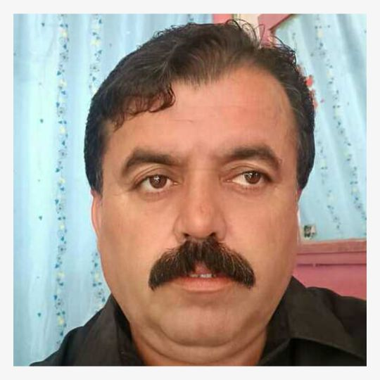 | Dr. Abdul Rahim
 | Experience
 | Tameer e Khalaq Foundation
Third Party Field Monitor. Pishin, Killa Abdullah Quetta, Lorelei, Zhob, Chaman and Naseer Abad.
October 2014 to January 2016 and April 2018 to 31 October 2022.
Field Monitoring activities consisting on three phases.
( Pre campaign , Intra campaign and Post campaign)
Pre campaign activities.
- Monitoring and online reporting of District Polio Eradication community meeting (DPEC)
- Monitoring and online reporting of Polio Area supervisor training.
- Monitoring and online reporting of Polio front line worker.
- Monitoring and online reporting of union council polio eradication community meetings.
- Monitoring and online reporting of desk review, field review and high risk population.(Micro plan revalidation)
- Performing cross verification of Micro senses.(Field and Registration book)
- Monitoring and online reporting of ‘Final readiness’ meeting
- Micro plan quality assessment (MPQA)
Intra campaign activities.
- Attending Morning meeting at union council level.
- Monitoring and online reporting of Area supervisors role.
- Taking house hold clusters consisting 3 clusters, 21 households.
- Observation of three front line workers
- Attending Tehsil , union council and District level meetings seven days in intra campaign.
Post campaign activities.
- Cross checking of recorded Refusals and Not available children.
- Monitoring Area supervisors’ role.
- Monitoring out door media activities ( Banner , streamers, Bill boards, and posters)
- Performing Lot Quality Assurance Sampling ( LQAS) activities ( District Quetta, Pishin and Killa Abdullah)
- Performing Post campaign Monitoring (PCM)

 | JERS
Third Party Field Monitor. Pishin, Killa Abdullah Quetta, Lorelei, Zhob, Chaman and Naseer Abad.
February 2016 to March 2018.
Field Monitoring activities consisting on three phases.
( Pre campaign , Intra campaign and Post campaign)
Pre campaign activities.
- Monitoring and online reporting of District Polio Eradication community meeting (DPEC)
- Monitoring and online reporting of Polio Area supervisor training.
- Monitoring and online reporting of Polio front line worker.
- Monitoring and online reporting of union council polio eradication community meetings.
- Monitoring and online reporting of desk review, field review and high risk population.(Micro plan revalidation)
- Performing cross verification of Micro senses.(Field and Registration book)
- Monitoring and online reporting of ‘Final readiness’ meeting
- Micro plan quality assessment (MPQA)
Intra campaign activities.
- Attending Morning meeting at union council level.
- Monitoring and online reporting of Area supervisors role.
- Taking house hold clusters consisting 3 clusters, 21 households.
- Observation of three front line workers
- Attending Tehsil , union council and District level meetings seven days in intra campaign.
Post campaign activities.
- Cross checking of recorded Refusals and Not available children.
- Monitoring Area supervisors’ role.
- Monitoring out door media activities ( Banner , streamers, Bill boards, and posters)
- Performing Lot Quality Assurance Sampling ( LQAS) activities ( District Quetta, Pishin and Killa Abdullah)
- Performing Post campaign Monitoring (PCM)
 | Tameer e Khalaq Foundation
 | Master Trainer Surkhab camps September 2012to September 2014
- Awareness session on public hygiene at BHU.
- Trained all children, Male & female outpoints.
- Organize and support community-based meetings in BHU.
- Monitor and organize health education activities.
- Identify and manage GBV cases in BHU.
- Compile and submit monthly reports to the coordinator on time every month.
 | SEHER
 | Medical Officer Saranan camps Jan 2012 to August 2012
- Consultation to all children, Male & female outdoor patients.
- Ensure the availability of staff and medicine at BHU.
- Organize and support community-based meetings in BHU.
- Monitor and organize health education activities.
- Identify and manage/refer high-risk cases in BHU.
- Ensure proper record keeping of all In/outpatients.
- Maintain equipment and medicines stock inventory.
- Compile and submit monthly reports to the coordinator on time every month.
 | American Refugees community.
 | Medical Officer Surkhab camps Jun 2008 to December 2011
- Consultation to all children, Male & female outdoor patients.
- Ensure the availability of staff and medicine at BHU.
- Organize and support community-based meetings in BHU.
- Monitor and organize health education activities.
- Identify and manage/refer high-risk cases in BHU.
- Ensure proper record keeping of all In/outpatients.
- Maintain equipment and medicines stock inventory.
- Compile and submit monthly reports to the coordinator on time every month.
 | PDMA/ Save the Children Flood relief Survey in Pishin/FAO, RHC/ECI, BLEP
PDMA survey August 2022 District Pishin
Save the Children Survey September 2022 District Pishin.
FAO/Rahman Habib consultant December 2022 to January 2023
ECL/ BLEF. January 2023 to February 2023

