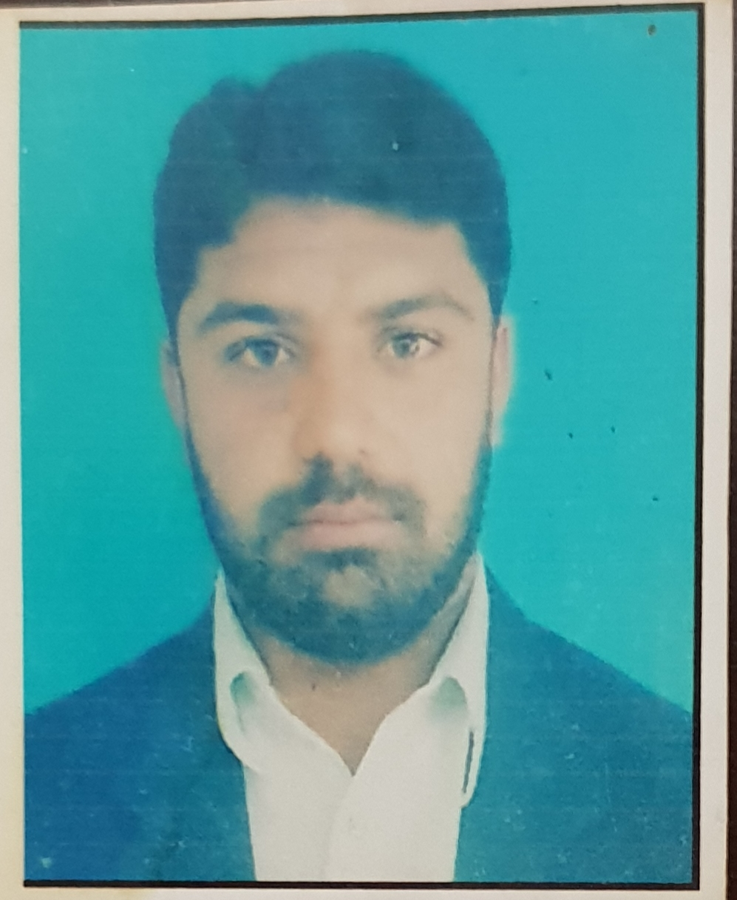

Said Ameen
Personal Info:
Date of Birth: Jul 17, 1985
Gender: Male
Nala kajori, Tehsil Bara, District Khyber, Po Box Bara (Permanent)
Domicile: Khyber
Peshawar - 25000
(03365599009/03025599009)
afridisaidamin@gmail.com

Experience:
Presently working as Tehsil Delivery Operation and Supervision officer Tirah Maidan

Worked as District Health Communication Support Officer in Pakistan Polio Eradication Initiative District Khyber from 14-03-2018- 2020

Worked as Tehsil Supervisor in Pakistan Polio Eradication Initiative in District Khyber at Tehsil Tirah Maidan, For 16 Months
Organization | Frontier Homeopathic Medical College, Peshawar.
Organization Type | Homoeopathic Medical College
Employer Contact Number | 03339344340
Designation | Lecturer in Community Medicine and Gynecology, Academic Registrar
Location | Peshawar, Pakistan
Type of Experience | Full Time
Tenure | Apr-2009 To June 2015
Description | Teaching Community Medicine and Gynecology,
Organization | Khyber Teaching Hospital
Organization Type | Govt hospital
Designation | Medical technician
Location | Peshawar, Pakistan
Type of Experience | Internship
Tenure | Feb-2008 To Apr-2008
Description | Emergency, Casualty, Post-surgery Care, Minor Surgery.
Reason for Leaving | Because my training was completed successfully.
Organization | Polio Campaign
Organization Type | WHO
Employer Contact Number | 03339414747
Designation | Polio Campaign Volunteer
Location | Khyber Agency, Pakistan
Type of Experience | Part Time
Tenure | Jan-2000 To 2009 May
Description | Independent monitor.  Focal person.  Social mobilizer and volunteer.

Skills:
Skill Name | Level |  | Last Used
Computer literate | Average
Windows 95, 97, 98 and XP 2002, Window 7 and 8.
MS DOS.
MS Word.
MS Excel.
MS Power Point.
Medical Software.
Computer assembling.
Knowledgeable in SPSS (Statistics)

Education:
M.Phil Microbiology: From Abasyn University Peshawar Pakistan with CGPA of 3.41.
Msc Microbiology:
With cumulative GPA of 3.2 from Abasyn University Peshawar.
Master in Public Health:
Level Attained | Masters Degree
Aggregate % | 3.2
Institute | Institute of Management Sciences | Peshawar
Address | Peshawar, Pakistan
Session | 2009 - 2011
Majors | Bio-statistics, Communication, Epidemiology, Health Care System, HIMS, Public Health, Applied Epidemiology, Health Education & Promotion, Health Management & Accounting, Health Policy, Primary Health Care Reproductive Health & Community Obstetrics, Child health and Community Pediatrics, Communicable Diseases, Health System Research, Hospital & Personnel Management, Nutrition, Occupational & Environmental Hazards.
Bachelor in Homeopathic Medical System (BHMS)
Level Attained | Bachelors Degree (2-3 Years)
Aggregate % | 69.00
Institute | University of Peshawar.
Address | Peshawar, Pakistan
Session | 2007 - 2009
Majors | Medicine, Pathology, Bacteriology, Parasitology, Gynecology & Obstetrics, Psychology, Community Medicine and Homeopathic Pharmacology.
Diploma in Homeopathic Medical System (DHMS).
Level Attained | Short Course
Aggregate % | 75.00
Institute | National Council For Homoeopathy, Rawalpindi
Address | Peshawar, Pakistan
Session | 2004 - 2008
Majors | Anatomy, Physiology, Pathology, Psychology, Hygiene & Public Administration, Gynecology, Minor Surgery, Clinical Methods in Medicine and Homeopathic Pharmacology.
Degree Name | Diploma in Medical Technologies
Level Attained | Diploma
Aggregate % | 54.00
Institute | Pakistan Institute of Medical Technologies, Medical Faculty Peshawar
Address | Peshawar, Pakistan
Session | 2005 - 2007
Majors | Anatomy, Physiology & Biochemistry, Pathology, Pharmacology, English. Medicine I, II, III, and Public Health.
EPI
Level Attained | Certification
Aggregate % | 70.00
Institute | Depptt of Health Khyber Pukhtoonkhuwa
Address | Peshawar, Pakistan
Session | 2006 - 2007
Majors | Routine Immunization techniques.
FSc Premedical
Level Attained | Certification
Aggregate % | 49.00
Institute | Govt Superior Science College, Peshawar
Address | Peshawar, Pakistan
Session | 2001 - 2003
Majors | Physics, Chemistry, Botany and Zoology.

Matric: Pass in 2001 with 1st division with Science subjects from Peshawar Board.
Language:
Read | Write | Speak | Understand | Typing | Shorthand
Pushtu
Easily | Easily | Easily | Easily | -- | --
Urdu
Easily | Easily | Easily | Easily | -- | --
English
Easily | Easily | Easily | Easily | -- | --
Hindku
Easily | Not Easily | Not Easily | Easily | -- | --
Punjabi
Easily | Easily | Not Easily | Easily | -- | --

Affiliation:
Organization | Polio Eradication Programme
Role Full Time employ
Session July 2016-Till date
Organization | Polio Eradication Programme
Role | Volunteer
Session | Jan-1997-2003

Reference:
Name | Title | Company | Phone/Email | Acquaintance
Col. Iqbal Shahin  Dr. Sher Amin | Principal  CBV Manager | Frontier Homeopathic Medical College, Peshawar.  CTC | 03339344340  03339161577 | 8 Years  3 Years
Mr. Ishfaq : WHO_________________________ In charge Independent Monitors

