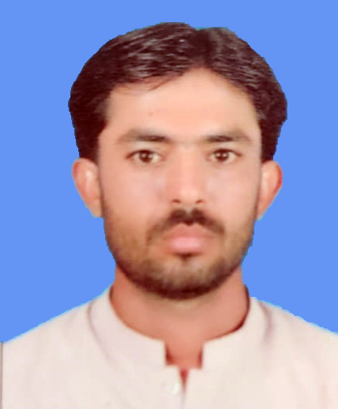

**FAWAD**

**Address: Village Lund Taluka K.N Shah District Dadu Sindh.**

**Mobile NO: 03033388597**

***C***

**V**

|  |  |
| --- | --- |
|  | ***CAREER OBJECTIVE:*** |

*Seeking a challenging job career oriented organization, where I can excel my skills and capabilities up to your entire satisfaction*

|  |  |
| --- | --- |
|  | ***PERSONAL INFORMATION:*** |

* *Father’s Name : Al Gohar*
* *Surname : Lund*
* *Date of Birth : 01-02-1994*
* *C.N.I.C No : 41202-7303915-5*
* *Religion : Islam*
* *Nationality : Pakistani*
* *Domicile : Dadu (R)*
* *Marital Status : Single*

|  |  |
| --- | --- |
|  | ***EDUCATIONAL QUALIFICATION:*** |

|  |  |  |
| --- | --- | --- |
| ***Degree/Certificate*** | ***Grade*** | ***Board/University*** |
| *Matriculation* | *C* | *BISE Hyderabad* |
| *Intermediates* | *B* | *BISE Hyderabad* |

|  |  |
| --- | --- |
|  | ***Experience*** |

*Three Years worked as Sales Man with National Food (PVT) LTD in District Dadu from August 2019 to October 2022.*

|  |  |
| --- | --- |
|  | ***LANGUAGES:*** |

* *English*
* *Urdu,*
* *Sindhi*
* *Balochi*

|  |  |
| --- | --- |
|  | ***References:*** |

* *Will furnished on demand.*