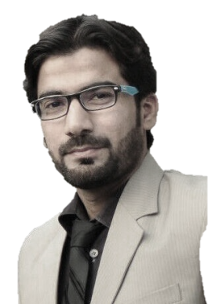**Resume**

**Muhammad Ijlal Khalid Awan**

**Email:** [**Ijlal_awan@yahoo.com**](mailto:Ijlal_awan@yahoo.com)

**Contact:** +92 345 9125364/ 0333 9767679

**DOB**: 19-November-1988

**Address:** Haji Camp Sethi Town Hussain Chowk Fayaz General Store Peshawar.

**Objective**

To join a dynamic organization where I can build my career through my abilities and prove myself as an energetic, enthusiastic and career oriented person under all circumstances and multicultural environments.

**Experience**

* **Association for Community Development**

Working as a Program Assistant PMDT LRH

25 April 2022 Continue

* **Pakistan Red Crescent Society (PRCS)**

Worked as a HR Assistant (Volunteer)

01 July 2021 to 30 March 2022

* **MERF**

Worked as a Data Entry Assistant

01 September 2021 to 31 December 2021.

* **De Laas Gul Welfare Programme (DLG)**

De Laas Gul Welfare Programme (DLG) In Take A Child to School Project by (British Council) as a Monitoring & Evaluation Officer.   
Job Descriptions: To validate data through cross checking data in school register, telephone calls to parents and teachers,  
Make Field Plan. Report verified data on Online Portal. As a monitoring & Evaluation officer I always believe in project quality and implement the project activities with it real sense. Monitoring & Evaluation is the key essence in any project as it assures the project quality as well as gauge the quality of project activities implemented throughout the project. Monitoring & evaluation make sure that all the outcomes and indicators of the project should be attained in the implementation phase, it also ascertains that appropriate record must be maintained accurately in the entire project activities.

05 May 2017 to 15 May 2021.

* **Meinhardt Pakistan Pvt Ltd**

Worked as Admin/Finance Officer

30 Aug 2013 to 20 Nov 2016.

* **J Software Solution**

Worked as System Developer

Aug 2007 to Jul 2010.

**IT Skills:**

* **Ms Office**.
* MIS using **Ms Excel**,
* Presentation **MS PowerPoint,**
* Drafting letters/ office Corresponding MS **WORD**
* Programming **C/C++**, **Visual Basic**, **HTML, DHTML**,
* Designing **Paint Artist**, **Adobe Photoshop**,
* Software Installations **IT Equipment’s**.
* IT Hardware maintenance,
* Typing Speed in **English 45** words per minute.
* **MS operating systems** and managing user through Network.

**Education**

* **MSC (Computer Science)**

University of Peshawar

Year 2013 1st Division

* **BSC (Computer Science)**

University of Peshawar

Year 2010 2nd Division

* **FSC (Computer Science)**

Suffa College Peshawar

Year 2008 2nd Division

* **SSC (Arts)**

Forward High School

Year 2005 1st Division

**Languages**

# Excellent Communication skills in English, Urdu, Pashto &Hindko.

**Reference**

Can be furnished if required.