Asim Ashiq

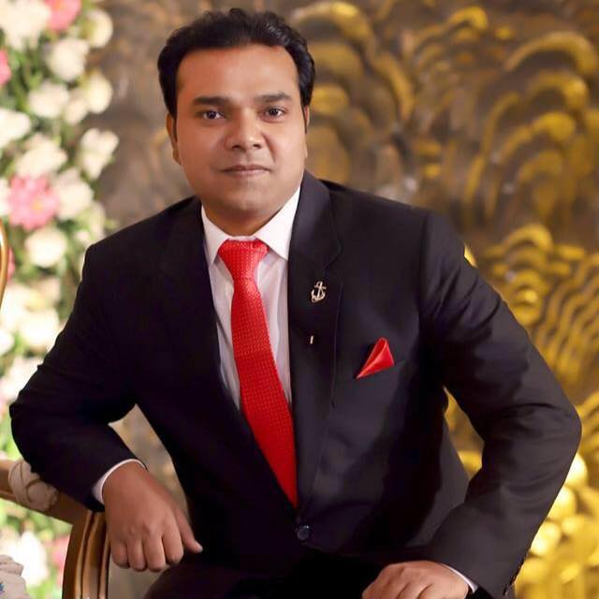

**Cell # 00923083083080**

**E-mail:aximzzz@gmil.com**

PROFILE

* A versatile professional who is enthusiastic, self-motivated, solution oriented with excellent problem solving skills and who work well under pressure.
* Experience of working with clients has taught the values of tact and diplomacy which has developed my confidence to deal effectively with people at all levels, which has also given me a good understanding of providing good customer service at all time.
* I can cope with stress and work under reasonable pressure to deadline. My commitments to quality and high standards are reflected in my work, and example for others to follow.
* Gained excellent knowledge in costumer services and providing perfect support.

Leadership Skill

* Strong selling skill
* Excellent skills in communication.
* Strong analytical and problem solving skills
* Capable of effective presentation.
* Good team player.

Administrative and Technical skill

* Excellent office a team to achieve common goals in efficient manners.
* Excellent problem solving skills
* Have an excellent computer operating skills including various operating systems like windows7, windows XP, and Microsoft office including MS word.

PROFESSIONAL DEVELOPMENT

Matric 2003 ST.MARYS HIGH SCHOOL Lahore Pakistan

I.com 2005 THE EDUCATOR College Lahore Pakistan

B.A 2008 PUNJAB UNIVERSITY

CERTIFICATION

* 2009 Certificate of Excellence awarded from The Brains College
* 2008 Certificate of Merit awarded from Nawab computer college ( NCC )
* 2007 Certificate of awarded mobile repairing from The Brains College
* 2006 Certificate of awarded hardware and software from The Brains College

**Hospitality**

Le Royal Meridian Stewarding Department (UAE)

Maisonette Hotel Front Office 1 Year

**MOBILINK GSM**

2014 TO 2016

OUTBOND CCR FOR 1 YEAR ON REACTIVATION PROJECT

INBOUND CCR FOR 111 HELPLINE

PROFESSSIONAL EXPERIENCE

* Two year experience for salesman in AlFatha store Lahore Pakistan as sales and service officer, duty include sales , after sales service and customer services from August 2002 to September 2007
* I have working experience in Hafeez Centre mobile sale/purchase Lahore Pakistan from December 2009to May 2011.

Personal Information

|  |  |  |
| --- | --- | --- |
| Nationality | **:** | Pakistani |
| Date of Birth | **:** | 28 June 1985 |
| Marital Status | **:** | Single |
| Languages | **:** | English, Urdu & Punjabi |
|  | **:** |  |
|  |  |  |
|  |  |  |

**REFERENCES**

It will be furnish upon request