KASHIF ULLAH
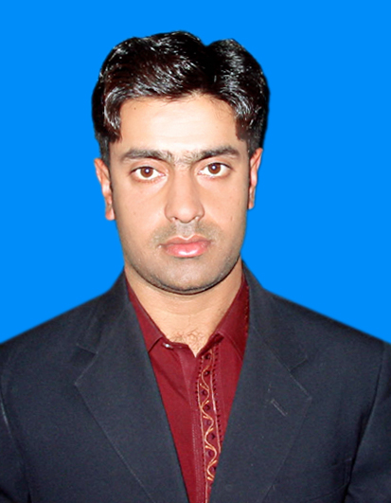

OBJECTIVE
Seeking a challenging growth-oriented position in a reputable and progressive academy that offers a challenging and dynamic environment, a stable career path and an opportunity to apply my qualification to the fullest and prove my skills.

ACADEMIC QUALIFICATIONS
S.No | Degree | Subject | Division | Marks/GPA | Year | Institute
1 | Mba | Hrm | 1st | 3.19 | 2012 | City University of Science & IT Peshawar
2 | B.Com | Accounts | 2nd | 784/1400 | 2009 | Government College of Management Sciences Peshawar
3 | D.Com | Accounts | 1st | 952/1400 | 2007 | Government College of Management Sciences Peshawar
4 | SSC | Science | 1st | 674/1050 | 2005 | Government High School Tarnab Farm
5 | MS Office | Computer | 1st | 60/100 | 2006 | SSCC Tarnab Farm
6 | D.I.T | Computer | A1 | 1205 | 2018 | Professional College Peshawar
PERSONAL DATA
Father Name : HABIB ULLAH
Address : Mohala Sadat, Village and P.O Box Tarnab Farm Peshawar
Contact No : 0092-333-9413683
Date of Birth : 08/01/1989
Nationality : Pakistani
CNIC# : 17301-6368525-7
E.Mail : Kashifonl4s@gmail.com
Domicile : Peshawar (Kpk)
Religion : Islam
Marital Status : Married
Languages : English, Urdu & Pashto
PROFESSIONAL COURSES
Course : Agri Business & WTO
Institute : GCMS Peshawar
EXPERIENCE

- Accountant from Feb 2012 to June 2016 at Muslim High School & College Tarnab Peshawar.
- Senior Coordinator from Sep 2016 to Dec 2016 at Cenna Collage Pabbi Nowshera.
- Administrator from Jan 2017 to June 2019 at Cambridge Public School Peshawar.
- Accountant & admission officer from June 2019 to May 2020 at Muslim collage Peshawar.
- Worked as HR officer at Muslim collage Peshawar from June 2020 to June 2022.
- Working as HR Officer at Pashat Hospital Bajaur under TCP (Public & Private Partnership) Project from Aug 16th 2022 to till date.
REFERENCES
- References will be provided on request.

