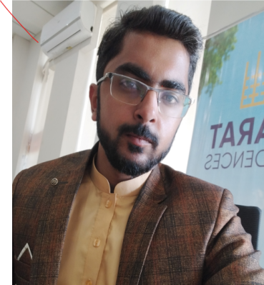  Objective  Seeking for Job Related Qualification in performance-oriented organization and to become a part of an organization that offers a challenging position in a good working environment where I can share my professional qualification, knowledge, skills and ability.  PERSONAL INFORMATION  CNIC# 54400-3666191-3  Marital Status: Unmarried  Domicile: Quetta  Contact  Address: H#23/1 Chiltan Road Quetta Cantt  PHONE: +92-317-8117712  EMAIL:  shaharyarmalik0606@gmail.com  Hobbies  Reading  Football |  | Shaharyar Ahmad  EDUCATION  SSC  2010 - 12  Science 755/1050 1st Division Grade A  HSSC  2013 - 15  Pre-Engineering 590/1100 2nd Division Grade C  Bachelors  2019  Arts 406/800 Grade C  WORK EXPERIENCE  M&P Couriers (E-Commerce)  Period: Sept 2018-July 2020  Position: Operations Assistant  Responsibilities: Record Keeping, Data Management and Customer Services.  Leopards Courier Services (E-Commerce)  Period: Aug 2020 –Sept 2022  Position: Team Leader Operations  Responsibilities: Reports Management, Branch Manager, Zonal Data Coordinator, Manager Customer Services and Sales Manager (E-commerce)  Professional Skills  MS Office  Leadership Skills  Teamwork Expert  Quick Learner  Excellent Communication Skills (Verbal and Written)  Data Management and Record Keeping Expert

