Aurang Zeb Khan S/o Jehan Zeb Khan
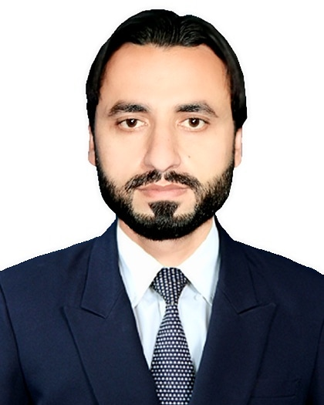
DOB: 21 JUNE 1989
STATUS: Single
CNIC: 11101-3278740-5
Mob No: +92334-8839886
Religion: Islam
Nationality: Pakistani
E-mail: aurangzebsurani@gmail.com
Address: Village Kachozai Surani P/o Nizam Bazar Tehsil and District Bannu KPK

- PERSONAL STATEMENT :

I am a confident and hard working person with the ability to learn and adapt quickly to new challenges and to handle difficult situation.

- ACADMIC QUALIFICATION :

DEGREES | SUBJECT | BOARD/UNIVERSITY | DURATION | MARKS
Master Of Arts | Political Science | University Of Science & Technology Bannu KPK Pakistan | 02 Years  (2015) | 417/900
Bachelor Of Arts | Law & Political Science | University Of Science & Technology Bannu KPK Pakistan | 02 Years  (2010) | 234/550
Higher Secondary Scholl Certificate | Pre-Medical | Board of Intermediate & Secondary Education Bannu KPK Pakistan | 02 Years  (2007) | 628/1100
Secondary School Certificate | Science | Board Of Intermediate & Secondary Education Bannu KPK Pakistan | 02 Years  (2005) | 665/1050

- MORE DEGREES/COURCES:

COURSE/DEGREE | SUBJECT | BOARD/UNIVERSITY | DURATION | MARKS
Basic Information Course Certificate | Computer/IT | P.P.C College Bannu | 06 Months  (2007) | Excellent Performance
Computer Course Achievement Certificate | Computer Basic Terminologies | Al-Arsh College of AutoCAD & Survey, Bannu | 03 Months  (2012) | Best Achievement  Certificate

- EXPERIENCE AS A TM Base Bannu in high-q pharmaceutical bannu:
(21 March 2020----22 February 2022 => (1 year & 11 Months)

- Product Promotion, Visiting doctor’s clinics and hospitals in different areas and cities.
- Complete knowledge about medicines.
- Attending meetings and trainings from company as well.

- EXPERIENCE AS AN ACCOUNTANT and system software controller AT SHARIF ULLAH HONDA CENTER bannu: (26 February 2022----Still Working)

- Complete Command On Honda Sales Showroom Software/ Q_SOL Dealership Management System Web.
- Complete Command On Honda Company Software/ B2B AHL PORTAL Web System.
- Cash Payment & Cash Receipt Responsibility on Daily Basis.
- Balancing System & Balancing Cash Book Responsibility on Daily Basis.
- Maintaining Of Balance Sheet, Different Types of Misalliance & Expenses Ledgers & Income Statement.
- Making Online Pay Orders to Atlas Honda Company for Motor Cycles.
- Staff Payroll responsibility As Well Maintaining Profit & loss A/c.

- COMPUTER SKILLS :

- Complete Knowledge About Computer System & MS Office.
- Complete Knowledge About Installation Of Different Windows (XP 2006, Vista Basic 2008, & Windows 07).
- Complete Knowledge About software & Hardware As Well Input & Output Devices.
- Complete Knowledge About Internet, Web Browsers, E-mailing, Uploading & Downloading.

- GENERAL SKILLS :

- Good Management Skill & Public Dealing As Well I Can Work In Any Type Of Organization On Any Position.
- Ability of Good Communication Skills & Business Dealing.
- Ability to Work in Challenging Environment.
- LANGUAGES :

- English (ii) Urdu (iii) Pashto
- REFERENCE :

- Reference Will Be Provide If Required…

