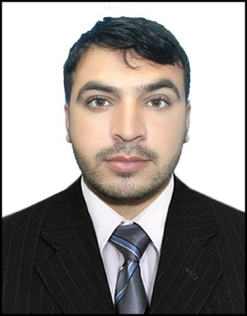

ABDUL BASIT (Safety Officer)

CONTACT INFORMATION

|  |  |
| --- | --- |
| **GMAIL** | Basitkhan3170@gmail.com |
| **PHONE** | 050-2209271 |
| **LOCATION** | Riyadh KSA |
| **VISA STATUS** | AMIL |

**PROFILE**

|  |
| --- |
| A meticulous, hard working and focused professional which I have long track record of identifying probable risks, preventing accidents and implementing safety regulations. I have considerable experience in a health and safety role and is an expert in the field of drawing up safe operational procedures and making recommendations following any accidents or incidents |

**PROFESSIONAL EXPERIENCE**

|  |  |
| --- | --- |
| **JOB TITLE** | SAFETY ASISTANT |
| **COMPANY** | China Railway Bearu 18th Group |
| **DURATION** | 2019-2021 |
| **RESPONSIBILITIES** | * I have to supply suitable personal protective equipment to workers * Inspection of fire extinguisher. * Arrange safety management meetings, Safety classes to all employees. * Prepare monthly statistics, the checklist, Accidents reports. * Prepare Tool Box Talk. |
| **JOB TITLE** | ASSISTANT SURVEYOR |
| **COMPANY** | Baizai Irrigation |
| **DURATION** | 2016-2017 |
| **RESPONSIBILITIES** | * Collected and stored points on job sites using rods, locators rovers and total stations. * Worked with Engineer to develop a road. * Designated to work on some government projects and especially survey. * Performed plot survey drafted certified survey maps in AutoCAD. |

**ACADEMIC QUALIFICATION**

|  |  |  |
| --- | --- | --- |
| CERTIFICATION | INSTITUTE | BOARD |
| NEBOSH | EDCONS Safety Institute of Pakistan | Nebosh UK |
| HSE | EDCONS Safety Institute of Pakistan | Rawalpindi |
| IOSG & OSHA | EDCONS Safety Institute of Pakistan | Rawalpindi |
| Civil Diploma | Peshawar Institute of technology | Mardan |
| Matric | Government Higher Secondary School Qasmi | Mardan |

**PROFESSIONAL SKILLS**

|  |  |  |
| --- | --- | --- |
| * Safety Training | * Safety Audit | * Safety Meeting |
| * IOSH Training | * OSHA Training | * HSE Training |

**LANGUAGES**

|  |  |  |  |
| --- | --- | --- | --- |
| * English | * Speaking | * Writing | * Reading |
| * Hinde | * Speaking | * Writing | * Reading |
| * Pashto | * Speaking | * Writing | * Reading |

**PERSONAL INFORMATION**

|  |  |
| --- | --- |
| Passport No | BA3874851 |
| Date of Issue | 15-NOV-2021 |
| Date of Expiry | 15-NOV-2031 |
| Place of Issue | Pakistan |
| CNIC No | 16103-0360485-7 |

|  |  |
| --- | --- |
| Date of Birth | 10-FEB-1996 |
| Nationality | Pakistani |
| Religion | Muslim |
| Marital Status | Single |
| Gender | Male |

**PERSONAL INTERESTS**

|  |  |  |  |  |
| --- | --- | --- | --- | --- |
| * Writing | * Cooking | * Traveling | * Sports | * Reading |
| * Sketching | * Gaming | * Music | * Blogging | * Designing |

**DECLARATION**

|  |
| --- |
| I do here by declare that all of the above information in true and correct of knowledge. |

**REFERENCE**

|  |
| --- |
| Reference details can be provided upon request. |