CURRICULUM VITAE

ABDULLAH RIND S/O ABDUL SAMAD

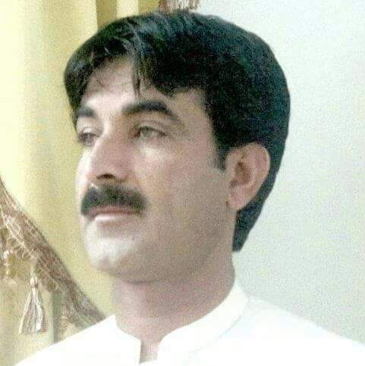

Killi karez kark Mastung, Balochistan
Cell No: 0333-7931765
CNIC No : 51602-5647283-3

Objective:

To find an enabling niche in order to gain strength through a promising and career oriented position in a prospectus driven organization that will challenge my cutting edge skills, analytical and problem solving abilities and utilize my strong leadership.

Personality Traits:

- Strong believer in US instead of Me
- In pursuit of excellence
- Competent and confident
- Excellent interpersonal skills, adaptability to change and ability to learn quickly.
- Willingness to accept challenging tasks.
- Strong and positive communication skills.

Academic Attainments:

Matriculation | Balochistan Board of Intermediate and Secondary Education ,Quetta
F.Sc | Balochistan Board of Intermediate and Secondary Education ,Quetta
B.Sc | University of Balochistan, Quetta
M.A | University of Balochistan, Quetta

JOB EXPERIENCE

DESIGNATION | ORGANIZATION | DURATION
Computer Operator | Agriculture Research Department (N.A.R.S-B) project through Pakistan Agriculture Research Council. | 08 years

Computer
- MS Office Ms Excell Ms Power point.
- Coral draw, Adobe photo shop
- Internet, Installation,
- Basic Software and Hardware.

Personal Information:

Father Name : Abdul Samad
Local : Mastung
Nationality : Pakistani
Date Of Birth : 09-10-1979

Linguistic Approach:

Language | Reading | Writing | Speaking
Urdu | Good | Good | Good
English | Good | Good | Good
Brauhi | Good | Good | Good

