Abdus Salam  - mail: salam345@gmail.com  Mobile No: 0333-9070619  0345-9002578 | 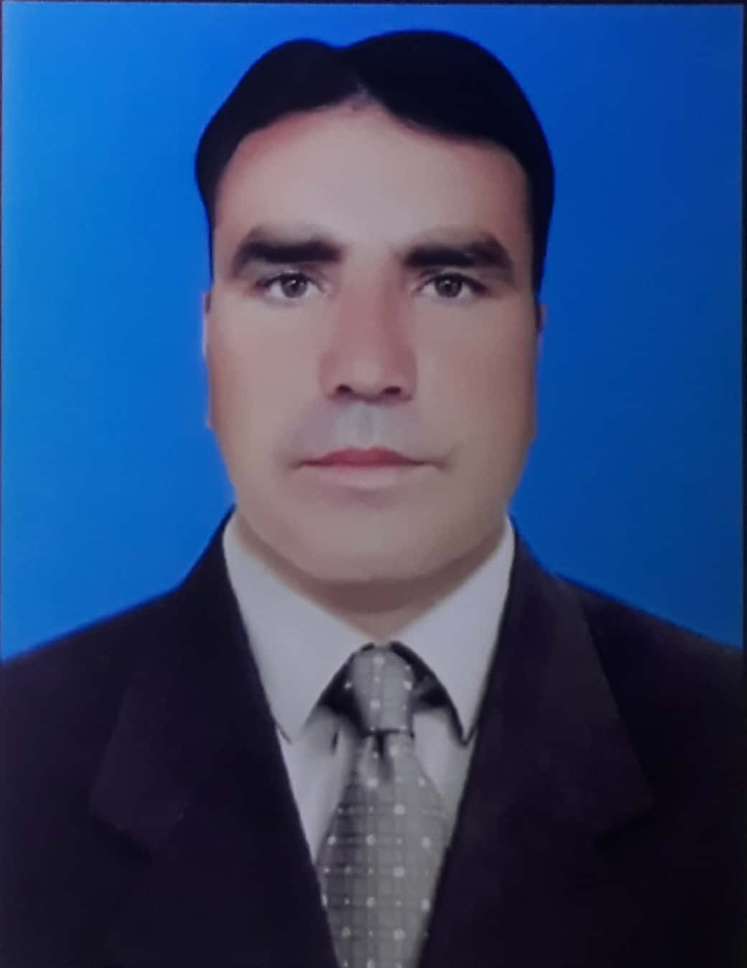

CAREER SUMMARY
Seeking challenging and responsible position, where my education, ability, potentials can be fully and effectively used with opportunities of growth, enhancement of knowledge and to serve in building nation.

PERSONAL DATA:
Name: Abdus Salam
F/ Name: Wali Khan
Date of Birth: 08/10/1984
Religion: Islam
N.I.C No: 17301-8757180-5
Domicile: Tribal Region Peshawar
Nationality: Pakistani
Marital Status: Married
Address: Village Mandai Mahalla Koi Khel Jana Kor FR Peshawar District and Tehsil Peshawar.

EDUCATIONAL QUALIFICATION:
Degree/Certificate | Institution | Session | Subject | Marks (%)
MBA | University of Science & Technology Bannu | 2009 | Finance | 1996/2600 (76.76)
B.Com | Professional College of Commerce Peshawar | 2007 | Commerce | 711/1400 (50.78)
F. Sc  (Medical) | Municipal Inter College Peshawar | 2003 | Science | 599/1100 (54.45)
S.S.C | Govt. High School Shamshatoo  F.R Peshawar | 2001 | Science | 563/850 (66.23)
H.R.M  (One Year) | PIMS Peshawar | 2008 | HRM | 865/1000 (86.5)
Diploma in Information Technology (DIT) | Peshawar Technical Board | 2007 | IT | 1137/ 1700 (67%)
Diploma in Physical Education (DP.Ed) | Abdul Wali Khan University | 2014 | - | 2.62 GPA

COMPUTER SKILLS:
- Diploma in Information Technology (DIT) B.T.E. Peshawar N.W.F.P

EXPERIENCE:
Organization | Designation | Duration of Employment
PEOPLE Pvt Ltd | UC Communication Officer | 1st April 2021 | Till Date
Chip Training & Consulting | UC Communication Officer | 2nd July 2012 | 31stMarch 2021
EPI CELL FATA | Social Mobilizer | 1st June 2011 | 30th June 2012

Major Tasks:
- Leading and supervision for Social Mobilizer.
- Relating and Networking (Community engagement).
- Planning and Organizing.
- Implementation and Monitoring.
- Data based planning of intervention.
- Training of front line workers.
- Tracking of missed children coverage and timely reporting to Emergency Operation centre.
- Monitoring and Supporting Social Mobilization & Awareness Activities regarding EPI/ PEI.

Reporting To:
      - COMNet Officer FATA
      - Communication for Development (C4D) UNICEF FATA
      - Agency Surgeon Office Tribal Region Peshawar
      - UNICEF Provincial Office.
      - Chip Training & Consulting Islamabad
      - FATA Control Room/ Emergency Operation Centre (EOC)
      - Tehsil Communication Officer (TCO)
      - PEOPLE Pvt Ltd
      - District Emergency Operation Centre (DEOC)

LANGUAGES:
- Pashto •Urdu •English
EXTRA ACTIVITIES:
•Games •Reading

