**ABID KHAN**

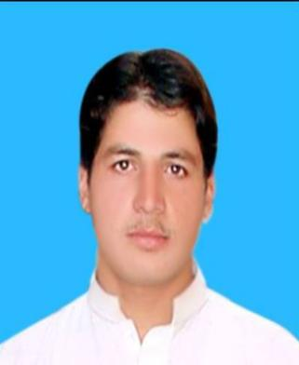**Paste Pho**  **to**

**Address:**

**Village: Nawa Abad P.O Box Garo Shah**

**Tehsil Takht Bhai Distt Mardan, KPK.**

**Cell No#: 0300-5710192**

**Mail: (abidsahil92@gmail.com)**

**Personal Information:**

|  |  |
| --- | --- |
| **Father’s Name:** | **Kashmali Gul** |
| **Date of Birth** | **03-03-1992** |
| **CNIC** | **16102-3849243-5** |
| **Domicile** | **Mardan (KPK)** |
| **Gender** | **Male** |
| **Marital Status** | **Single** |
| **Religion** | **Islam** |
| **Nationality** | **Pakistani** |

**General Academic Qualification:**

|  |  |  |  |  |
| --- | --- | --- | --- | --- |
| **Degree Level** | **Degree Title** | **Score** | **Year** | **Board/University** |
| **SSC** | **Metric (Science)** | **64%** | **2008** | **BISE Mardan** |
| **HSSC** | **DAE**  **Computer Hardware/Software** | **66%** | **2010** | **KPBTE Peshawar** |
| **BS(Hons)** | **BSCS(Hons)** | **71%** | **2015** | **BKUC, Charsadda** |

**Technical Academic Qualification:**

|  |  |  |  |  |  |
| --- | --- | --- | --- | --- | --- |
| **Degree Level** | **Degree Title** | **Major Subject** | **Score** | **Year** | **Board/ University** |
| **Certificate** | **Microsoft Office Course** | **(Word, Excel & Power Point)** | **71%** | **2010** | **TTB, Peshawar** |

**Experience**

* Working as a **Computer Operator** in Climate Change, Forestry, Environment and Wildlife Department KP Peshawar.
* Worked as a **Computer Operator** in IT Section of Public Health KP Health Department (DGHIS).
* Worked as a **Computer Operator** in IT Section of Women University, Swabi (WUS).
* Worked as a **Computer Operator** in IT Section of Govt: Degree college (Boys) Takht Bhai (Mardan).

**Hobbies:**

* Reading books.
* Using Internet.
* Thinking for Good Achievement.