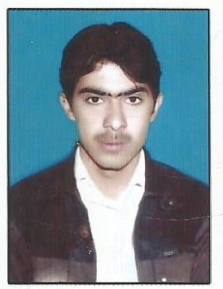



**ADNAN AHAMD**

OBJECTIVE:

To pursue a position as a responsible team member in a Successful organization and to develop and fully utilize my current educational and experience abilities in a productive environment.



Personal Information:

* Name : ADNAN AHMAD
* Father’s Name : JAHAN ZEB KHAN
* C.N.I.C. : 11101-2307957-5
* Domicile : Bannu (KPK)
* Religion : Islam
* Marital Status : Married
* Nationality : Pakistani
* Mob No : **03459740954 + 03339641522**
* Permanent Address: Village and post office Landi Jalander Distt bannu.
* Present Address: Village and post office Landi Jalander Distt bannu

**Academic Detail**

|  |  |  |  |  |
| --- | --- | --- | --- | --- |
| **Examination** | **PASSING**  **Year** | **Obt/Total Mark** | **Percentage** | **Board/Uni** |
| Ssc | 2005 | 610/1050 | 58% | BISE Bannu |
| DAE(Electrical ) | 2008 | 2018/3550 | 56.84% | BTE  Peshawar |
| B.A | 2012 | 276/550 | 50.2% | UST Bannu |
| Safety Supervisor | 2013 | 279/300 | 91.5% | TTB Bannu |
| MA. Urdu | 2020 | 498/1200 | 41.5 | UST Bannu |

* + Computer Skills :
* Internet browsing
* Expert of Ms Office ,Ms power point ,Ms Excel

**Languages Details**

|  |  |  |  |
| --- | --- | --- | --- |
| Language | Read | Write | Speak |
| English | Advanced | Advanced | Good |
| Urdu | Advanced | Advanced | Good |

Experience: 03 years experience as a junior Instructor Karsaz Polytechnic institute of Technology Domel Bannu.