**AHMAD HUSSAIN**

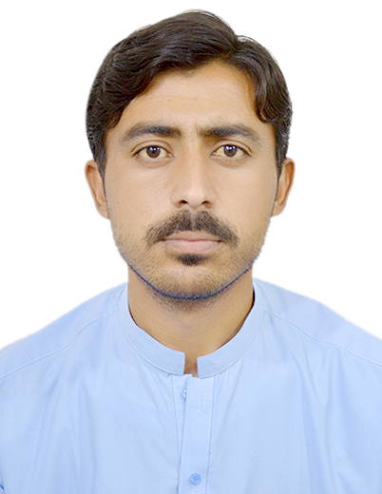

**OBJECTIVE**:

I am enthusiastic and enjoy working in a busy environment. If I am given a chance I shall prove a good and hardworking member of your faculty. My personal details are as under.

Father’s Name : Barajan

Mobile number : 0332 3918234

Date of birth : 01.01.2001

Domicile : North waziristan

Nationality : Pakistani

Religion : Islam

Address : Village shamiri tehsil

spinwam .

Email address : ahmadhussain06666@gmail.com

**ACADEMIC** **QUALIFICATION**:

|  |  |  |  |
| --- | --- | --- | --- |
| **DEGREE** | **Board/university** | **Year of passing** | **Marks** |
| BSC | Ust bannu | 2021 | 365/550 |
| FSC | BISE Bannu | 2019 | 897/1100 |
| SSC | BISE bannu | 2016 | 949/1100 |

**EXPERIENCE** :

2 year experience as a supervisor in kabul english language and computer academ

**HOBBY**:

Book reading, playing game, watching movies.

**LANGUAGE**: English, urdu,pashto