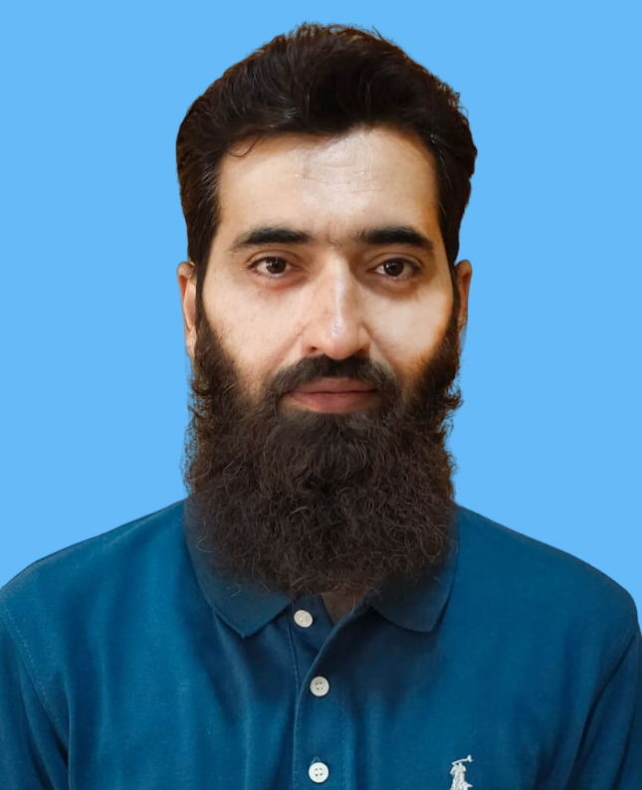
AHMED JAMAL
Contact: 0333-7843408
E-mail: ahmedjamal52625@gmail.com

OBJECTIVE

Achieve a key position in a dynamic team, working in the field Development Sector, where I can turn my educational qualifications into a career boosting experience.

PERSONAL

Father Name: Riaz Muhammad
D.O.B: September, 05, 1985
Marital Status: Married
CNIC #: 54400-8688448-1
Address: H # F-65 Wahdat Colony 3rd Stop, Brewery Road, Quetta.

QUALIFICATIONS

Professional:

B.Com University Of Baluchistan
(2006)
Academic:
HSC - (D.Com) BBISE Quetta
(2004)
SSC - (Science) BBISE Quetta
(2001)

PROFESSIONAL EXPERIENCE

Chip Training & Consulting (CTC)
DEOC (District Emergency Operations Center)
DC Office Quetta DA (Data Assistant)
(May-2023 to date)
Responsibilities:
- Trainings of UC level and AS level staff on data collection and reporting tools
- Follow up with UC staff for submission of data for reports.
- Monitor and follow-up with UC staff on regular data upload on polio info database.
- UC level data collection and compilation on key indicators to generate pre, intra and post campaign report.
- Collate and analyse campaign data, monitor feedback from UCOs and generate daily CCPV, COMNet monitoring updates during campaigns.
- Ensure timely submission of periodic reports including 30 HH cluster survey / detail epidemiological investigation form for urgent AFP and polio cases.
- Analyse data of dashboard indicators with UC wise feedback to the UCO and SMs.
- Maintain close liaison with DPCR data operator for two way data flow.
- Generate and share extended catch up coverage report from DSC dataset with the concerned DPCR. Collate and relay CCPV dataset as per DSC SOP.
- To work as focal person for DSC correspondence and follow-up with field staff.
- Collection of data for campaign planning from UC level for onward submission.

Chip Training & Consulting (CTC)
DPCR (District Polio Control Room) TDO (Tehsil Data Officer)
(Nov-2017 to May-2023)
Responsibilities:
- Collate daily staff attendance SMS and generate monthly attendance report for the assigned district.
- Training of CCPV and COMNet staff on reporting tools.
- Follow – up with UC staff for submission of data for reports.
- Monitor and follow-up with UC staff on regular data upload on polio info database.
- Have access to PCR and polio info datasets for COMNet and CCPV planning.
- Maintain datasets of CCPV and COMNet UCs in the assigned district / agencies.
- UC level data collection and compilation on key indicators to generate pre, intra and post campaign report.
- Collate and analyse campaign data, monitor feedback from UCOs and generate daily CCPV, COMNet monitoring updates during campaigns.
- Ensure timely submission of periodic reports including 30 HH cluster survey / detail epidemiological investigation form for urgent AFP and polio cases.
- Analyse data of dashboard indicators with UC wise feedback to the UCO and SMs.
- Maintain close liaison with DPCR data operator for two way data flow.
- Generate and share extended catch up coverage report from DSC dataset with the concerned DPCR. Collate and relay CCPV dataset as per DSC SOP.
- To work as focal person for DSC correspondence and follow-up with field staff.
- Collection of data for campaign planning from UC level for onward submission.
- Maintain the data of social characteristics of polio cases of the respective district.
- Spot check missed children logbook and child registration logbook of the assigned district.

MicroMerger (Pvt) Ltd
IT Solutions Islamabad
DSC Quetta DVA (Data Verification Associate)
(Sep-2015 to Oct-2017)
Responsibilities:

- Manage a team of professionals on daily basis to meet or exceed objectives.
- Perform resource allocation, workload assignment and schedule management for POLIO campaigns.
- Printing and compilation of the sheets received from the District Union Councils (K.Abdullah).
- Sorting of missing sheets, blur sheets, mistakes and inform UCOs before further process.
- Keep in touch with UCOs and keep updated about the changes of Supervisors and teams in Union Councils to avoid uncertain situation during campaign.
Conduct regular performance evaluation of UCOs and inform the District Co-ordinator.
- Address team concerns and provide direction whenever needed.
- Ensure that all operations are done in accordance with provided standards.
- Resolve all issues and ensure to provide output.
- Conduct performance evaluation of supporting DEOs’ and provide feedback for improvements.
- Build strong working relationships and maintain effective communications with team members.
- Identify challenges and suggest appropriate action plans.
- Ensure that teams follow company policies and procedures at all times.

Tameer-e-Khalq Foundation
Quetta (TKF) Field Officer
(Jan 2014 to Aug 2014)
Responsibilities:

- To lead and coordinate the effective management of organization and general administration functions in operational areas.
- Manage and make coordination for all aspects of the project.
- Ensure the organization meet all its commitments to the donors and be the contact person for donors in all matters to develop.
- Implementing the organizational strategy approved by the senior management.
- Visit field office to check and support them in their capacity building/strengthening.

SIGNIFICANT ACHIEVMENTS:

- Certified for Pakistan’s longest walk of 110xKm from Quetta to Ziarat as a juniper defender in 2000
- Certified from Baluchistan Rowing, Canoeing Association, Pakistan
- Best Performance award as Data Support Officer (DEOC) in 2021.
- Completed a comprehensive Training Program in Power BI
- Completed a comprehensive Training Program in QGIS

COMPUTER LITERACY
- DIT
- MS Office
- Tableau
- Power BI
- Google Studio
- SPSS
- Adobe Photoshop
- Adobe Illustrator
- GIS Mapping
- Trouble shooting Hardware / Software

REFERENCE
Dr. Safdar Zarkoon Mr. Khalid Kasi
District Deputy Polio Lead (DDPL) (DEOC) District Communication Officer
Quetta Quetta.
Mob# 0333-3848898 Mob# 0333-7855922

